# AWS Basics

<https://aws.amazon.com/about-aws/global-infrastructure/?p=ngi&loc=0>

AWS infrastructure

1. **AWS Regions** 🡪Based on geography us-east-1, eu-west-3
2. **AWS Availability Zones** 🡪 3 or more AZ compose a region
3. **AWS Data Centres** 🡪 Each availability zone is a **physically separate data centre** within a region, with independent power, cooling, and networking infrastructure
4. **AWS Edge Locations or Points of Presence** 🡪 The Edge Locations are strategically positioned data centres located around the world designed to optimize the delivery of content and applications. They serve as points of presence (POPs) for the AWS services enabling data to be served from the location closest to the end user which significantly reduces latency.

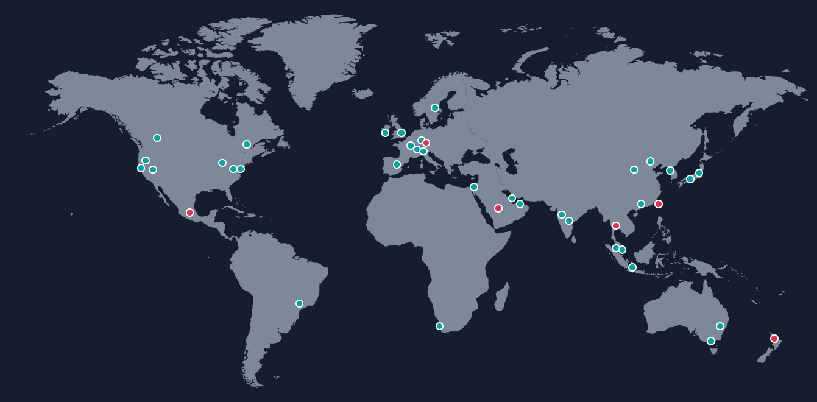

AWS Regions

* AWS has Regions all around the world based on geography
* Names can be us-east-1, eu-west-3…
* A region is a cluster of data centers
* Most AWS services are region-scoped

How to choose an AWS Region?

* Compliance with data governance and legal requirements: data never leaves a region without your explicit permission
* Proximity to customers: reduced latency
* Available services within a Region: new services and new features aren’t available in every Region
* Pricing: pricing varies region to region and is transparent in the service pricing page

AWS Availability Zones

* Each region has many availability zones (usually 3, min is 3, max is 6). Example:

1. ap-southeast-2a
2. ap-southeast-2b
3. ap-southeast-2c

* Each availability zone (AZ) is one or more discrete data centres with redundant power, networking, and connectivity
* They’re separate from each other, so that they’re isolated from disasters
* They’re connected with high bandwidth, ultra-low latency networking

AWS has Global Services:

* Identity and Access Management (IAM)
* Route 53 (DNS service)
* CloudFront (Content Delivery Network)
* WAF (Web Application Firewall)

AWS services are Region-scoped:

* Amazon EC2 (Infrastructure as a Service)
* Elastic Beanstalk (Platform as a Service)
* Lambda (Function as a Service)
* Rekognition (Software as a Service)

Region Table: <https://aws.amazon.com/about-aws/global-infrastructure/regional-product-services>

# EC2

EC2 is one of the most popular of AWS’ offerings

* EC2 = Elastic Compute Cloud = Infrastructure as a Service
* It mainly consists of the capability of:

1. Renting virtual machines (EC2)
2. Storing data on virtual drives (EBS)
3. Distributing loads across machines (ELB)
4. Scaling the services using an auto-scaling group (ASG)

EC2 size & configuration options

1. Operating System (OS): Linux, Windows or Mac OS
2. How much power & cores (CPU)
3. How much random-access memory (RAM)
4. How much storage space: Network-attached (EBS & EFS) hardware (EC2 Instance Store)
5. Network card: speed of the card, Public IP address
6. Firewall rules: security group
7. Bootstrap script (configure at first launch): EC2 User Data

EC2 User Data

* It is possible to boot-strap our instances using an EC2 User data script. Bootstrapping means launching commands when a machine starts. That script is only run once at the first start
* EC2 user data is used to automate boot tasks such as:

1. Installing updates
2. Installing software
3. Downloading common files from the internet

* The EC2 User Data Script runs with the root user

*#!/bin/bash*

*# Use this for your user data (script from top to bottom)*

*# install httpd (Linux 2 version)*

yum update -y

yum install -y httpd

systemctl start httpd

systemctl enable httpd

echo "<h1>Hello World from $(hostname -f)</h1>" > /var/www/html/index.html

EC2 Instance Types - Overview

You can use different types of EC2 instances that are optimized for different use cases (<https://aws.amazon.com/ec2/instance-types/> ).AWS has the following naming convention:

m5.2xlarge

* m: instance class
* 5: generation (AWS improves them over time)
* 2xlarge: size within the instance class

Different types

1. **General Purpose** Great for a diversity of workloads such as web servers or code repositories. Starts with M or T. It balances between:
   1. Compute
   2. Memory
   3. Networking
2. **Compute Optimized** Great for compute-intensive tasks that require high performance processors: Starts with C. Use cases
   1. Batch processing workloads
   2. Media transcoding
   3. High performance web servers
   4. High performance computing (HPC)
   5. Scientific modelling & machine learning
   6. Dedicated gaming servers
3. **Memory Optimized** Fast performance for workloads that process large data sets in memory. Use cases:
   1. High performance, relational/non-relational databases
   2. Distributed web scale cache stores
   3. In-memory databases optimized for BI (business intelligence)
   4. Applications performing real-time processing of big unstructured data
4. **Storage Optimized** Great for storage-intensive tasks that require high, sequential read and write access to large data sets on local storage. Use cases
   1. High frequency online transaction processing (OLTP) systems
   2. Relational & NoSQL databases
   3. Cache for in-memory databases (for example, Redis)
   4. Data warehousing applications
   5. Distributed file systems

## Security Groups

Security Groups are the fundamental of network security in AWS. They control how traffic is allowed into or out of our EC2 Instances. Security groups only contain rules. Security groups rules can reference by IP or by security group.

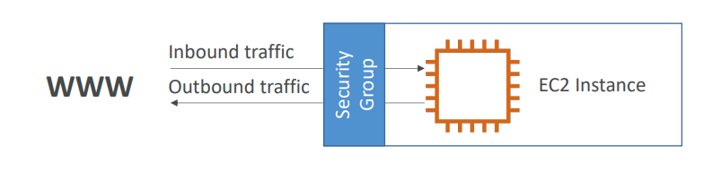

Security groups are acting as a “firewall” on EC2 instances They regulate:

* Access to Ports
* Authorized IP ranges – IPv4 and IPv6
* Control of inbound network (from other to the instance)
* Control of outbound network (from the instance to other)

Imp

Can be attached to multiple instances

* Locked down to a region / VPC combination
* Does live “outside” the EC2 – if traffic is blocked the EC2 instance won’t see it
* It’s good to maintain one separate security group for SSH access
* If your application is not accessible (time out), then it’s a security group issue
* If your application gives a “connection refused “error, then it’s an application error or it’s not launched
* All inbound traffic is blocked by default
* All outbound traffic is authorized by default

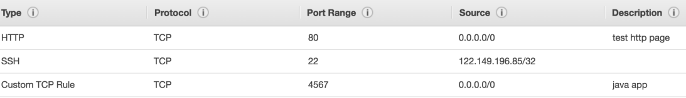

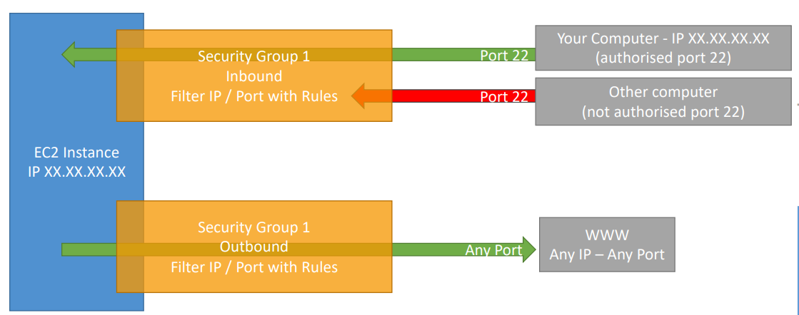

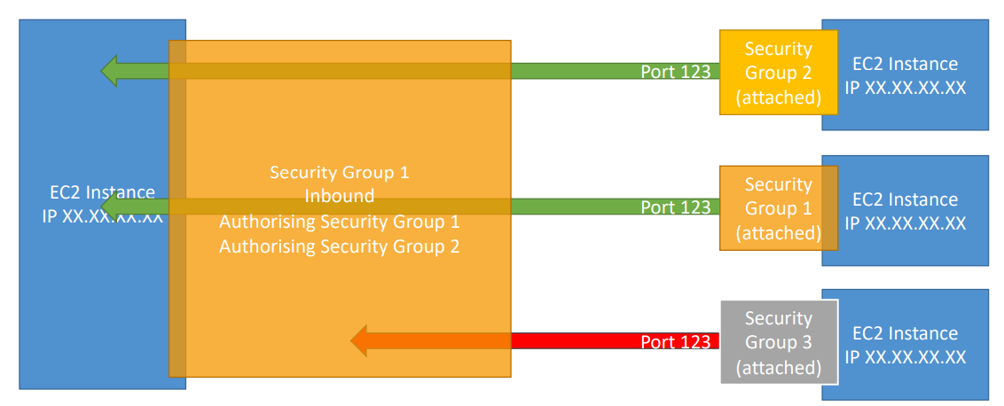

Important ports for security group

• 22 = SSH (Secure Shell) - log into a Linux instance

• 21 = FTP (File Transfer Protocol) – upload files into a file share

• 22 = SFTP (Secure File Transfer Protocol) – upload files using SSH

• 80 = HTTP – access unsecured websites

• 443 = HTTPS – access secured websites

• 3389 = RDP (Remote Desktop Protocol) – log into a Windows instance

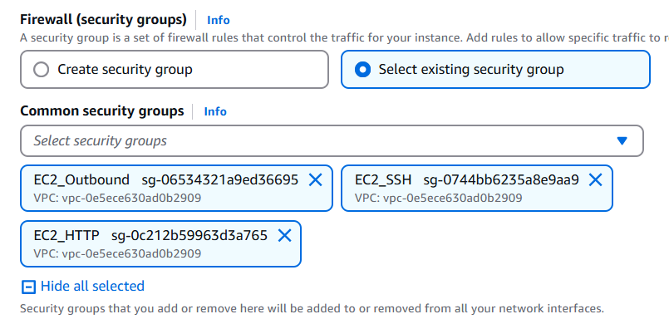

## Purchasing options

1. **On-Demand Instances** – short workload, predictable pricing, pay by second
2. **Reserved Instances** – long workloads
   * **Convertible Reserved Instances** – long workloads with flexible instances
3. **Savings Plans (1 & 3 years)** –commitment to an amount of usage, long workload
4. **Spot Instances** – short workloads, cheap, can lose instances (less reliable)
5. **Dedicated Hosts** – book an entire physical server, control instance placement
6. **Dedicated Instances** – no other customers will share your hardware
7. **Capacity Reservations** – reserve capacity in a specific AZ for any duration

### 1 EC2 On Demand

* Ideal for short-term, unpredictable workloads.
* Billed per second (Linux/Windows) or per hour (other OS).
* No long-term commitment, highest cost.
* No upfront payment

### 2 EC2 Reserved Instances

* Suitable for steady-state workloads (e.g., databases).
* Commit to 1 or 3 years, with up to **72% discount**. – 1 year (+discount) or 3 years (+++discount)
* Convertible RIs offer flexibility in instance type, family, OS, etc., but with a slightly lower discount (up to 66%).
* You reserve a specific instance attribute (Instance Type, Region, Tenancy(multi-tenant means multiple customer apps will run), OS)
* Payment Options – No Upfront (+), Partial Upfront (++), All Upfront (+++)
* Reserved Instance’s Scope – Regional or Zonal (reserve capacity in an AZ)
* You can buy and sell in the Reserved Instance Marketplace

### 3 EC2 Savings Plans

What is the flexibility in changing instances?

* Like Reserved instance but based on spending commitment in dollars, not instance attributes.
* 1 or 3-year terms, with up to 70% discount.
* Allows flexibility across instance sizes, OS, and tenancy.
* Commit to a certain type of usage ($10/hour for 1 or 3 years)
* Usage beyond EC2 Savings Plans is billed at the On-Demand price
* Locked to a specific instance family & AWS region (e.g., M5 in us-east-1)
* Flexible across below metrics:
* Instance Size (e.g., m5. xlarge, m5.2xlarge)
* OS (e.g., Linux, Windows)
* Tenancy (Host, Dedicated, Default)

### 4 EC2 Spot Instances

* Can get a discount of up to 90% compared to On-demand
* Instances that you can “lose” at any point of time if your max price is less than the current spot price
* Useful for workloads that are resilient to failure. Not suitable for critical jobs or databases
* Batch jobs
* Data analysis
* Image processing
* Any distributed workloads

**How Spot Pricing Works?**

* You define a maximum spot price that you're willing to pay.
* The spot price fluctuates based on supply and demand and varies across Availability Zones (AZs).
* If the current spot price is less than or equal to your max price, the instance is launched or continues to run.
* If the current spot price exceeds your max price, you get a 2-minute warning before the instance is interrupted.
* You then have two options:
  1. Stop the instance: Data is preserved, and the instance can be resumed when the spot price falls back below your max price.
  2. Terminate the instance: All data is lost unless you have backups or are using persistent storage

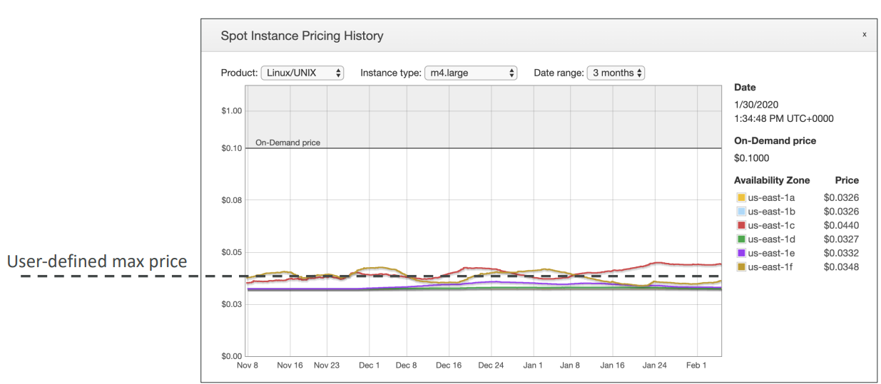

How to do spot requests

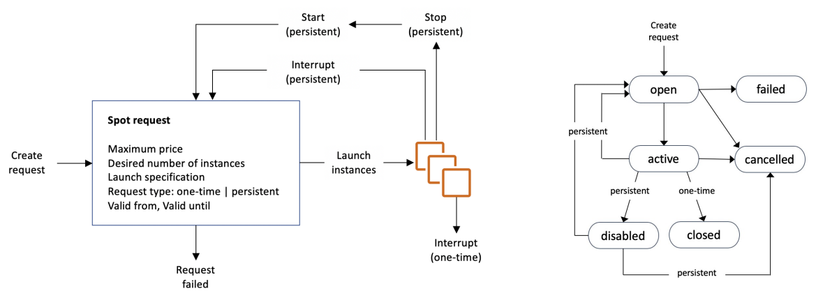

With the spot request, you are defining how many instances you want, your maximum price you're going to pay, the launch specification, so the AMI and so on, and when your request is valid from and until, but it can be infinite. And then the request type.

Type of Spot requests

* **one-time request:** As soon as your spot request is fulfilled, your instances are going to be launched and then your spot request itself will get deleted.
* **persistent request**: AWS continues to request spot instances until the request expires or is cancelled.
  + If somehow your instances do get stopped or interrupted based on the spot price, then your spot request will go back into action and when the prices are favourable, the instances will be launched again.
  + If you stop a spot instance in persistent mode and your spot request is still active, your spot request automatically will be smart enough to restart a launch and instance for you.

Termination Process:

* 1. Cancel the Spot Request to prevent AWS from relaunching instances.
  2. Terminate the Spot Instance to free up resources.
* If you terminate instances without cancelling the request, AWS will automatically relaunch instances to meet the persistent request criteria.

Spot Fleets: The Advanced Spot Request Strategy:

* A Spot Fleet allows you to request multiple instance types across multiple AZs to achieve cost savings while maintaining capacity.
* You can define multiple launch pools (instance type (m5. large), OS, Availability Zone).
* Spot Fleet stops launching instances when reaching capacity or max cost
* AWS will select the optimal pool based on your chosen strategy:
  1. **Lowest Price:** Selects the pool with the lowest spot price (good for short, cost-sensitive workloads).
  2. **Diversified:** Spreads instances across multiple pools to improve availability (suitable for long-running workloads).
  3. **Capacity Optimized:** Focuses on pools with the highest available capacity.
  4. **Price Capacity Optimized:** Selects the pool with the highest capacity and then chooses the lowest price within that pool (best for balancing cost and capacity).

### 5 EC2 Dedicated Instances

EC2 instances that run **on hardware dedicated to a single customer** — **you don’t share the physical server** with other AWS accounts.

**Key Characteristics:**

* AWS **manages placement** — you can’t control which physical host your instance lands on.
* You get **isolation**, but not visibility into or control over the host.
* Good for **basic isolation needs** (e.g., compliance).

**Billing:**

* **Per-instance billing** (like On-Demand or Reserved).
* Includes a **slight premium** for dedicated infrastructure.

**Use Cases:**

* Regulatory/compliance requirements (e.g., must not share hardware with others).
* Need instance-level isolation but don’t need control over the host.

### 6 EC2 Dedicated Hosts

You **reserve an entire physical server** (host) for your use. You can **control instance placement** and use your own **software licenses** (e.g., BYOL – Bring Your Own License for Windows/SQL Server).

**Key Characteristics:**

* Full **visibility and control** over the physical server.
* You choose **which instances** to run and where on the host.
* Useful for **licensing**, compliance, and workload consistency.

**Billing:**

* **Per-host billing** (you pay for the whole physical server, regardless of usage).
* Can be more cost-effective if you run multiple instances on the same host.

**Use Cases:**

* BYOL for Microsoft or other software tied to physical cores.
* Workloads requiring **hardware affinity** or **constant performance**.
* High-compliance environments with strict control/audit needs.

| **Characteristic** | **Dedicated Instances** | **Dedicated Hosts** |
| --- | --- | --- |
| Enables the use of dedicated physical servers | ✅ | ✅ |
| Per instance billing (subject to a $2 per region fee) | ✅ |  |
| Per host billing |  | ✅ |
| Visibility of sockets, cores, host ID |  | ✅ |
| Affinity between a host and instance |  | ✅ |
| Targeted instance placement |  | ✅ |
| Automatic instance placement | ✅ | ✅ |
| Add capacity using an allocation request |  | ✅ |

### 7 EC2 Capacity Reservations

With **On-Demand Instances**, **there is no guarantee** that AWS will have available capacity for the specific instance type, Availability Zone (AZ), or region you request **at the time you try to launch it**.

You **reserve capacity** for specific instance types in a specific Availability Zone (AZ) to ensure that you can launch instances whenever you need them.

**Key Characteristics:**

* **Guaranteed capacity:** Ensures you can launch instances even during high-demand periods.
* **No cost unless you use it:** You’re only charged if you launch and run an instance using the reservation (unless you mark it as *Always On*).
* Can be combined with On-Demand or Savings Plans pricing.
* You still pay **On-Demand rates** unless combined with a Savings Plan.

**Use Cases:**

* Mission-critical applications requiring guaranteed compute capacity.
* Disaster recovery or high-availability strategies.
* Compliance requirements demanding reserved resource

**Comparison Summary:**

| **Feature** | **On-Demand Instance** | **Capacity Reservation** |
| --- | --- | --- |
| **Commitment** | No long-term commitment | No commitment to usage, but capacity is held |
| **Billing** | Charged per second/hour when running | Charged only when instances are running (unless Always On) |
| **Availability** | No capacity guarantee | Guarantees capacity in a specific AZ |
| **Flexibility** | Highly flexible | Fixed instance type, count, and AZ |
| **Use Case** | Flexible, spiky, or short-term workloads | Critical workloads needing guaranteed resources |

### Summary

Comparing EC2 instance to a hotel

* **On-Demand:** Pay as you go at the full price (like booking a hotel room at the last minute).
* **Reserved:** Book in advance for a long stay at a discount (like a long-term hotel booking).
* **Savings Plan:** Commit to spending a certain amount regardless of room type (like a resort membership).
* **Spot:** Get last-minute deals but risk losing the room (like discounted, cancellable hotel rooms).
* **Dedicated Host:** Book an entire building (exclusive access to the server).
* **Capacity Reservation:** Reserve a room without using it (pay to keep a room available).

Price Comparison Example – m4. large – us-east-1

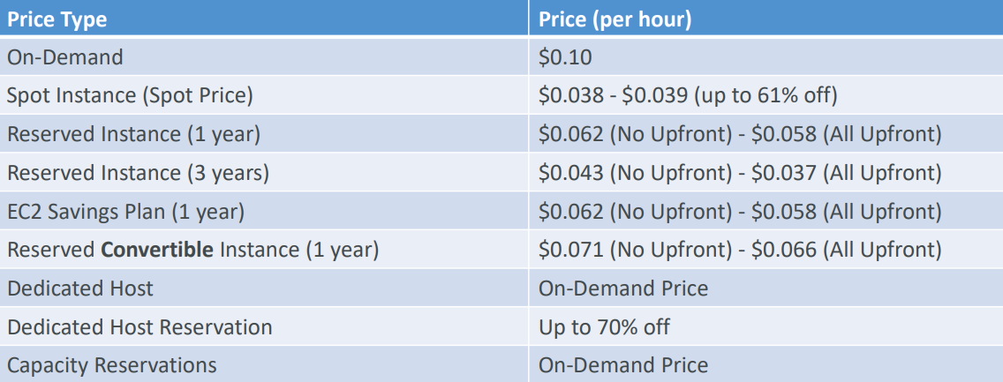

## Public IP charges

**✅ 1. Public IPv4 Charges Overview:**

* AWS now charges **$0.005 per hour** for every Public IPv4 address associated with your account, whether it is in use or not.
* This amounts to approximately **$3.60 per month per IP**.
* The charge applies to all services that use Public IPv4, such as EC2, RDS, and Load Balancers.
* The goal of this change is to incentivize users to migrate to IPv6, which has no such charges.

**✅ 2. Free Tier for Public IPv4 in EC2:**

* New AWS accounts get a **12-month free tier** for EC2 that includes **750 hours per month of Public IPv4 usage**.
* This limit applies **collectively** to all EC2 instances.
  + Example: If you run two instances, each with a Public IPv4, the hours are counted together.
  + If the total usage exceeds 750 hours in a month, the standard charges will apply.
* Other AWS services like RDS and Load Balancers do **not** get any free tier for IPv4 usage.

**✅ 3. How Public IPv4 Charges Apply to Different Services:**

* **EC2 Instances:** Covered by the 750-hour free tier. Charges apply after exceeding the limit.
* **Load Balancers:** Charges apply immediately since there is no free tier.
  + Example: If you deploy a load balancer in **three AZs**, you will have **three Public IPv4s** and incur charges for all three.
* **RDS Databases:** Charges apply immediately for public IPs since RDS is not covered by the free tier.
* **Any Other AWS Service:** Charges apply immediately for public IPs.

**✅ 4. IPv6 Considerations:**

* AWS encourages the use of **IPv6** to avoid these IPv4 charges.
* IPv6 addresses are **free**, but not all ISPs and networks support IPv6.
* AWS recommends using [test-ipv6.com](http://test-ipv6.com) to verify IPv6 compatibility.
* Implementing IPv6 requires **additional networking configuration** and **custom security group rules**.
* Beginners should stick to IPv4 due to its simplicity and broader compatibility.

**✅ 5. Troubleshooting IPv4 Charges:**

* To monitor and understand IPv4 usage and associated charges:
  + Navigate to **Billing and Cost Management** → **Bills** in the AWS console.
  + Check for **Public IPv4 charges** under each service.
  + Use the **Amazon VPC IP Address Manager (IPAM)** to get a comprehensive view of all public IPs in use.
  + IPAM provides **Public IP Insights** to track and manage IP addresses effectively, and it is available under the free tier.

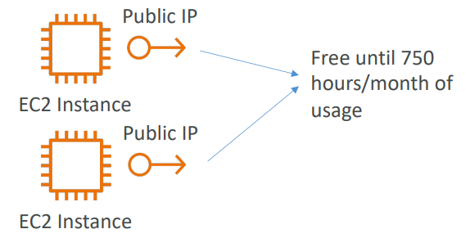 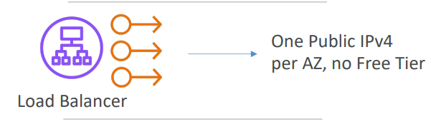 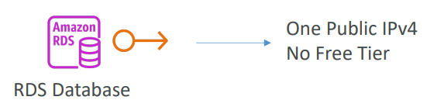

What about IPv6?

* Unfortunately, many Internets Service Provider (ISP) around the world don’t support IPv6, so the course would not work for some of you
* You can test IPv6 by going to <https://test-ipv6.com/>
* If you use IPv6 in this course, you’re on your own (security groups, networking…) but you can do it!

How do you troubleshoot charges?

* Go into your AWS Bill
* Look into the AWS Public IP Insights service
* Nice article here: <https://repost.aws/articles/ARknH_OR0cTvqoTfJrVGaB8A/why-am-i-seeing-charges-for-public-ipv4-addresses-when-i-am-under-the-aws-free-tier>

## Public Private IP

* Networking has two sorts of IPs. IPv4 and IPv6:
* IPv4: 1.160.10.240
* IPv6: 3ffe: 1900:4545:3:200: f8ff: fe21:67cf
* IPv4 is still the most common format used online.
* IPv6 is newer and solves problems for the Internet of Things (IoT).
* IPv4 allows for 3.7 billion different addresses in the public space which are running out
* IPv4: [0-255]. [0-255]. [0-255]. [0-255].

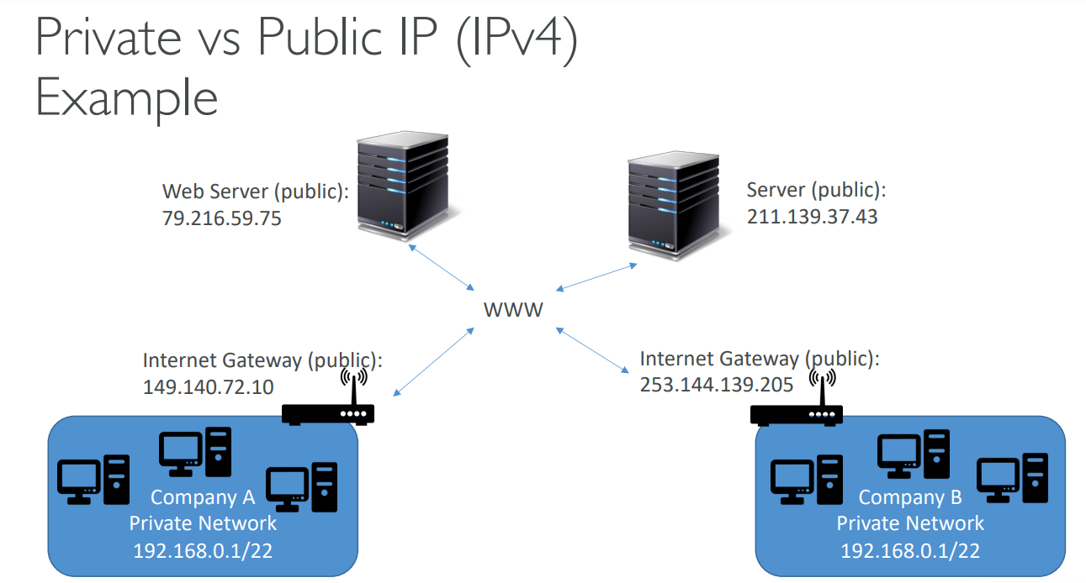

Private vs Public IP (IPv4) Fundamental Differences

* Public IP:
* Public IP means the machine can be identified on the internet (WWW)
* Must be unique across the whole web (not two machines can have the same public IP).
* Can be geo-located easily
* Private IP:
* Private IP means the machine can only be identified on a private network only
* The IP must be unique across the private network
* BUT two different private networks (two companies) can have the same IPs.
* Machines connect to WWW using a NAT + internet gateway (proxy)
* Only a specified range of IPs can be used as private

## Elastic IPs

When you stop and then start an EC2 instance, it can change its public IP. If you need to have a fixed public IP for your instance, you need an Elastic IP An Elastic IP is a public IPv4 IP you own if you don’t delete it. You can attach it to one instance at a time

With an Elastic IP address, you can mask the failure of an instance or software by rapidly remapping the address to another instance in your account. You can only have 5 Elastic IP in your account (you can ask AWS to increase that).

* Overall, try to avoid using Elastic IP:
* They often reflect poor architectural decisions
* Instead, use a random public IP and register a DNS name to it
* Or, as we’ll see later, use a Load Balancer and don’t use a public IP

Private vs Public IP (IPv4) In AWS EC2

* By default, your EC2 machine comes with:
* A private IP for the internal AWS Network
* A public IP, for the WWW.
* When we are doing SSH into our EC2 machines:
* We can’t use a private IP, because we are not in the same network
* We can only use public IP.
* If your machine is stopped and then started, the public IP can change

## Placement Groups

We don't get direct interaction with the hardware of AWS, but we let AWS know how we would like our EC2 instance to be placed compared to one another.

In **AWS (Amazon Web Services)**, a **Placement Group** is a feature used to influence the placement of a group of EC2 (Elastic Compute Cloud) instances to meet specific workload needs. It controls how instances are physically placed within the AWS infrastructure for performance or availability reasons.

1. Cluster Placement Group

* **Purpose:** Low latency and high throughput between instances.
* **How it works:** Places instances **close together** within a single Availability Zone.
* **Use case:** High-performance computing (HPC), big data workloads, or tightly-coupled applications that need fast communication between instances.

**Pros:**

* Very low latency.
* High network throughput (up to 100 Gbps between supported instance types).

**Cons:**

* Limited to a single Availability Zone (less fault-tolerant).
* Can run into capacity issues; best to launch all instances at once.

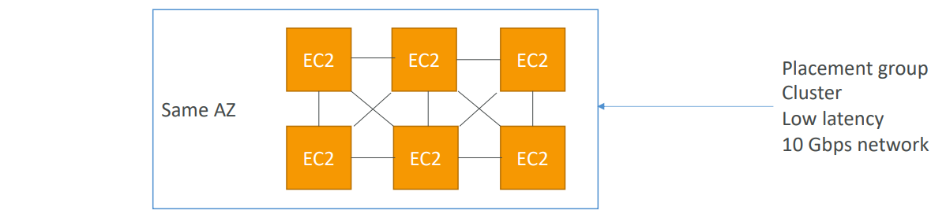

* Use case:
* Big Data job that needs to complete fast
* Application that needs extremely low latency and high network throughput

2. Spread Placement Group

* **Purpose:** High availability and fault tolerance.
* **How it works:** Places instances on **distinct hardware**, minimizing risk of simultaneous failure.

**Use case:**

* Critical workloads where each instance must be isolated from failure of others (e.g., multiple app servers or DBs).

**Pros:**

* Maximum fault isolation (one instance per rack, per Availability Zone).
* Can span multiple Availability Zones.

**Cons:**

* Limited to 7 running instances per Availability Zone per group.

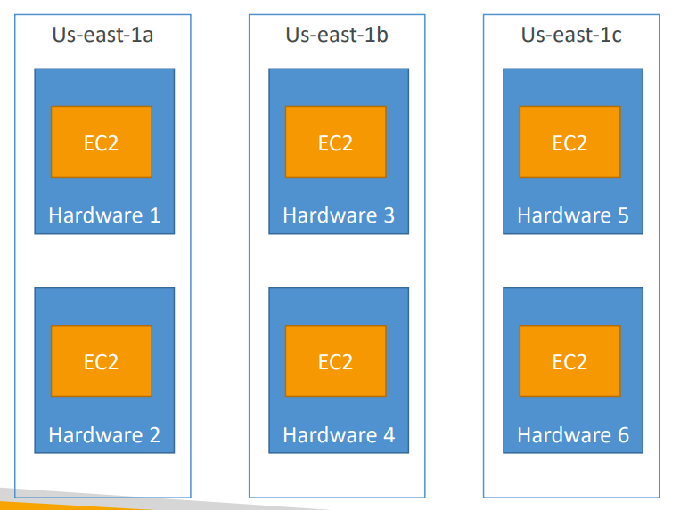

**3. Partition Placement Group**

* **Purpose:** Balance between availability and scalability for large, distributed workloads.
* **How it works:** Divides each group into **partitions** (logical groups). Each partition is isolated from others, with its own set of hardware (rack).

**Use case:**

* Large-scale distributed systems like Hadoop, Cassandra, or Kafka.

**Pros:**

* Isolation between partitions helps reduce correlated failures.
* Can support hundreds of instances.
* Can span multiple Availability Zones.

**Cons:**

* More complex to manage compared to Cluster or Spread groups.

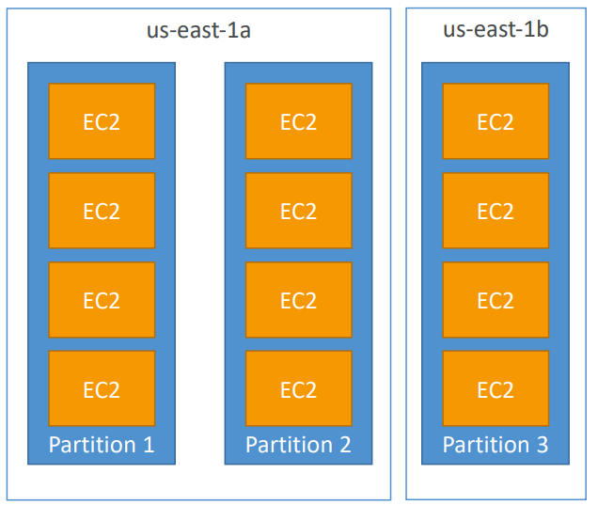

**Summary Table:**

| **Type** | **Goal** | **Fault Tolerance** | **Low Latency** | **AZ Scope** |
| --- | --- | --- | --- | --- |
| Cluster | High performance networking | Low | High | Single AZ |
| Spread | Max fault isolation | High | Low | Multi-AZ allowed |
| Partition | Scalable fault isolation | Medium | Medium | Multi-AZ allowed |

## Elastic Network Interfaces (ENI)

An ENI (Elastic Network Interface) in AWS is a virtual network interface that you can attach to an EC2 instance in a VPC (Virtual Private Cloud). It represents a virtual network card and is a fundamental building block of networking in AWS.

🔹 Key Features of ENI:

1. Private IPv4 address (mandatory)
2. One or more secondary IPv4 addresses (optional)
3. One Elastic IP address (per private IPv4, optional)
4. One or more security groups
5. MAC address
6. Source/destination check flag
7. Attachment to one EC2 instance at a time
8. Can move between instances (same AZ)

**🔹 Types of ENIs**

1. **Primary ENI**: Automatically created and attached when an instance is launched.
2. **Secondary ENI**: Manually created and attached to instances. Can be detached and re-attached.

**🔸 ENI Behaviour**

* An ENI lives in a subnet and inherits the subnet’s AZ.
* When attached, the instance can communicate using the ENI’s IP addresses.
* You can detach a secondary ENI and attach it to another instance — great for failover setups.
* ENIs support enhanced networking (with compatible instance types and drivers) for high performance.

Use case: Say our application connects to an internal AWS IP. EC2, whenever they are created, will get a dynamic IP. We can create an ENI and attach to EC2 and use that in our application. In case of failover, we can attach the ENI to a new EC2 instance.

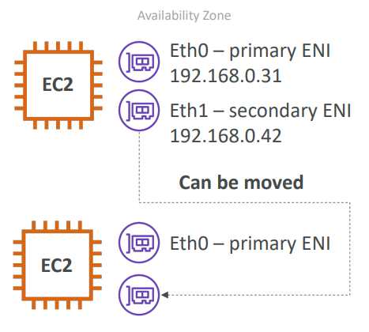

## EC2 Hibernate

* We know we can stop, terminate instances

1. Stop – the data on disk (EBS) is kept intact in the next start
2. Terminate – any EBS volumes (root) also set-up to be destroyed is lost

* At the start, the following happens:

1. First start: the OS boots & the EC2 User Data script is run
2. Following starts: the OS boots up
3. Then your application starts, caches get warmed up, and that can take time!

EC2 Hibernate is a feature in Amazon EC2 that allows you to pause an instance by saving its in-memory RAM state to disk (Amazon EBS), and then resume it later from where it left off — just like hibernation on a laptop.

🔸 How It Works:

1. When you hibernate an EC2 instance:
   * The contents of RAM (memory) are saved to the root EBS volume.
   * The instance shuts down, but EBS volumes remain attached and billed.
   * Elastic IP (if assigned) and instance ID are retained.
2. When you start the hibernated instance again:
   * EC2 restores the RAM from the EBS volume.
   * The OS and applications resume as if they never stopped.

**🔹 Benefits of EC2 Hibernate:**

| **Benefit** | **Description** |
| --- | --- |
| **Fast resume** | No need to reboot the OS or restart apps. |
| **Keeps app state** | Useful for long-running processes, in-memory databases, or cached sessions. |
| **Same instance ID/IP** | No need to reconfigure services relying on specific IDs/IPs. |
| **Efficient for spot recovery** | Resume a spot instance quickly without reinitialization. |

| **Requirement / Limitation** | **Details** |
| --- | --- |
| **Instance type** | Only supported on specific instance families (e.g., C3, C4, M3, M4, R3, R4, etc.). |
| **Root volume** | Must be **EBS (not instance store)** and **encrypted**. |
| **RAM size** | RAM content must fit on the root EBS volume. |
| **Operating systems** | Supported only on **Amazon Linux 2**, **Ubuntu**, and **Windows** AMIs provided by AWS. |
| **Max hibernation time** | You can hibernate an instance for **up to 60 days**. |

| **Feature** | **Hibernate** | **Stop** | **Terminate** |
| --- | --- | --- | --- |
| RAM Saved? | ✅ Yes (saved to EBS) | ❌ No | ❌ No |
| EBS Saved? | ✅ Yes | ✅ Yes | ❌ Deleted (unless configured) |
| Instance ID? | ✅ Preserved | ✅ Preserved | ❌ Released |
| Charges? | EBS charges only | EBS charges only | No charges (if volumes deleted) |

## Questions

Top of Form

Which EC2 Purchasing Option can provide you the biggest discount, but it is not suitable for critical jobs or databases?

* Convertible Reserved Instances
* Dedicated Hosts
* Spot Instances

Bottom of Form

Top of Form

What should you use to control traffic in and out of EC2 instances?

* Network Access Control List (NACL)
* Security Groups
* IAM Policies

Bottom of Form

Top of Form

How long can you reserve an EC2 Reserved Instance?

* 1 or 3 years
* 2 or 4 years
* 6 months or 1 year
* Anytime between 1 and 3 years

Bottom of Form

1 or 3 years

Top of Form

You would like to deploy a High-Performance Computing (HPC) application on EC2 instances. Which EC2 instance type should you choose?

* Storage Optimized
* Compute Optimized
* Memory Optimized
* General Purpose

Bottom of Form

Compute Optimized EC2 instances are great for compute-intensive workloads requiring high-performance processors (e.g., batch processing, media transcoding, high-performance computing, scientific modeling & machine learning, and dedicated gaming servers).

Top of Form

Which EC2 Purchasing Option should you use for an application you plan to run on a server continuously for 1 year?

* Reserved Instances
* Spot Instances
* On-Demand Instances

Bottom of Form

Reserved Instances are good for long workloads. You can reserve EC2 instances for 1 or 3 years.

Top of Form

You are preparing to launch an application that will be hosted on a set of EC2 instances. This application needs some software installation, and some OS packages need to be updated during the first launch. What is the best way to achieve this when you launch the EC2 instances?

* Connect to each EC2 instance using SSH, then install the required software and update your OS packages manually
* Write a bash script that installs the required software and updates to your OS, then contact AWS Support and provide them with the script. They will run it on your EC2 instances at launch
* Write a bash script that installs the required software and updates to your OS, then use this script in EC2 User Data when you launch your EC2 instances

EC2 User Data is used to bootstrap your EC2 instances using a bash script. This script can contain commands such as installing software/packages, download files from the Internet, or anything you want.

Bottom of Form

Top of Form

Which EC2 Instance Type should you choose for a critical application that uses an in-memory database?

* Compute Optimized
* Storage Optimized
* Memory Optimized
* General Purpose

Memory Optimized EC2 instances are great for workloads requiring large data sets in memory.Bottom of Form

Top of Form

You have an e-commerce application with an OLTP database hosted on-premises. This application has popularity which results in its database has thousands of requests per second. You want to migrate the database to an EC2 instance. Which EC2 Instance Type should you choose to handle this high-frequency OLTP database?

* Compute Optimized
* Storage Optimized
* Memory Optimized
* General Purpose

Bottom of Form

Storage Optimized EC2 instances are great for workloads requiring high, sequential read/write access to large data sets on local storage.

Top of Form

Security Groups can be attached to only one EC2 instance.

* False
* True

Bottom of Form

Security Groups can be attached to multiple EC2 instances within the same AWS Region/VPC.

Top of Form

You're planning to migrate on-premises applications to AWS. Your company has strict compliance requirements that require your applications to run on dedicated servers. You also need to use your own server-bound software license to reduce costs. Which EC2 Purchasing Option is suitable for you?

* Convertible Reserved Instances
* Dedicated Hosts
* Spot Instances

Bottom of Form

Dedicated Hosts are good for companies with strong compliance needs or for software that have complicated licensing models. This is the most expensive EC2 Purchasing Option available.

Top of Form

You would like to deploy database technology on an EC2 instance and the vendor license bills you based on the physical cores and underlying network socket visibility. Which EC2 Purchasing Option allows you to get visibility into them?

* Spot Instances
* On-Demand
* Dedicated Hosts
* Reserved Instances

Bottom of Form

Dedicated Hosts

Top of Form

Spot Fleet is a set of Spot Instances and optionally ...............

* Reserved Instances
* On-Demand Instances
* Dedicated Hosts
* Dedicated Instances

Bottom of Form

Spot Fleet is a set of Spot Instances and optionally On-demand Instances. It allows you to automatically request Spot Instances with the lowest price.

Top of Form

You have launched an EC2 instance that will host a NodeJS application. After installing all the software required and configuring your application, you noted down the EC2 instance public IPv4 so you can access it. Then, you stopped and then started your EC2 instance to complete the application configuration. After restart, you can't access the EC2 instance, and you found that the EC2 instance public IPv4 has been changed. What should you do to assign a fixed public IPv4 to your EC2 instance?

* Allocate an Elastic IP and assign it to your EC2 instance
* From inside your EC2 instance OS, change network configuration from DHCP to static and assign it a public IPv4
* Contact AWS Support and request a fixed public IPv4 to your EC2 instance
* This can't be done, you can only assign a fixed private IPv4 to your EC2 instance

Elastic IP is a public IPv4 that you own as long as you want and you can attach it to one EC2 instance at a time.Bottom of Form

Top of Form

You have an application performing big data analysis hosted on a fleet of EC2 instances. You want to ensure your EC2 instances have the highest networking performance while communicating with each other. Which EC2 Placement Group should you choose?

* Spread Placement Group
* Cluster Placement Group
* Partition Placement Group

Cluster Placement Groups place your EC2 instances next to each other which gives you high-performance computing and networking.Bottom of Form

Top of Form

You have a critical application hosted on a fleet of EC2 instances in which you want to achieve maximum availability when there's an AZ failure. Which EC2 Placement Group should you choose?

* Cluster Placement Group
* Partition Placement Group
* Spread Placement Group

Spread Placement Group places your EC2 instances on different physical hardware across different AZs.Bottom of Form

Top of Form

Elastic Network Interface (ENI) can be attached to EC2 instances in another AZ.

* True
* False

Elastic Network Interfaces (ENIs) are bounded to a specific AZ. You cannot attach an ENI to an EC2 instance in a different AZ.Bottom of Form

Top of Form

The following are true regarding EC2 Hibernate, **EXCEPT**:

* EC2 Instance Root Volume must be an Instance Store volume
* Supports On-Demand and Reserved Instances
* EC2 Instance RAM must be less than 150GB
* EC2 Instance Root Volume type must be an EBS volume

To enable EC2 Hibernate, the EC2 Instance Root Volume type must be an EBS volume and must be encrypted to ensure the protection of sensitive content.Bottom of Form

# IAM

## IAM: Users & Groups

* IAM = Identity and Access Management, is a Global service
* Root account created by default when we register for AWS, it shouldn’t be used or shared
* We can give access to other Users within your organization by creating separate logins for them. They can use individual credentials to log in.
* For giving privileges to do something in AWS the users need permission.
* The best practice is to create a group in AWS for users who have similar role and give permission to this Groups from which users can inherit the permission.
* Groups only contain users, not other groups.
* There can be users which don’t belong to any group but it’s not best practice.
* Users can belong to multiple groups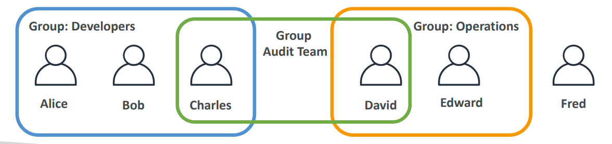

## IAM policies & permission

|  |  |
| --- | --- |
| Users or Groups can be assigned JSON documents called policies   * These policies define the permissions of the users * In AWS, you don't allow everyone to do everything that would be catastrophic, because a new user could basically launch so many services and they will cost you a lot of money or would be valid for security. In AWS you apply the least privileged principle: don’t give more permissions than a user needs. * In this example, we can see that we allow people to use the EC2 to service and do describe on it, to use the elastic load balancing service and to describe on it and to use CloudWatch. | {      "Version": "2012-10-17",      "Statement": [          {              "Effect": "Allow",              "Action": "ec2:Describe*",              "Resource": "*"          },          {              "Effect": "Allow",              "Action": "elasticloadbalancing:Describe*",              "Resource": "*"          },          {              "Effect": "Allow",              "Action": [                  "cloudwatch:ListMetrics",                  "cloudwatch:GetMetricStatistics",                  "cloudwatch:Describe*"              ],              "Resource": "*"          }      ]  } |

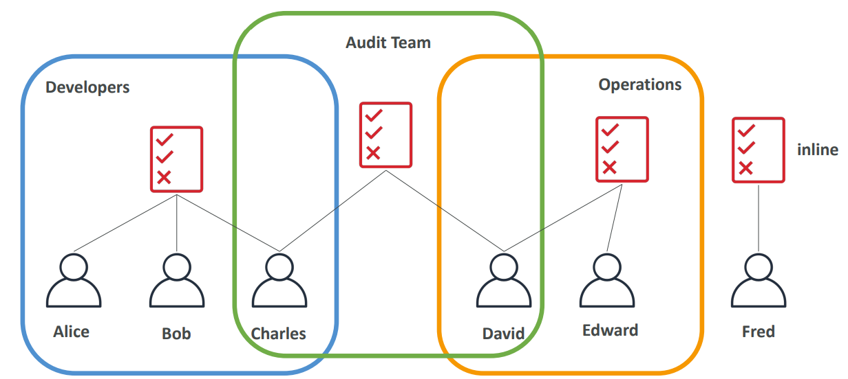

Users 🡪 Group 🡪 Policy

|  |  |
| --- | --- |
| Policy consists of   * Version: policy language version, always include “2012 -10-17” * Id: an identifier for the policy (optional) * Statement: one or more individual statements (required)   • Statements consist of   * **Sid**: an identifier for the statement (optional) * **Effect**: whether the statement allows or denies access (Allow, Deny) * **Principal**: account/user/role to which this policy applied to * **Action**: list of actions this policy allows or denies * **Resource**: list of resources to which the actions applied to * **Condition**: conditions for when this policy is in effect (optional) |  |

## Access Keys

How can users access AWS? To access AWS, you have three options:

1. AWS Management Console (protected by password + MFA)
2. AWS Command Line Interface (CLI): protected by access keys
3. AWS Software Developer Kit (SDK) - for code: protected by access keys

Access Keys are generated through the AWS Console. Users manage their own access keys. Access Keys are secret, just like a password. Don’t share them

* Access Key ID ~= username
* Secret Access Key ~= password

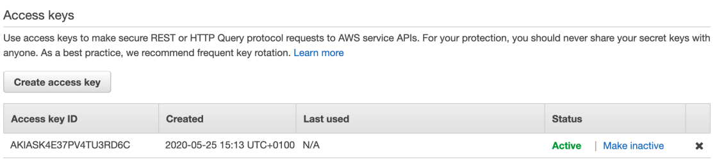

## AWS CLI

What’s AWS CLI?

* A tool that enables you to interact with AWS services using commands in your command-line shell
* Direct access to the public APIs of AWS services.
* You can develop scripts to manage your resources
* It’s open source <https://github.com/aws/aws-cli> EC2 Instance Storage

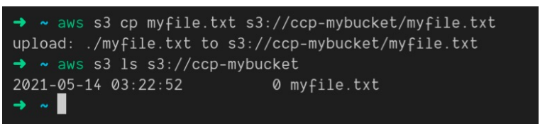

## SDK

What’s AWS SDK? AWS Software Development Kit (AWS SDK)

* Language-specific APIs (set of libraries)
* Enables you to access and manage AWS services
* programmatically
* Embedded within your application
* Supports
  1. SDKs (JavaScript, Python, PHP, .NET, Ruby, Java, Go, Node.js, C++)
  2. Mobile SDKs (Android, iOS, …)
  3. IoT Device SDKs (Embedded C, Arduino, …)
* Example: AWS CLI is built on AWS SDK for Python

## IAM Roles

IAM Roles for Services

Some AWS services will need to perform action on your behalf, for example we want to list no of users from EC2. We can do that using AWS configure on EC2 with AWS CLI, but we should never do such things because then all the actions will be tagged with the user with which CLI is initialized. Instead, we should use IAM role, where we will assign permissions to AWS services

For example, we can give permission to EC2 instance to list users

Go to IAM 🡪 role 🡪 Create role

Select “AWS services” from options and then from drop down select which service we want to add role, we can select EC2.

Then select IAMReadOnlyAccess

Give Role name

Then while creating instance add this IAM role

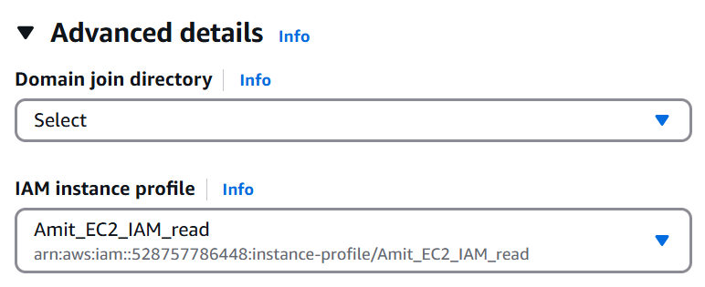

Common roles:

1. EC2 Instance Roles
2. Lambda Function Roles
3. Roles for CloudFormation

IAM Guidelines & Best Practices

* Don’t use the root account except for AWS account setup
* One physical user = One AWS user
* Assign users to groups and assign permissions to groups
* Creating a strong password policy
* Use and enforce the use of Multi Factor Authentication (MFA)
* Create and use Roles for giving permissions to AWS services
* Use Access Keys for Programmatic Access (CLI / SDK)
* Audit permissions of your account using IAM Credentials Report & IAM
* Access Advisor
* Never share IAM users & Access Keys

IAM Section – Summary

* Users: mapped to a physical user, has a password for AWS Console
* Groups: contain users only
* Policies: JSON document that outlines permissions for users or groups
* Roles: for EC2 instances or AWS services
* Security: MFA + Password Policy
* AWS CLI: manage your AWS services using the command-line
* AWS SDK: manage your AWS services using a programming language
* Access Keys: access AWS using the CLI or SDK
* Audit: IAM Credential Reports & IAM Access Advisor

## Questions

Top of Form

What is the proper definition of an IAM Role?

* IAM Users in multiple User Groups
* An IAM entity that defines a password policy for IAM Users
* An IAM entity that defines a set of permissions for making requests to AWS services, and will be used by an AWS service
* Permissions assigned to IAM Users to perform actions

Bottom of Form

Top of Form

Which of the following is an IAM Security Tool?

* IAM Credentials Report
* IAM Root Account Manager
* IAM Services Report
* IAM Security Advisor

Bottom of Form

IAM Credentials report lists all your AWS Account's IAM Users and the status of their various credentials.

Top of Form

Which answer is **INCORRECT** regarding IAM Users?

* IAM Users can belong to multiple User Groups
* IAM Users don't have to belong to a User Group
* IAM Policies can be attached directly to IAM Users
* IAM Users access AWS services using root account credentials

Bottom of Form

Top of Form

Which of the following is IAM best practice?

* Create several IAM Users for one physical person
* Don't use the root user account
* Share your AWS account credentials with your colleague, so (s)he can perform a task for you
* Do not enable MFA for easier access

Bottom of Form

Top of Form

What are IAM Policies?

* A set of policies that defines how AWS accounts interact with each other
* JSON documents that define a set of permissions for making requests to AWS services, and can be used by IAM Users, User Groups, and IAM Roles
* A set of policies that define a password for IAM Users
* A set of policies defined by AWS that show how customers interact with AWS

Bottom of Form

Top of Form

Which principle should you apply regarding IAM Permissions?

* Grant most privilege
* Grant more permissions if your employee asks you to
* Grant least privilege
* Restrict root account permissions

Top of Form

What should you do to increase your root account security?

* Remove permissions from the root account
* Only access AWS services through AWS Command Line Interface (CLI)
* Don't create IAM Users, only access your AWS account using the root account
* Enable Multi-Factor Authentication (MFA)Bottom of Form

Bottom of Form

Top of Form

IAM User Groups can contain IAM Users and other User Groups.

* True
* False

Bottom of Form

IAM User Groups can not be part of other User Groups.

Top of Form

An IAM policy consists of one or more statements. A statement in an IAM Policy consists of the following, **EXCEPT**:

* Effect
* Principal
* Version
* Action
* Resource

Bottom of Form

# EBS

Some basics before going into ESB

* **I/O** An I/O is a single read/write request.
* **I/O Request Size** The I/O request has a size. The request can be small (like 1 Kilobyte) or large (several megabytes)
* **IOPS**: stands for I/O Operations Per Second. It is a performance metric that is used (and abused) a lot in the world of storage. It tells us how many I/O requests per second can be handled by storage (for a particular workload). This metric is meaningless without a latency figure
* **Bandwidth or throughput** If you multiply the IOPS figure with the (average) I/O request size, you get the bandwidth or throughput. if we issue a workload of 1000 IOPS with a request size of 4 Kilobytes, we will get a throughput of 1000 x 4 KB = 4000 KB. This is about ~4 Megabytes per second.
* **Latency** is the time it takes for the I/O request to be completed. We start our measurement from the moment the request is issued to the storage layer and stop measuring when either we get the requested data or get confirmation that the data is stored on disk. Latency is the single most important metric to focus on when it comes to storage performance, under most circumstances. For hard drives, an average latency somewhere between 10 to 20 MS is considered acceptable (20 MS is the upper limit). For solid state drives, depending on the workload, it should never reach higher than 1-3 MS. In most cases, workloads will experience less than 1ms latency numbers.
* **IOPS and Latency:** The IOPS metric is meaningless without a statement about latency. You must understand how long each I/O operation will take because latency dictates the responsiveness of individual I/O operations. If a storage solution can reach 10,000 IOPS but only at an average latency of 50 MS that could result in very bad application performance. If we want to hit an upper latency target of 10 milli seconds the storage solution may only be capable of 2,000 IOPS.

## EBS Volume

An EBS (Elastic Block Store) Volume is a network drive you can attach to your instances while they run. When we create EC2, a volume is attached by default. We can create move volumes and attach to our instance. Characteristics below

* Persist data, after EC2 termination
* Mounted on one instance at a time (at the CCP level)
* Bound to a specific availability zone
* Free tier: 30 GB of free EBS storage of type General Purpose (SSD) or Magnetic per month
* It’s a network drive (i.e. not a physical drive)

1. It uses the network to communicate the instance, which means there might be a bit of latency
2. It can be detached from an EC2 instance and attached to another one quickly

* It’s locked to an Availability Zone (AZ)

1. An EBS Volume in us-east-1a cannot be attached to us-east-1b
2. To move a volume across, you first need to snapshot it

* Have a provisioned capacity (size in GBs, and IOPS) which means while creating we must mention the size IOPS needed

1. You get billed for all the provisioned capacity
2. You can increase the capacity of the drive overtime

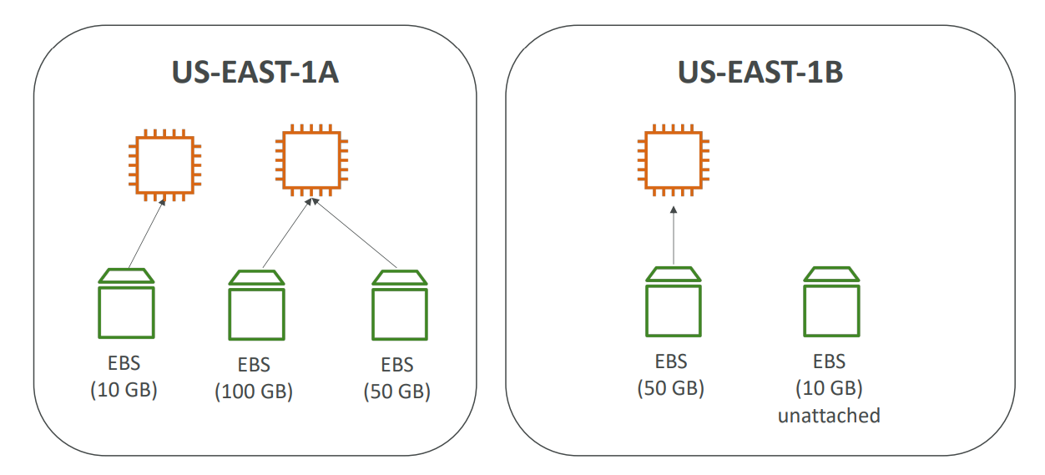

EBS – Delete on Termination attribute

* We can control the EBS behaviour when an EC2 instance terminates

1. By default, the root EBS volume is deleted (attribute enabled). The volume created while EC2 is created is set to delete on termination
2. By default, any other attached EBS volume is not deleted (attribute disabled)

* This can be controlled by the AWS console / AWS CLI

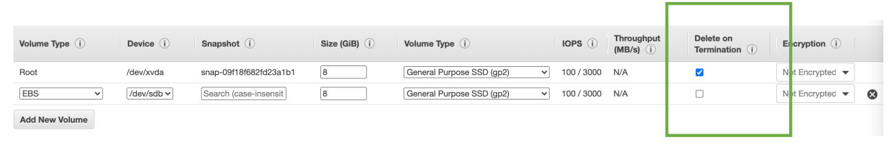

## EBS Snapshots

* Make a backup (snapshot) of your EBS volume at a point in time
* It is not necessary to detach volume to do snapshots, but recommended
* Create snapshots from vol 🡪 Can copy snapshots across AZ or Region🡪 Recreate volume
* If we are just looking to create Volumes from snapshots in an AZ, we don’t need to do the copy snapshot.

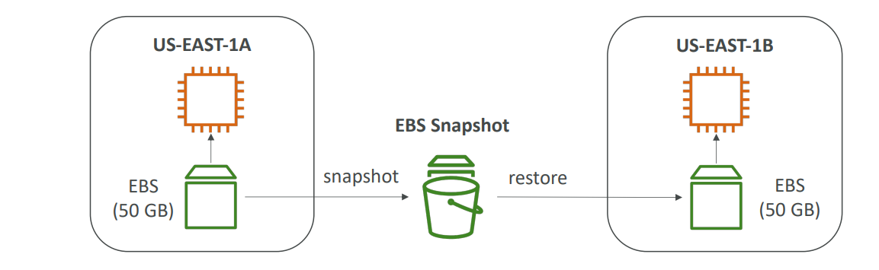

EBS Snapshots Features

|  |  |
| --- | --- |
| EBS Snapshot Archive   * Move a Snapshot to an” archive tier” that is 75% cheaper * It takes 24 to 72 hours to restore the archive |  |
| Recycle Bin for EBS Snapshots   1. Setup retention rules to retain deleted snapshots so you can recover them after an accidental deletion 2. Specify retention (from 1 day to 1 year) |  |

Fast Snapshot Restore (FSR) - this forces a full initialization of your snapshot to have no latency on the first use. This is particularly helpful if your snapshot is big, very big and need to initialize an EBS volume or needs to instance out of it very quickly, but this feature costs a lot of money

## AMI

* AMI = Amazon Machine Image
* AMI are a customization of an EC2 instance

1. You add your own software, configuration, operating system, monitoring…
2. Faster boot / configuration time because all your software is pre-packaged

* AMI are built for a specific region (and can be copied across regions)
* You can launch EC2 instances from:

1. A Public AMI: AWS provided like Amazon Linux 2
2. Your own AMI: you make and maintain them yourself
3. An AWS Marketplace AMI: an AMI someone else made (and potentially sells)

AMI Process (from an EC2 instance)

* Start an EC2 instance and customize it like below

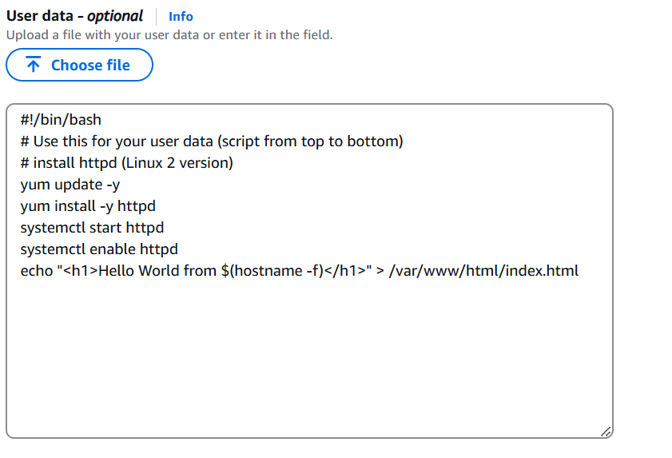

* Stop the instance (for data integrity)
* Build an AMI – this will also create EBS snapshots
* Launch instances from other AMIs

Features like security group, IAM role and SSH keys are not copied just the user data

AMIs are built for a specific AWS Region, they're unique for each AWS Region. You can't launch an EC2 instance using an AMI in another AWS Region, but you can copy the AMI to the target AWS Region and then use it to create your EC2 instances.

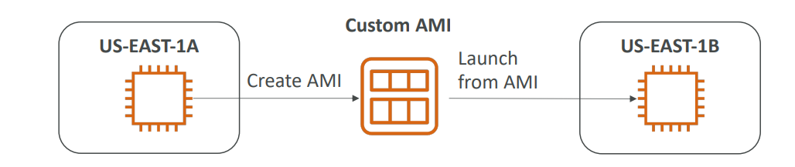

## EC2 Instance Store

EC2 Instance Store is a storage located on disks that are physically attached to the host of your EC2 instance. Can be used only on one EC2 instance at a time. It's ideal for temporary storage such as buffers, caches, etc.

* EBS volumes are network drives with good but “limited” performance
* If you need a high-performance hardware disk, use EC2 Instance Store
* Better I/O performance
* EC2 Instance Store lose their storage if they’re stopped (ephemeral)
* Good for buffer / cache / scratch data / temporary content
* Risk of data loss if hardware fails
* Backups and Replication are your responsibility

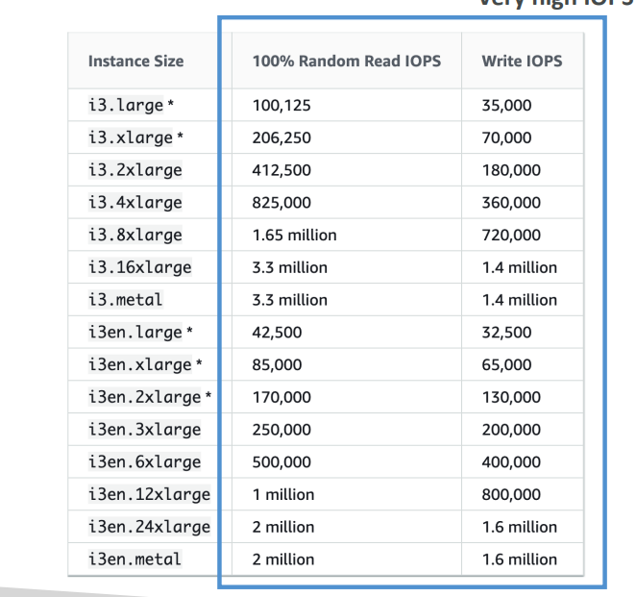

## EBS Volume Types

* EBS Volumes come in 6 types

1. **gp2 / gp3 (SSD):** General purpose SSD volume that balances price and performance for a wide variety of workloads
2. **io1 / io2 Block Express (SSD)**: Highest-performance SSD volume for mission-critical low-latency or high-throughput workloads
3. **st1 (HDD):** Low-cost HDD volume designed for frequently accessed, throughput- intensive workloads
4. **sc1 (HDD):** Lowest cost HDD volume designed for less frequently accessed workloads

* EBS Volumes are characterized in Size | Throughput | IOPS (I/O Ops Per Sec)
* Only gp2/gp3 and io1/io2 Block Express can be used as boot volumes for EC2

EBS Volume Types Use cases

General Purpose SSD GP2/GP3

It is cost-effective storage, with low latency good for System boot volumes, Virtual desktops, Development and test environments

* 1 GiB - 16 TiB
* IOPS is linked with size with max IOPS at 16000

gp2:

1. Small gp2 volumes can burst IOPS to 3,000
2. Size of the volume and IOPS are linked, max IOPS is 16,000
3. 3 IOPS per GB, means at 5,334 GB we are at the max IOPS

gp3:

1. Baseline of 3,000 IOPS and throughput of 125 MiB/s
2. Can increase IOPS up to 16,000 and throughput up to 1000 MiB/s independently

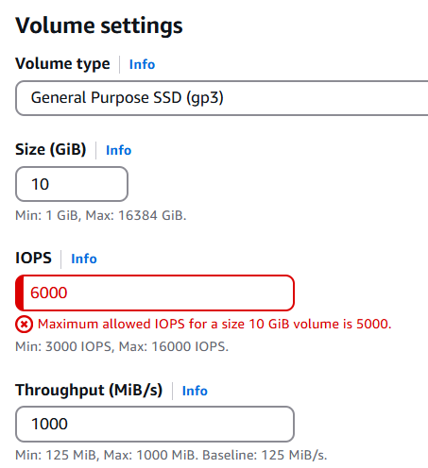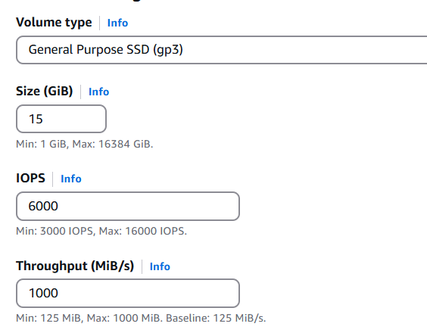

Summary:

* gp2, gp3, is for cost-effective storage latency
* gp3, you can independently set the IOPS and the throughput
* whereas for gp2, they're linked together.
* Both have max IOPS at 16000,
* In gp2, IOPS is very tightly linked to size of the disk
* gp3 also is linked but a bit more freedom

Provisioned IOPS (PIOPS) SSD

* Critical business applications with sustained IOPS performance
* Or applications that need more than 16,000 IOPS
* Great for databases workloads (sensitive to storage perf and consistency)
* io1 (4 GiB - 16 TiB):

1. Max PIOPS: 64,000 for Nitro EC2 instances & 32,000 for others
2. Can increase PIOPS independently from storage size

* io2 Block Express (4 GiB – 64 TiB):

1. Sub-millisecond latency
2. Max PIOPS: 256,000 with an IOPS:GB ratio of 1,000:1

* Supports EBS Multi-attach

st1/sc1 Hard Disk Drives (HDD)

* Cannot be a boot volume
* 125 GiB to 16 TiB
* Throughput Optimized HDD (st1)

1. Big Data, Data Warehouses, Log Processing
2. Max throughput 500 MiB/s – max IOPS 500

* Cold HDD (sc1):

1. For data that is infrequently accessed
2. Scenarios where the lowest cost is important
3. Max throughput 250 MiB/s – max IOPS 250

From requirement point of view

|  |  |  |  |
| --- | --- | --- | --- |
| Gp2 | 1GB-16TB | 16000 | Throughput linked with size good for VDI, System vol, Dev test. Low latency |
| Gp3 | 1GB-16TB | 16000 |
| Io1 | 4 GB - 16 TB | 64k with EC2 nitro  32k | Throughput IOSP provisioned not linked with size, millisecond latency uses case Data base |
| Io2 | 4 GB - 16 TB | 256,000 K |
| St1 | 125 GiB to 16 TiB | 500 | Big data, log processing |
| Sc1 |  | 250 | Infrequent data |

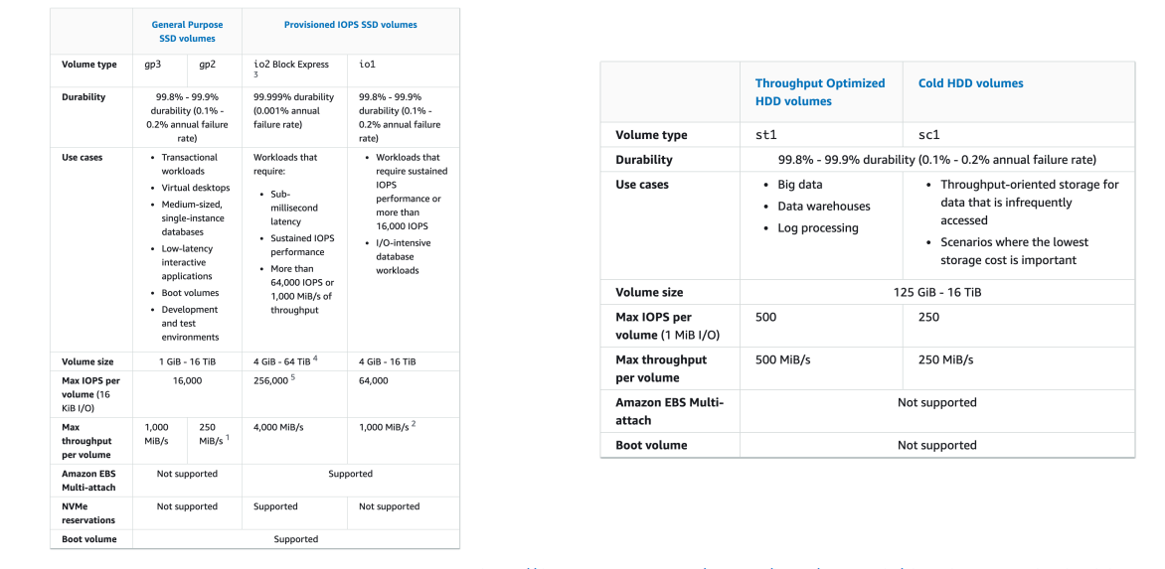

## EBS multi-attach

– io1/io2 family only

|  |  |
| --- | --- |
| * Attach the same EBS volume to multiple EC2 instances in the same AZ * Each instance has full read & write permissions to the high-performance volume * Use case:  1. Achieve higher application availability in clustered Linux applications (ex: Teradata) 2. Applications must manage concurrent write operations  * Up to 16 EC2 Instances at a time * Must use a file system that’s cluster-aware (not XFS, EXT4, etc.) |  |

## EBS Encryption

* When you create an encrypted EBS volume, you get the following:

1. Data at rest is encrypted inside the volume
2. All the data in flight moving between the instance and the volume is encrypted
3. All snapshots are encrypted
4. All volumes created from the snapshot

* Encryption and decryption are handled transparently (you have nothing to do)
* Encryption has a minimal impact on latency
* EBS Encryption leverages keys from KMS (AES-256)
* Copying an unencrypted snapshot allows encryption
* Snapshots of encrypted volumes are encrypted

Encryption: encrypt an unencrypted EBS volume

* Create an EBS snapshot of the volume
* Encrypt the EBS snapshot (using copy )
* Create new EBS volume from the snapshot (the volume will also be encrypted )
* Now you can attach the encrypted volume to the original instance

## Amazon EFS – Elastic File System

* Managed NFS (network file system) that can be mounted on many EC2
* EFS works with EC2 instances in multi-AZ
* Highly available, scalable, expensive (3x gp2), pay per use

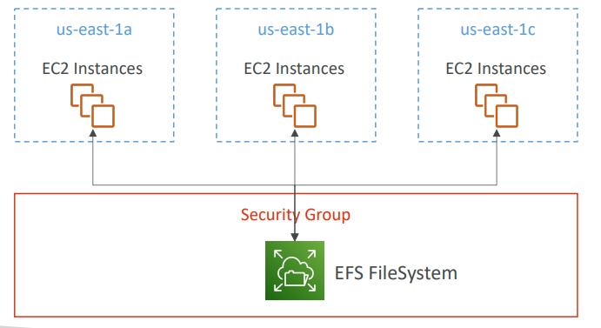

Amazon EFS – Elastic File System

* Use cases: content management, web serving, data sharing, WordPress
* Uses NFSv4.1 protocol
* Uses security group to control access to EFS
* Compatible with Linux based AMI (not Windows)
* Encryption at rest using KMS
* POSIX file system (~Linux) that has a standard file API
* File system scales automatically, pay-per-use, no capacity planning!

EFS – Performance & Storage Classes

* EFS Scale

1. 1000s of concurrent NFS clients, 10 GB+ /s throughput (systems that access files stored on a remote shared server over a network and make use of those file systems as if they are locally mounted)
2. Grow to Petabyte-scale network file system, automatically

* Performance Mode (set at EFS creation time)

1. General Purpose (default) – latency-sensitive use cases (web server, CMS, etc…)
2. Max I/O – higher latency, throughput, highly parallel (big data, media processing)

* Throughput Mode

1. Bursting – 1 TB = 50MiB/s + burst of up to 100MiB/s
2. Provisioned – set your throughput regardless of storage size, ex: 1 GiB/s for 1 TB storage
3. Elastic – automatically scales throughput up or down based on your workloads

* Up to 3GiB/s for reading and 1GiB/s for writes
* Used for unpredictable workloads

## EFS – Storage Classes

|  |  |
| --- | --- |
| • Storage Tiers We can move data across different storage tiers to save costs.   1. Standard: for frequently accessed files 2. Infrequent access (EFS-IA): cost to retrieve files, lower price to store. 3. Archive: rarely accessed data (few times each year), 50% cheaper 4. When the file is accessed again we can move back to standard tier.     • Availability and durability   1. Standard: Multi-AZ, great for prod 2. One Zone: One AZ, great for dev,      1. backup enabled by   default, compatible with IA (EFS One Zone-IA)  • Over 90% in cost savings |  |

Performance setting Throughput

1. **Bursting** is a way for you to have the throughput scale with the amount of storage you're using and going a little bit over. If you have one gigabyte, you get a throughput based on one gigabyte. If you have one terabyte, you get higher throughput .

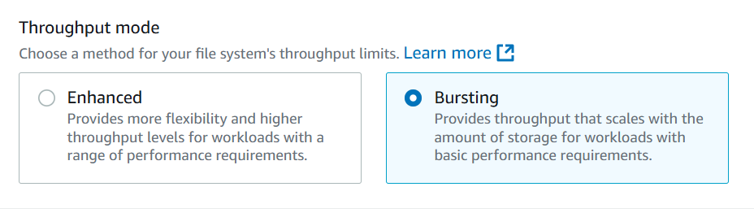

1. **Enhanced mode elastic** (recommended): Regardless of the size of your EFS file system, we’re going to give you all the I/O you need, and we'll scale automatically. This is best when you have a workload with unpredictable I/O where, for example, you can scale from zero megabytes per second to a hundred megabytes per second in no time. This is why it is the recommended mode because it doesn't require you to think about any settings

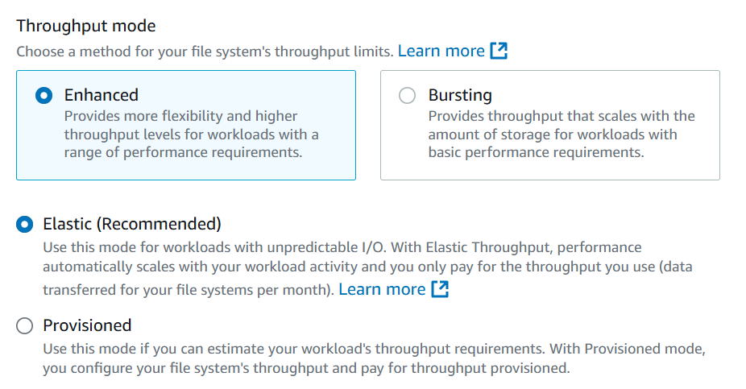

1. **Enhanced mode Provisioned:** This is when you know in advance the throughput you're going to be needing. So, you say, Hey, I will need 100 megabytes per second for sure. And then you also have a bursting limit of 300 megabytes per second. And because you provision throughput in advance, you're going to pay for it in advance.

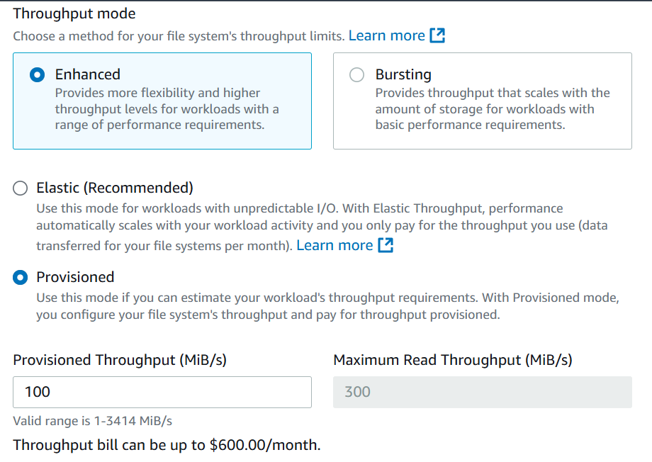

Performance setting Performance Mode

If you use bursting or if you use provisioned, then you have the option between two settings.

* **General purpose**, which is giving you high performance and low latency,
* **Max I/O** if you want to get a maximum amount of I/O mode, and you can tolerate higher latency then you can choose I/O. So, at the expense of a higher latency, you also get more I/O. This is for highly paralyzed workloads like big data type of setting

But the best recommended setting now for AWS is to use enhanced with general purpose and elastic.

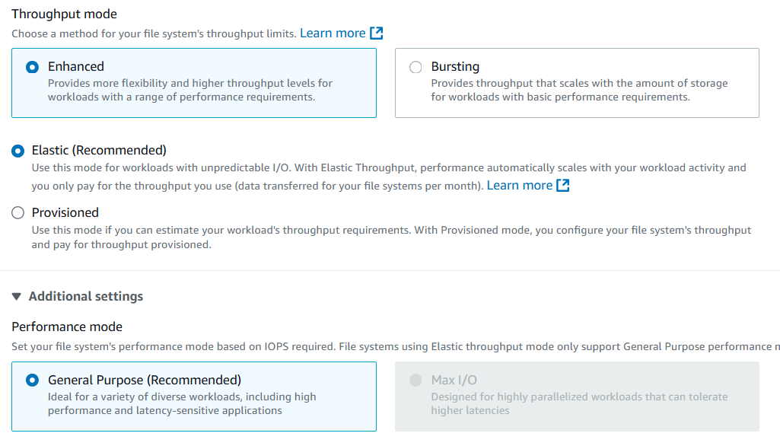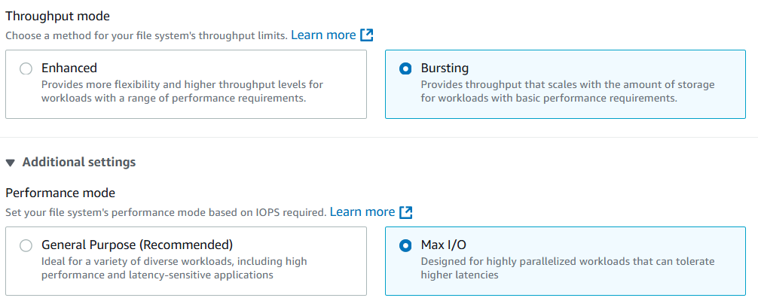

How to create EFS and mount to EC2

1. Create a Security Group with outbound rules to allow all traffic

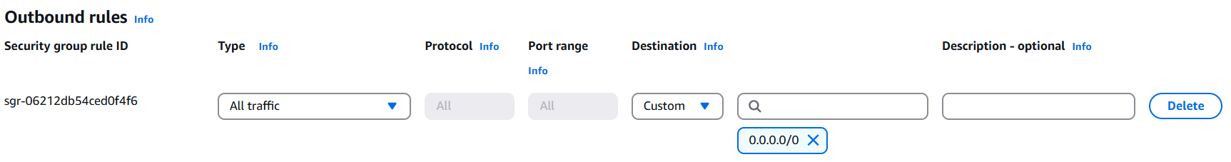

1. Create EFS with the settings below

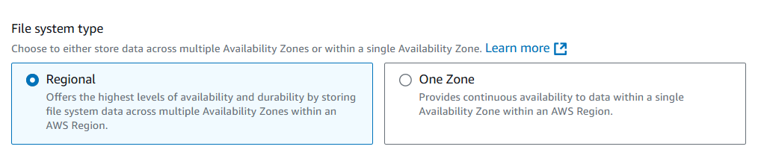

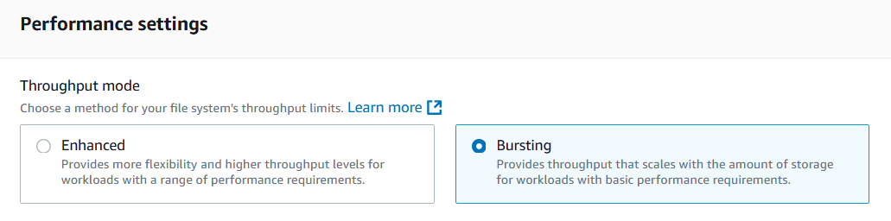

1. Add security Group

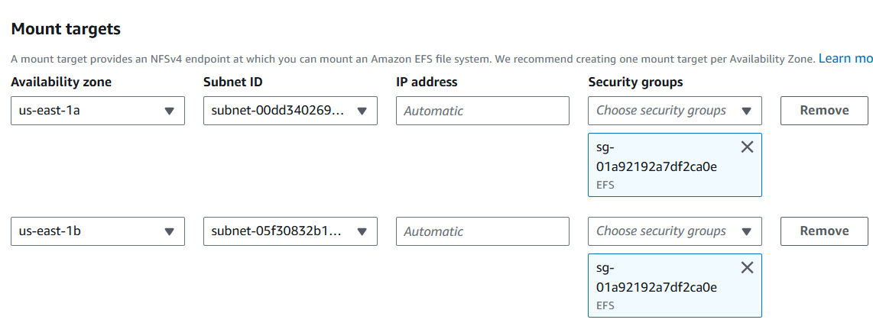

1. Create EFC
2. Create EC2 instance in one region e.g. Us-east-1d

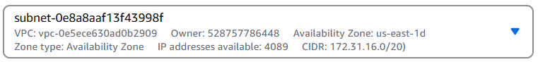

1. Add file systems



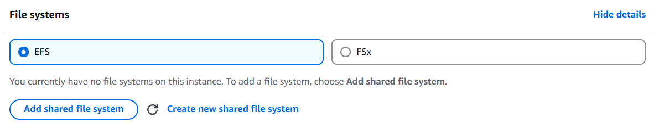

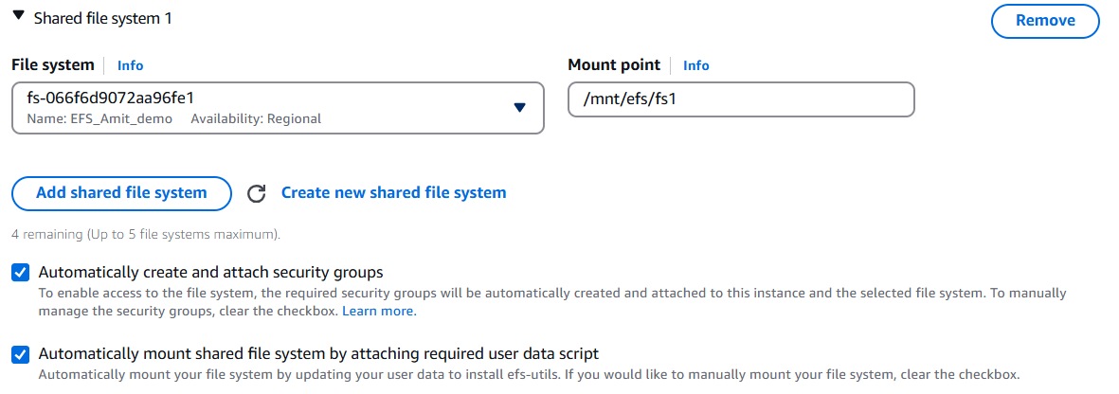

1. Now launch another Ec2 in another AZ with same steps
2. Login to any EC2 instance
3. Elevate to sudo access sudo su
4. Check mounted drive cd /mnt/efs/fs1
5. Create a file touch hello.txt. Write into file using vim or nano
6. Read file cat hello.txt and ls
7. Now connect from other instance and check that file is present

## EBS vs EFS – Elastic Block Storage

|  |  |
| --- | --- |
| EBS volumes…   1. one instance (except multi-attach io1/io2) 2. are locked at the Availability Zone (AZ) level 3. gp2: IO increases if the disk size increases 4. gp3 & io1: can increase IO independently   • To migrate an EBS volume across AZ   1. Take a snapshot 2. Restore the snapshot to another AZ 3. EBS backups use IO, and you shouldn’t run 4. them while your application is handling a lot 5. of traffic   • Root EBS Volumes of instances get  terminated by default if the EC2 instance  gets terminated. (you can disable that) | • Mounting 100s of instances across AZ  • EFS share website files (WordPress)  • Only for Linux Instances (POSIX)  • EFS has a higher price point than EBS  • Can leverage Storage Tiers for cost savings |

## Questions

Top of Form

You have just terminated an EC2 instance in us-east-1a, and its attached EBS volume is now available. Your teammate tries to attach it to an EC2 instance in us-east-1b but he can't. What is a possible cause for this?

* He's missing IAM permissions
* EBS volumes are locked to an AWS Region
* EBS volumes are locked to an Availability Zone

Bottom of Form

EBS Volumes are created for a specific AZ. It is possible to migrate them between different AZs using EBS Snapshots.

Top of Form

You have launched an EC2 instance with two EBS volumes, Root volume type and the other EBS volume type to store the data. A month later you are planning to terminate the EC2 instance. What's the default behavior that will happen to each EBS volume?

* Both the root volume type and the EBS volume type will be deleted
* The Root volume type will be deleted and the EBS volume type will not be deleted
* The root volume type will not be deleted and the EBS volume type will be deleted
* Both the root volume type and the EBS volume type will not be deleted

Bottom of Form

By default, the Root volume type will be deleted as its "Delete On Termination" attribute checked by default. Any other EBS volume types will not be deleted as its "Delete On Termination" attribute disabled by default.

Top of Form

You can use an AMI in N.Virginia Region us-east-1 to launch an EC2 instance in any AWS Region.

* True
* False

Bottom of Form

AMIs are built for a specific AWS Region, they're unique for each AWS Region. You can't launch an EC2 instance using an AMI in another AWS Region, but you can copy the AMI to the target AWS Region and then use it to create your EC2 instances.

Top of Form

Which of the following EBS volume types can be used as boot volumes when you create EC2 instances?

* gp2, gp3, st1, sc1
* gp2, gp3, io1, io2
* io1, io2, st1, sc1

Bottom of Form

When creating EC2 instances, you can only use the following EBS volume types as boot volumes: gp2, gp3, io1, io2, and Magnetic (Standard).

Top of Form

What is EBS Multi-Attach?

* Attach the same EBS volume to multiple EC2 instances in multiple AZs
* Attach multiple EBS volumes in the same AZ to the same EC2 instance
* Attach the same EBS volume to multiple EC2 instances in the same AZ
* Attach multiple EBS volumes in multiple AZs to the same EC2 instance

Bottom of Form

Using EBS Multi-Attach, you can attach the same EBS volume to multiple EC2 instances in the same AZ. Each EC2 instance has full read/write permissions.

Top of Form

You would like to encrypt an unencrypted EBS volume attached to your EC2 instance. What should you do?

* Create an EBS snapshot of your EBS volume. Copy the snapshot and tick the option to encrypt the copied snapshot. Then, use the encrypted snapshot to create a new EBS volume
* Select your EBS volume, choose Edit Attributes, then tick the Encrypt using KMS option
* Create a new encrypted EBS volume, then copy data from your unencrypted EBS volume to the new EBS volume.
* Submit a request to AWS Support to encrypt your EBS volume

Bottom of Form

Ans 1

Top of Form

You have a fleet of EC2 instances distributes across AZs that process a large data set. What do you recommend to make the same data to be accessible as an NFS drive to all of your EC2 instances?

* Use EBS
* Use EFS
* Use an Instance Store

Bottom of Form

EFS is a network file system (NFS) that allows you to mount the same file system on EC2 instances that are in different AZs.

Top of Form

You would like to have a high-performance local cache for your application hosted on an EC2 instance. You don't mind losing the cache upon the termination of your EC2 instance. Which storage mechanism do you recommend as a Solutions Architect?

* EBS
* EFS
* Instance Store

Bottom of Form

EC2 Instance Store provides the best disk I/O performance.

Top of Form

You are running a high-performance database that requires an IOPS of 310,000 for its underlying storage. What do you recommend?

* Use an EBS gp2 drive
* Use an EBS io1 drive
* Use an EC2 Instance Store
* Use an EBS io2 Block Express drive

Bottom of Form

256,000 is the maximum IOPS you can achieve when you're using the EBS io2 Block Express volume type.

You can run a database on an EC2 instance that uses an Instance Store, but you'll have a problem that the data will be lost if the EC2 instance is stopped (it can be restarted without problems). One solution is that you can set up a replication mechanism on another EC2 instance with an Instance Store to have a standby copy. Another solution is to set up backup mechanisms for your data. It's all up to you how you want to set up your architecture to validate your requirements. In this use case, it's around IOPS, so we have to choose an EC2 Instance Store.

# High Availability & Scalability

* Scalability means that an application / system can handle greater loads. There are two kinds of scalability:

1. Vertical Scalability
2. Horizontal Scalability (= elasticity)

* Scalability and high availability is linked but not exactly same.

Vertical Scalability

* Vertically scalability means increasing the size of the instance
* For example, your application runs on t2. Micro. Scaling that application vertically means running it on a t2. large
* Vertical scalability is very common for non-distributed systems, such as databases and monolith applications.
* RDS and Elastic Cache are services that can scale vertically.
* There’s usually a limit to how much you can vertically scale (hardware limit)

Horizontal Scalability

* Horizontal Scalability means increasing the number of instances / systems for your application
* Horizontal scaling implies distributed systems. This is very common for web applications /modern applications
* It’s easy to horizontally scale thanks the cloud offerings such as Amazon EC2

High Availability

* High Availability usually goes hand in hand with horizontal scaling
* High availability means running your application / system in at least 2 data centers (== Availability Zones)
* The goal of high availability is to survive data center loss
* The high availability can be passive (for RDS Multi AZ for example)
* The high availability can be active (for horizontal scaling)

High Availability & Scalability for EC2

* Vertical Scaling: Increase instance size (= scale up / down)

1. From: t2. nano - 0.5G of RAM, 1 vCPU
2. To: u-12tb1.metal – 12.3 TB of RAM, 448 vCPUs

* Horizontal Scaling: Increase number of instances (= scale out / in)

1. Auto Scaling Group
2. Load Balancer

* High Availability: Run instances for the same application across multi AZ

1. Auto Scaling Group multi-AZ
2. Load Balancer multi-AZ

## Load balancing

Elastic Load Balancer EC2 Instance EC2 Instance EC2 Instance • Load Balances are servers that forward traffic to multiple servers (e.g., EC2 instances) downstream

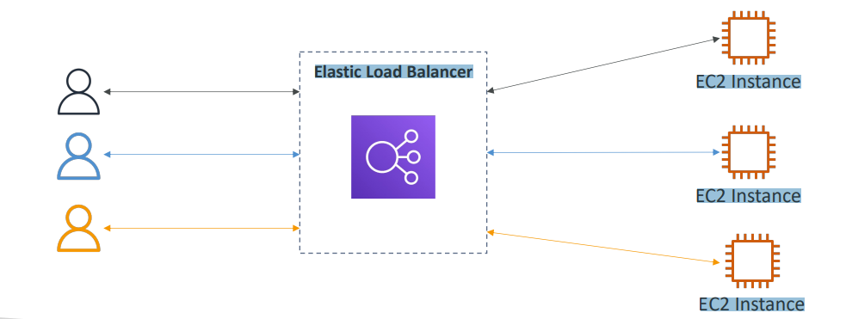

Use case

* Spread load across multiple downstream instances
* Expose a single point of access (DNS) to your application
* Seamlessly handle failures of downstream instances
* Do regular health checks for your instances
* Provide SSL termination (HTTPS) for your websites
* Enforce stickiness with cookies
* High availability across zones
* Separate public traffic from private traffic

Benefits of Elastic Load balancer vs inhouse

* An Elastic Load Balancer is a managed load balancer

1. AWS guarantees that it will be working
2. AWS takes care of upgrades, maintenance, high availability
3. AWS provides only a few configurations knobs

* It costs less to set up your own load balancer, but it will be a lot more effort on your end
* It is integrated with many AWS offerings / services

1. EC2, EC2 Auto Scaling Groups, Amazon ECS
2. AWS Certificate Manager (ACM), CloudWatch
3. Route 53, AWS WAF, AWS Global Accelerator

Health Checks

* Health Checks are crucial for Load Balancers
* They enable the load balancer to know if instances it forwards traffic to are available to reply to requests
* The health check is done on a port, and a route (/health is common)
* If the response is not 200 (OK), then the instance is unhealthy

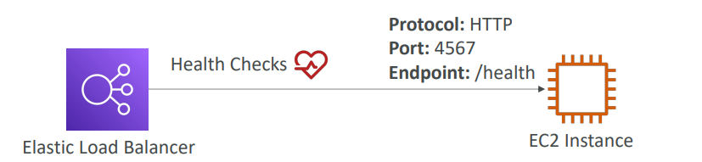

Types of load balancer on AWS

AWS has 4 kinds of managed Load Balancers

1. **Classic Load Balancer** (v1 - old generation) – 2009 – CLB: HTTP, HTTPS, TCP, SSL (secure TCP)
2. **Application Load Balancer** (v2 - new generation) – 2016 – ALB: HTTP, HTTPS, WebSocket
3. **Network Load Balancer** (v2 - new generation) – 2017 – NLB: TCP, TLS (secure TCP), UDP
4. **Gateway Load Balancer** – 2020 – GWLB: Operates at layer 3 (Network layer) – IP Protocol

Overall, it is recommended to use the newer generation load balancers as they provide more features. Some load balancers can be set up as internal (private) or external (public) ELBs

Load Balancers uses Security Group

So the users can access your load balancer from anywhere using HTTP or HTTPS. And therefore the security group rule is going to look like something like this, where the port range is going to be 80 or 443. And the source is going to be 0.0.0.0/0, which means anywhere.

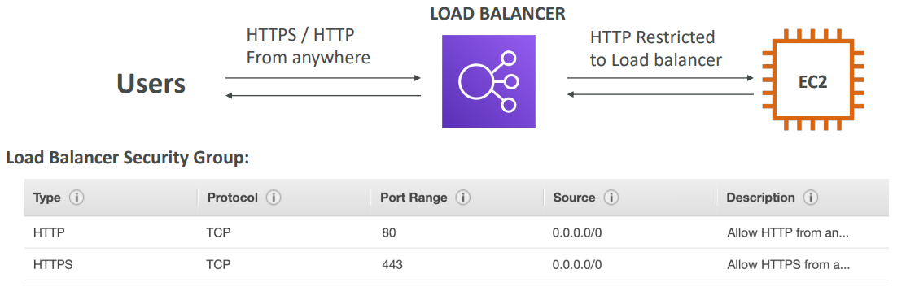

EC2 instances should only allow traffic coming directly from the load balancer. And therefore, the security group rule for your EC2 instances is going to look a little bit different. It's going to allow HTTP traffic on port 80 and the source of it is not going to be an IP range instead is going to be a security group.

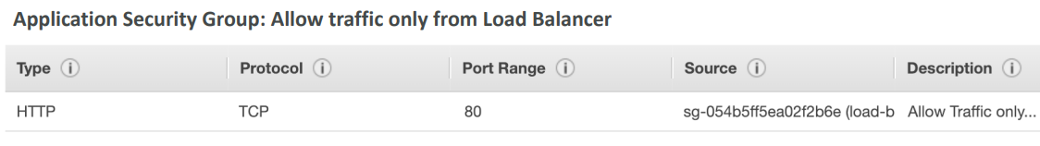

|  |  |  |  |
| --- | --- | --- | --- |
| Classic Load Balancer | Application Load Balancer | Network Load Balancer | Gateway Load Balancer |
|  |  |  |  |
| Choose a Classic Load Balancer when you have an existing application running in the EC2-Classic network. | Choose an Application Load Balancer when you need a flexible feature set for your applications with HTTP and HTTPS traffic. Operating at the request level, Application Load Balancers provide advanced routing and visibility features targeted at application architecture, including microservices and containers. | Choose a Network Load Balancer when you need ultra-high performance, TLS offloading at scale, centralized certificate deployment, support for UDP, and static IP addresses for your applications. Operating at the connection level, Network Load Balancers are capable of handling millions of requests per second securely while maintaining ultra-low latencies. | Choose a Gateway Load Balancer when you need to deploy and manage a fleet of third-party virtual appliances that support GENEVE. These appliances enable you to improve security, compliance, and policy controls. |

## Classic Load Balancers

|  |  |
| --- | --- |
| * Supports TCP (Layer 4), HTTP & HTTPS (Layer 7) * Health checks are TCP or HTTP based * Fixed hostname XXX.region.elb.amazonaws.com |  |

## Application Load Balancer (v2)

* Application load balancers are Layer 7 (HTTP).
* Load balancing to multiple HTTP applications across machines (target groups)
* Load balancing to multiple applications on the same machine (ex: containers)
* Support for HTTP/2 and WebSocket
* Support redirects (from HTTP to HTTPS for example)
* Routing tables for different target groups:

1. Routing based on path in URL (example.com/users & example.com/posts)
2. Routing based on hostname in URL (one.example.com & other.example.com)
3. Routing based on Query String, Headers (example.com/users?id=123&order=false)

* ALB are a great fit for micro services & container-based application (example: Docker & Amazon ECS)
* Has a port mapping feature to redirect to a dynamic port in ECS
* In comparison, we’d need multiple Classic Load Balancer per application

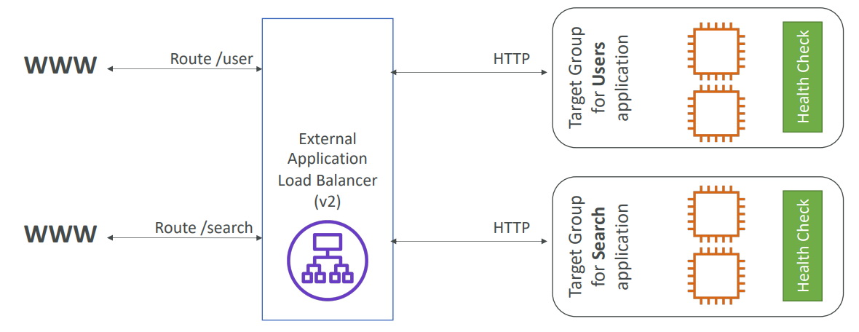

Target Groups

* EC2 instances (can be managed by an Auto Scaling Group) – HTTP
* ECS tasks (managed by ECS itself) – HTTP
* Lambda functions – HTTP request is translated into a JSON event
* IP Addresses – must be private IPs
* ALB can route to multiple target groups
* Health checks are at the target group level

Query Strings/Parameters Routing

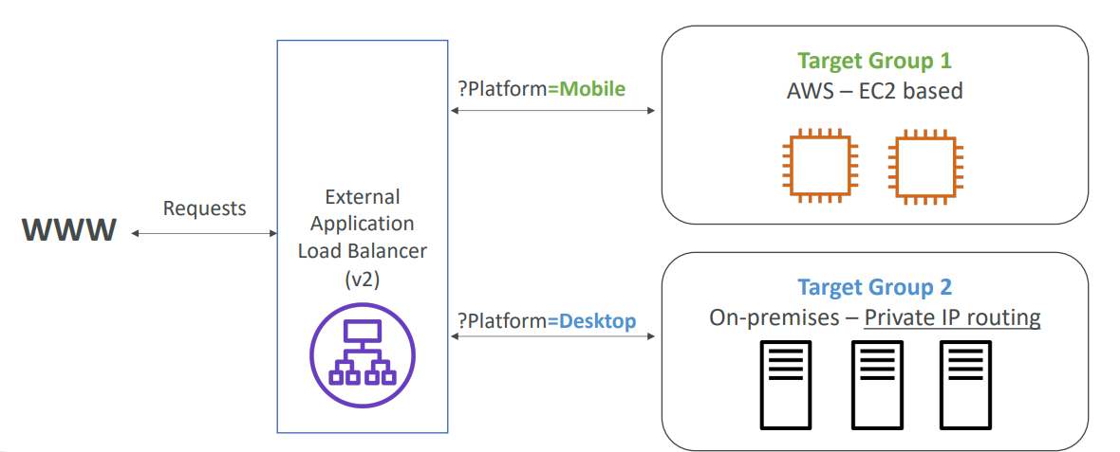

* Fixed hostname (XXX.region.elb.amazonaws.com)
* The application servers don’t see the IP of the client directly

1. The true IP of the client is inserted in the header X-Forwarded-For
2. We can also get Port (X-Forwarded-Port) and proto (X-Forwarded-Proto)

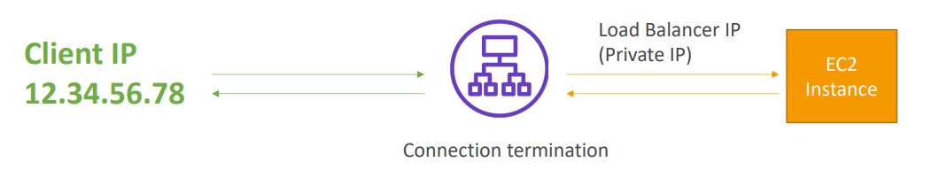

Hands On

Let’s say we have 2 EC2 instances now we create ALB

Keep only those regions which have my Ec2

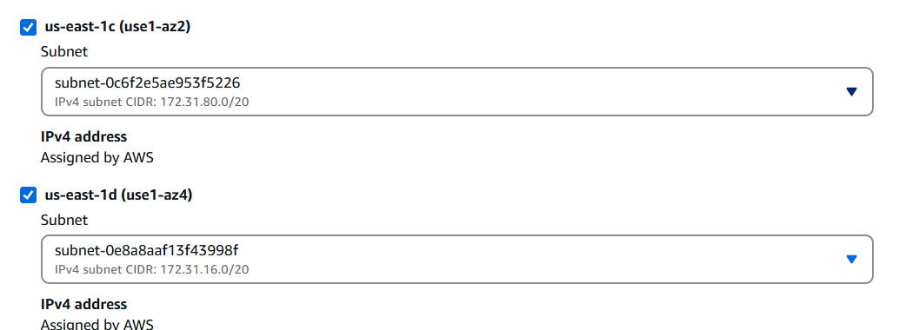

Create SG to allow HTTP from all

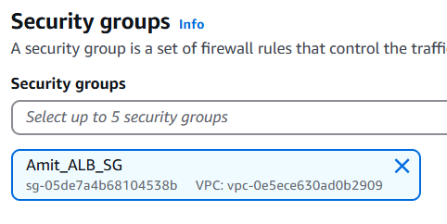

Then we create Target group and assign our EC2 instances as targets

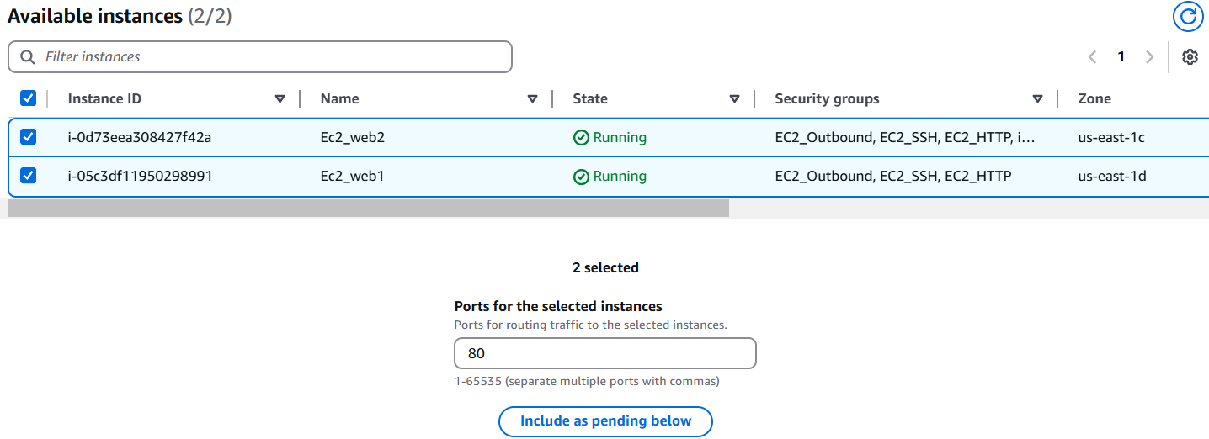

Assigning TG to ALB

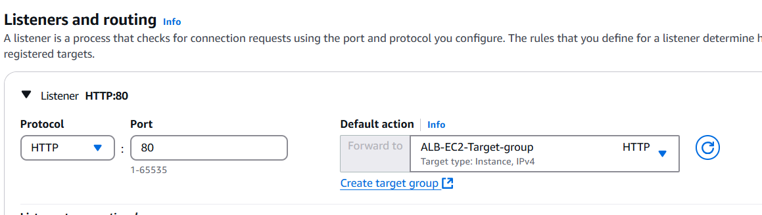

After this we can access our web pages using ALB endpoint

We can also remove the public access SG of EC2 and assign a SG which will allow traffic from SG assigned to ALB. In this SG instead of allowing traffic from any IP will allow traffic from SG assigned to ALB, due to which traffic will be allowed

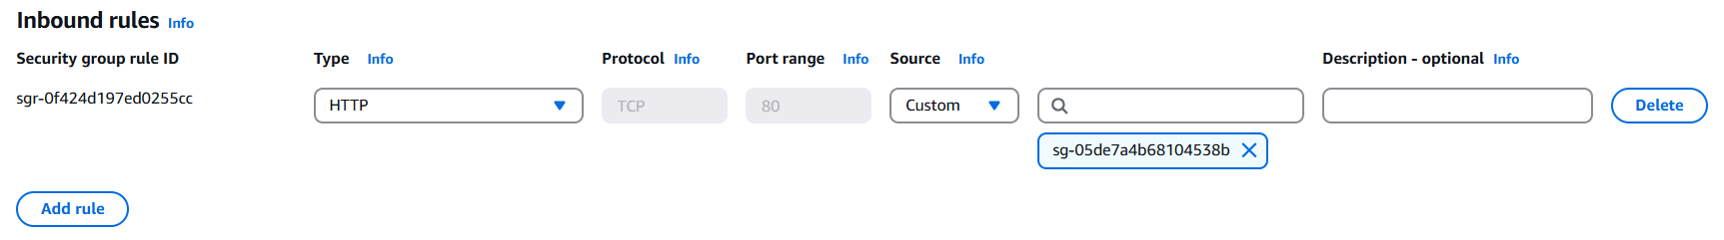

ALB Listeners

In ALB we have listeners where we can add rules

## Network Load Balancer (v2)

* Network load balancers (Layer 4) allow to:

1. Forward TCP & UDP traffic to your instances
2. Handle millions of requests per second

* Ultra-low latency
* NLB has one static IP per AZ, and supports assigning Elastic IP (helpful for whitelisting specific IP)
* NLB are used for extreme performance, TCP or UDP traffic
* Not included in the AWS free tier

We create target groups, and then the network balancer will redirect to them.

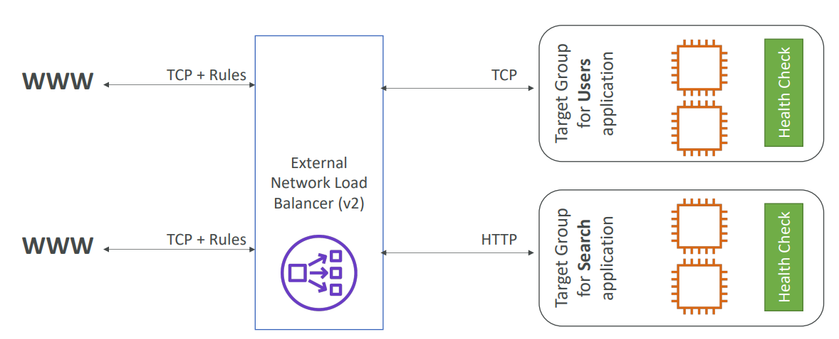

Target Groups

* EC2 instances
* IP Addresses – must be private Ips for e.g. private IP of the EC2 instance but also you could use the private IP of a server that you have in your own data center
* Application Load Balancer- We can put NLB in front of ALB thanks to the Network Load Balancer, reason, you would get, the fixed IP addresses from NLB and then, thanks to the ALB , you can get all the rules that you have around handling HTP type of traffic, so it is a valid combination

Health Checks support the TCP, HTTP and HTTPS Protocols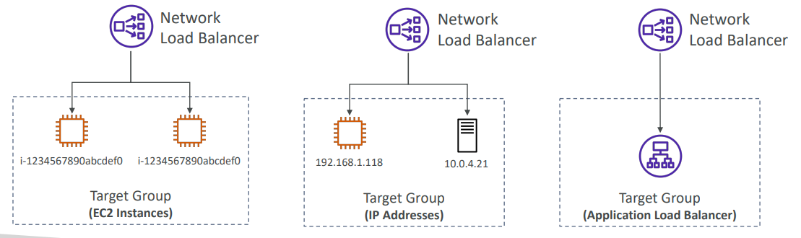

## Gateway Load Balancer

|  |  |
| --- | --- |
| • Deploy, scale, and manage a fleet of 3rd party network virtual appliances in AWS  • Example: Firewalls, Intrusion Detection and Prevention Systems, Deep Packet Inspection Systems, payload manipulation, …  • Operates at Layer 3 (Network Layer) – IP Packets  • Combines the following functions:   1. Transparent Network Gateway – single entry/exit for all traffic 2. Load Balancer – distributes traffic to your virtual appliances   • Uses the GENEVE protocol on port 6081 |  |

Target Groups

* EC2 instances
* IP Addresses – must be private Ips

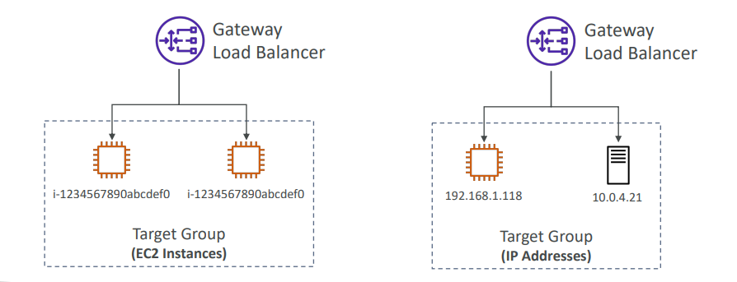

## Sticky Sessions (Session Affinity)

|  |  |
| --- | --- |
| • It is possible to implement stickiness so that the same client is always redirected to the same instance behind a load balancer  • This works for Classic Load Balancer, Application Load Balancer, and Network Load  Balancer  • For both CLB & ALB, the “cookie” used for stickiness has an expiration date you control  • Use case: make sure the user doesn’t lose his session data  • Enabling stickiness may bring imbalance to the load over the backend EC2 instances |  |

Types of cookies

1. Application-based Cookies

* Custom cookies
  1. Generated by the target
  2. Can include any custom attributes required by the application
  3. Cookie name must be specified individually for each target group
  4. Don’t use AWSALB, AWSALBAPP, or AWSALBTG (reserved for use by the ELB)
* Application cookies
  1. Generated by the load balancer
  2. Cookie’s name is AWSALBAPP

1. Duration-based Cookies

* Cookie generated by the load balancer
* Cookie name is AWSALB for ALB, AWSELB for CLB

Sticky sessions can be enabled at target group level by editing target group

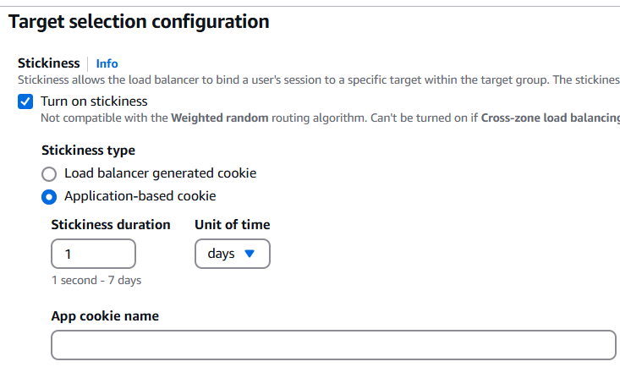

## Cross-Zone Load Balancing

|  |  |
| --- | --- |
| With Cross Zone Load Balancing: each load balancer instance distributes evenly across all registered instances in all AZ | Without Cross Zone Load Balancing: Requests are distributed in the instances of the node of the Elastic Load Balancer |
|  |  |

* Application Load Balancer

1. Enabled by default (can be disabled at the Target Group level)
2. No charges for inter AZ data

* Network Load Balancer & Gateway Load Balancer

1. Disabled by default
2. You pay charges ($) for inter AZ data if enabled

* Classic Load Balancer

1. Disabled by default
2. No charges for inter AZ data if enabled

## SSL/TLS - Basics

* An SSL Certificate allows traffic between your clients and your load balancer to be encrypted in transit (in-flight encryption)
* SSL refers to Secure Sockets Layer, used to encrypt connections
* TLS refers to Transport Layer Security, which is a newer version
* Nowadays, TLS certificates are mainly used, but people still refer as SSL
* Public SSL certificates are issued by Certificate Authorities (CA)
* Comodo, Symantec, GoDaddy, GlobalSign, Digicert, Letsencrypt, etc…
* SSL certificates have an expiration date (you set) and must be renewed

Load Balancer - SSL Certificates

* The load balancer uses an X.509 certificate (SSL/TLS server certificate)
* You can manage certificates using ACM (AWS Certificate Manager)
* You can create upload your own certificates alternatively
* HTTPS listener:

1. You must specify a default certificate
2. You can add an optional list of certs to support multiple domains
3. Clients can use SNI (Server Name Indication) to specify the hostname they reach
4. Ability to specify a security policy to support older versions of SSL / TLS (legacy clients)

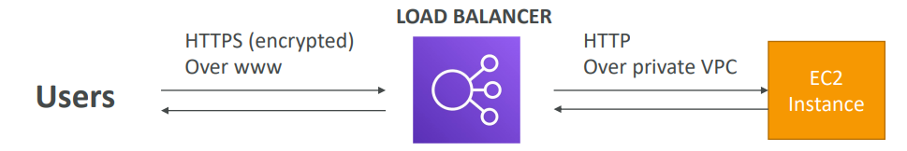

SSL – Server Name Indication (SNI)

|  |  |
| --- | --- |
| * SNI solves the problem of loading multiple SSL certificates onto one web server (to serve multiple websites) * It’s a “newer” protocol, and requires the client * to indicate the hostname of the target server in the initial SSL handshake * The server will then find the correct * certificate, or return the default one   Note:   1. Only works for ALB & NLB (newer generation), CloudFront 2. Does not work for CLB (older gen) |  |

Elastic Load Balancers – SSL Certificates

* Classic Load Balancer (v1)

1. Support only one SSL certificate
2. Must use multiple CLB for multiple hostnames with multiple SSL certificates

* Application Load Balancer (v2)

1. Supports multiple listeners with multiple SSL certificates
2. Uses Server Name Indication (SNI) to make it work

* Network Load Balancer (v2)

1. Supports multiple listeners with multiple SSL certificates
2. Uses Server Name Indication (SNI) to make it work

Connection Draining

|  |  |
| --- | --- |
| * Feature naming  1. Connection Draining – for CLB 2. Deregistration Delay – for ALB & NLB  * The concept is that it will give time to complete “in-flight requests” while the instance is de-registering or unhealthy * And once the instance is drained stop sending new requests to the EC2 instance which is de-registering * Between 1 to 3600 seconds (default: 300 seconds) * Can be disabled (set value to 0) * Set to a low value if your requests are short so that EC2 can be drained quickly and replaced by new EC2 but if requests are long for e.g. uploads etc., then we need to set high so that requests don’t fail , but then it will take time to set up new instances |  |

## Auto Scaling Group

* In real life, the load on your websites and applications can change
* In the cloud, you can create and get rid of servers very quickly
* The goal of an Auto Scaling Group (ASG) is to:

1. Scale out (add EC2 instances) to match an increased load
2. Scale in (remove EC2 instances) to match a decreased load
3. Ensure we have a minimum and a maximum number of EC2 instances running
4. Automatically register new instances to a load balancer
5. Re-create an EC2 instance in case a previous one is terminated (ex: if unhealthy)

* ASG are free (you only pay for the underlying EC2 instances)

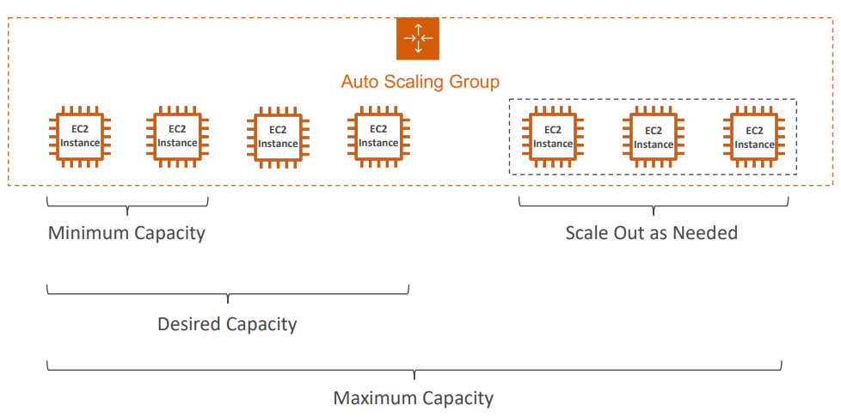

With Load Balancer

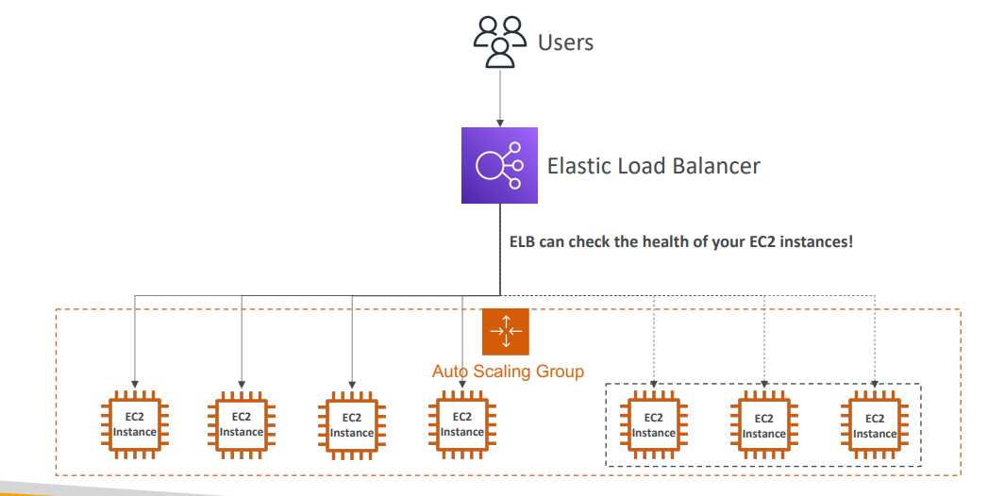

|  |  |
| --- | --- |
| * A Launch Template (older “Launch Configurations” are deprecated)  1. AMI + Instance Type 2. EC2 User Data 3. EBS Volumes 4. Security Groups 5. SSH Key Pair 6. IAM Roles for your EC2 Instances 7. Network + Subnets Information 8. Load Balancer Information  * Min Size / Max Size / Initial Capacity * Scaling Policies |  |

Auto Scaling - CloudWatch Alarms & Scaling

* It is possible to scale an ASG based on CloudWatch alarms
* An alarm monitors a metric (such as Average CPU, or a custom metric)
* Metrics such as Average CPU are computed for the overall ASG instances
* Based on the alarm:

1. We can create scale-out policies (increase the number of instances)
2. We can create scale-in policies (decrease the number of instances)

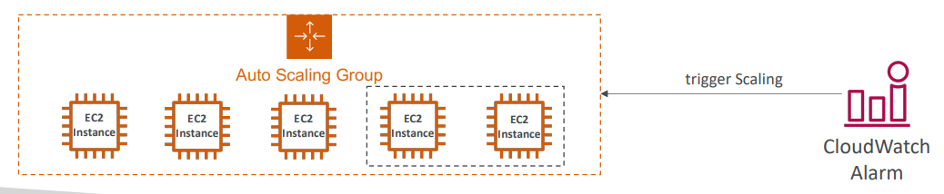

Auto Scaling Groups – Scaling Policies

* Dynamic Scaling
* Target Tracking Scaling

1. Simple to set-up
2. Example: I want the average ASG CPU to stay at around 40%

* Simple / Step Scaling

1. When a CloudWatch alarm is triggered (example CPU > 70%), then add 2 units
2. When a CloudWatch alarm is triggered (example CPU < 30%), then remove 1

* Scheduled Scaling

1. Anticipate scaling based on known usage patterns
2. Example: increase the min capacity to 10 at 5 pm on Fridays

* **Predictive scaling**: continuously forecast load and schedule scaling ahead

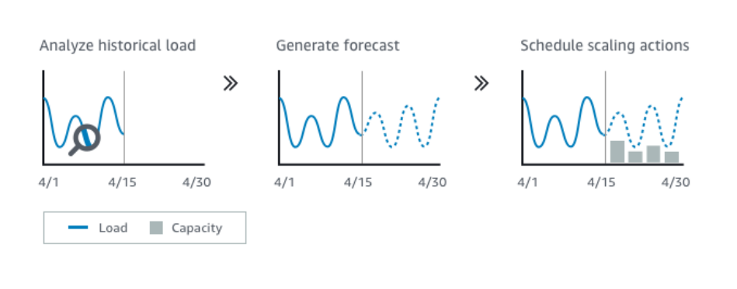

Good metrics to scale on

|  |  |
| --- | --- |
| * CPUUtilization: Average CPU utilization across your instances * RequestCountPerTarget: to make sure the number of requests per EC2 instances is stable * Average Network In / Out (if you’re application is network bound) * Any custom metric (that you push using CloudWatch) |  |

Auto Scaling Groups - Scaling Cooldowns

|  |  |
| --- | --- |
| • After a scaling activity happens, you are in the cooldown period (default 300 seconds) • During the cooldown period, the ASG will not launch or terminate additional instances (to allow for metrics to stabilize)  • Advice: Use a ready-to-use AMI to reduce configuration time in order to be serving request fasters and reduce the cooldown period |  |

We create Launch template by providing AMI, Security Group, key pair etc.

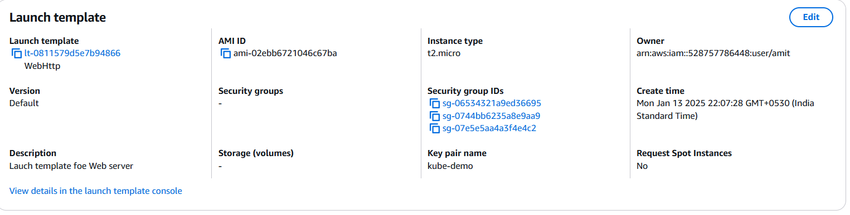

We select Network

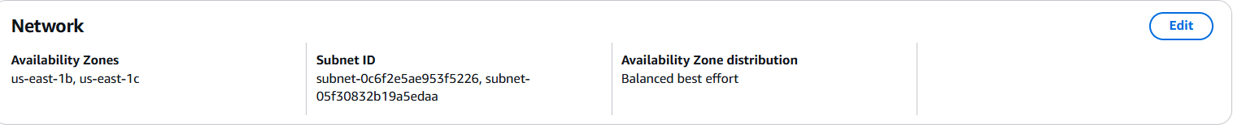

We assign an ALB. We select if we want to monitor the EC2 or the ALB traffic also



Health Checks



And capacity

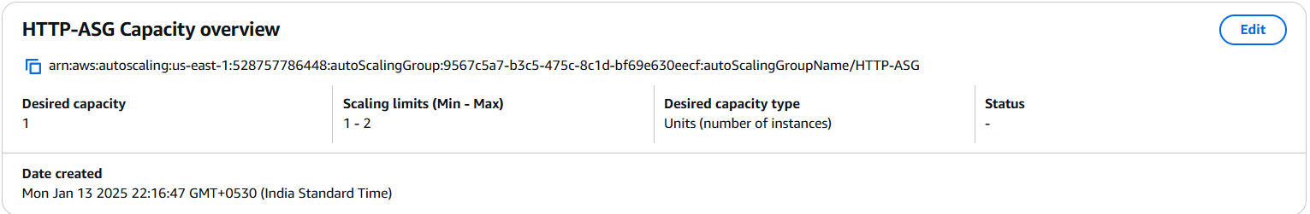

## Questions

Scaling an EC2 instance from r4.large to r4.4xlarge is called .....................

* Horizontal Scaling
* Vertical Scaling

Running an application on an Auto Scaling Group that scales the number of EC2 instances in and out is called .....................

* Horizontal Scaling
* Vertical Scaling

Elastic Load Balancers provide a .......................

* Static IPV4
* Static DNS
* Static IVP6

Only Network Load Balancer provides both static DNS name and static IP. While, Application Load Balancer provides a static DNS name but it does NOT provide a static IP. The reason being that AWS wants your Elastic Load Balancer to be accessible using a static endpoint, even if the underlying infrastructure that AWS manages changes.

You are running a website on 10 EC2 instances fronted by an Elastic Load Balancer. Your users are complaining about the fact that the website always asks them to re-authenticate when they are moving between website pages. You are puzzled because it's working just fine on your machine and in the Dev environment with 1 EC2 instance. What could be the reason?

* Multiple severs
* IP address of EC2 is not visible to client rather than ELB IP is visible
* Sticky session

ELB Sticky Session feature ensures traffic for the same client is always redirected to the same target (e.g., EC2 instance). This helps that the client does not lose his session data.

You are using an Application Load Balancer to distribute traffic to your website hosted on EC2 instances. It turns out that your website only sees traffic coming from private IPv4 addresses which are in fact your Application Load Balancer's IP addresses. What should you do to get the IP address of clients connected to your website?

* Modify your website's frontend so that users send their IP in every request
* Modify your website's backend to get the client IP address from the X-Forwarded-For header
* Modify your website's backend to get the client IP address from the X-Forwarded-Port header
* Modify your website's backend to get the client IP address from the X-Forwarded-Proto header

When using an Application Load Balancer to distribute traffic to your EC2 instances, the IP address you'll receive requests from will be the ALB's private IP addresses. To get the client's IP address, ALB adds an additional header called "X-Forwarded-For" contains the client's IP address.

Top of Form

You hosted an application on a set of EC2 instances fronted by an Elastic Load Balancer. A week later, users begin complaining that sometimes the application just doesn't work. You investigate the issue and found that some EC2 instances crash from time to time. What should you do to protect users from connecting to the EC2 instances that are crashing?

* Enable ELB Health Checks
* Enable ELB Stickiness
* Enable SSL Termination
* Enable Cross-Zone Load Balancing

When you enable ELB Health Checks, your ELB won't send traffic to unhealthy (crashed) EC2 instances.

Bottom of Form

Top of Form

You are working as a Solutions Architect for a company and you are required to design an architecture for a high-performance, low-latency application that will receive millions of requests per second. Which type of Elastic Load Balancer should you choose?

* Application Load Balancer
* Classic Load Balancer
* Network Load Balancer

Bottom of Form

Network Load Balancer provides the highest performance and lowest latency if your application needs it.

Top of Form

Application Load Balancers support the following protocols, **EXCEPT**:

* HTTP
* HTTPS
* TCP
* WebSocket

Application Load Balancers support HTTP, HTTPS and WebSocketBottom of Form

Top of Form

Application Load Balancers can route traffic to different Target Groups based on the following, **EXCEPT**:

* Client's Location (Geography)
* Hostname
* Request URL Path
* Source IP Address

ALBs can route traffic to different Target Groups based on URL Path, Hostname, HTTP Headers, and Query Strings.Bottom of Form

Top of Form

Registered targets in a Target Groups for an Application Load Balancer can be one of the following, **EXCEPT**:

* EC2 Instances
* Network Load Balancer
* Private IP Addresses
* Lambda Functions

Ans NLB

Top of Form

For compliance purposes, you would like to expose a fixed static IP address to your end-users so that they can write firewall rules that will be stable and approved by regulators. What type of Elastic Load Balancer would you choose?

* Application Load Balancer with an Elastic IP attached to it
* Network Load Balancer
* Classic Load Balancer

Bottom of Form

Network Load Balancer has one static IP address per AZ and you can attach an Elastic IP address to it. Application Load Balancers and Classic Load Balancers have a static DNS name.

Top of Form

You want to create a custom application-based cookie in your Application Load Balancer. Which of the following you can use as a cookie name?

* AWSALBAPP
* APPUSERC
* AWSALBTG
* AWSALB

Bottom of Form

The following cookie names are reserved by the ELB (AWSALB, AWSALBAPP, AWSALBTG).

Top of Form

You have a Network Load Balancer that distributes traffic across a set of EC2 instances in us-east-1. You have 2 EC2 instances in us-east-1b AZ and 5 EC2 instances in us-east-1e AZ. You have noticed that the CPU utilization is higher in the EC2 instances in us-east-1b AZ. After more investigation, you noticed that the traffic is equally distributed across the two AZs. How would you solve this problem?

* Enable Cross-Zone Load Balancing
* Enable Sticky Sessions
* Enable ELB Health Checks
* Enable SSL Termination

Bottom of Form

When Cross-Zone Load Balancing is enabled, ELB distributes traffic evenly across all registered EC2 instances in all AZs.

Top of Form

Which feature in both Application Load Balancers and Network Load Balancers allows you to load multiple SSL certificates on one listener?

* TLS Termination
* Server Name Indication (SNI)
* SSL Security Policies
* Host Headers

Bottom of Form

ANS SNI

Top of Form

You have an Application Load Balancer that is configured to redirect traffic to 3 Target Groups based on the following hostnames: **users.example.com**, **api.external.example.com**, and **checkout.example.com**. You would like to configure HTTPS for each of these hostnames. How do you configure the ALB to make this work?

* Use an HTTP to HTTPS redirect rule
* Use a security group SSL certificate
* Use Server Name Indication (SNI)

Bottom of Form

Server Name Indication (SNI) allows you to expose multiple HTTPS applications each with its own SSL certificate on the same listener. Read more here: https://aws.amazon.com/blogs/aws/new-application-load-balancer-sni/

Top of Form

You have an application hosted on a set of EC2 instances managed by an Auto Scaling Group that you configured both desired and maximum capacity to 3. Also, you have created a CloudWatch Alarm that is configured to scale out your ASG when CPU Utilization reaches 60%. Your application suddenly received huge traffic and is now running at 80% CPU Utilization. What will happen?

* Nothing
* The desired capacity will go up to 4 and the maximum capacity will stay at 3
* The desired capacity will go up to 4 and the maximum capacity will stay at 4

Bottom of Form

The Auto Scaling Group can't go over the maximum capacity (you configured) during scale-out events.

Top of Form

You have an Auto Scaling Group fronted by an Application Load Balancer. You have configured the ASG to use ALB Health Checks, then one EC2 instance has just been reported unhealthy. What will happen to the EC2 instance?

* The ASG will keep the instance running and re-start the application
* The ASG will detach the EC2 instance and leave it running
* The ASG will terminate the EC2 instance

Bottom of Form

You can configure the Auto Scaling Group to determine the EC2 instances' health based on Application Load Balancer Health Checks instead of EC2 Status Checks (default). When an EC2 instance fails the ALB Health Checks, it is marked unhealthy and will be terminated while the ASG launches a new EC2 instance.

Top of Form

Your boss asked you to scale your Auto Scaling Group based on the **number of requests per minute** your application makes to your database. What should you do?

* Create a CloudWatch custom metric then create a CloudWatch Alarm on this metric to scale your ASG
* You politely tell him it's impossible
* Enable Detailed Monitoring then create a CloudWatch Alarm to scale your ASG

Bottom of Form

There's no CloudWatch Metric for "requests per minute" for backend-to-database connections. You need to create a CloudWatch Custom Metric, then create a CloudWatch Alarm.

Top of Form

An application is deployed with an Application Load Balancer and an Auto Scaling Group. Currently, you manually scale the ASG and you would like to define a Scaling Policy that will ensure the average number of connections to your EC2 instances is around 1000. Which Scaling Policy should you use?

* Simple Scaling Policy
* Step Scaling Policy
* Target Tracking Policy
* Scheduled Scaling Policy

Bottom of Form

Ans Target

Top of Form

You have an ASG and a Network Load Balancer. The application on your ASG supports the HTTP protocol and is integrated with the Load Balancer health checks. You are currently using the TCP health checks. You would like to migrate to using HTTP health checks, what do you do?

* Migrate to an Application Load Balancer
* Migrate the health check to HTTP

Bottom of Form

the NLB supports HTTP health checks as well as TCP and HTTPS

Top of Form

You have a website hosted in EC2 instances in an Auto Scaling Group fronted by an Application Load Balancer. Currently, the website is served over HTTP, and you have been tasked to configure it to use HTTPS. You have created a certificate in ACM and attached it to the Application Load Balancer. What you can do to force users to access the website using HTTPS instead of HTTP?

* Send an email to all customers to use HTTPS instead of HTTP
* Configure the Application Load Balancer to redirect HTTP to HTTPS
* Configure the DNS record to redirect HTTP to HTTPS

Bottom of Form

And B

Bottom of Form

# RDS, Aurora & Elastic Cache

Amazon RDS Overview

* RDS stands for Relational Database Service
* It’s a managed DB service for DB using SQL as a query language.
* It allows you to create databases in the cloud that are managed by AWS that supports

1. Postgres
2. MySQL
3. MariaDB
4. Oracle
5. Microsoft SQL Server
6. IBM DB2
7. Aurora (AWS Proprietary database)

Ans

Advantage over using RDS versus deploying DB on EC2

RDS is a managed service and amazon provides

1. Automated provisioning (DB set up), OS patching
2. Continuous backups and restore to specific timestamp (Point in Time Restore)!
3. Monitoring dashboards
4. Read replicas for improved read performance
5. Multi AZ setup for DR (Disaster Recovery)
6. Maintenance windows for upgrades
7. Scaling capability (vertical and horizontal)
8. Storage backed by EBS

* BUT you can’t SSH into your instances

RDS Storage Auto Scaling

|  |  |
| --- | --- |
| * Help you increase storage on your RDS DB instance dynamically * When RDS detects you are running out of free database storage, it scales automatically * Avoid manually scaling your database storage which can be painful * You have to set Maximum Storage Threshold (maximum limit for DB storage) * Automatically modify storage if:  1. Free storage is less than 10% of allocated storage 2. Low storage lasts at least 5 minutes 3. 6 hours have passed since last modification  * Useful for applications with unpredictable workloads   Supports all RDS database engines |  |

## RDS Read Replicas for reading scalability

|  |  |
| --- | --- |
| * RDS supports Up to 15 Read Replicas only for select query * Within AZ, Cross AZ or Cross Region * Replication is ASYNC, so reads are eventually consistent * Replicas can be promoted to their own DB * Applications must update the connection string to leverage read replicas |  |

RDS Read Replicas – Use Cases

|  |  |
| --- | --- |
| * You have a production database that is taking on normal load. * You want to run a reporting application to run some analytics * You create a Read Replica to run the new workload there * The production application is unaffected * Read replicas are used for SELECT (=read) only kind of statements (not INSERT, UPDATE, DELETE) |  |

RDS Read Replicas – Network Cost

* In AWS there’s a network cost when data goes from one AZ to another
* For RDS Read Replicas within the same region, you don’t pay that fee
* Cross region replicas will have cost

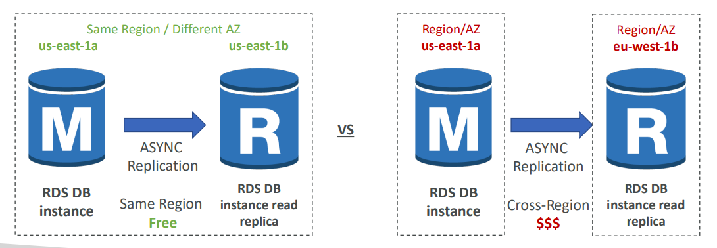

RDS Multi AZ (Disaster Recovery)

|  |  |
| --- | --- |
| • SYNC replication every transaction must be synced to be accepted  • One DNS name – automatic app failover to standby  • Increase availability  • Failover in case of loss of AZ, loss of network, instance or storage failure  • Don’t need to do any manual intervention in your apps if it tries to keep on connecting to your database automatically at some point, it will fail over to the standby that will be promoted as the Master,  • Not used for scaling. The standby database is just for standby. No one can read it. No one can write to it; it's just here as a failover in case anything goes on with your Master database. So, quick  • Note: The Read Replicas be set up as Multi AZ for Disaster Recovery (DR) |  |

RDS – From Single-AZ to Multi-AZ

|  |  |
| --- | --- |
| • Zero downtime operation (no need to stop the DB) for making it multi-AZ  • Just click on “modify” for the database  • The following happens internally:   1. A snapshot is taken 2. A new DB is restored from the snapshot in a new AZ 3. • Synchronization is established between the two databases |  |

Hands ON

Engines supported

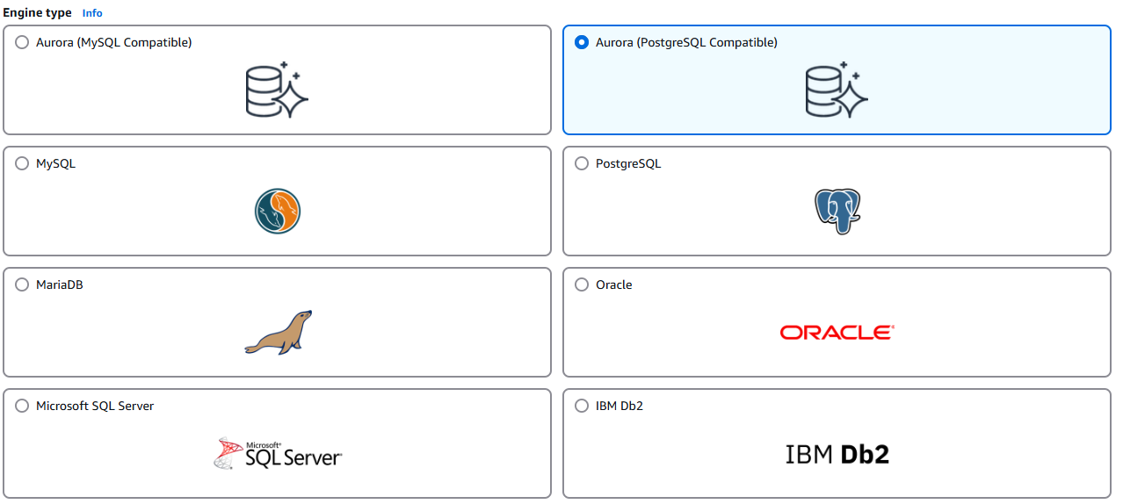

We have templates to meet our use case. In production we have full control

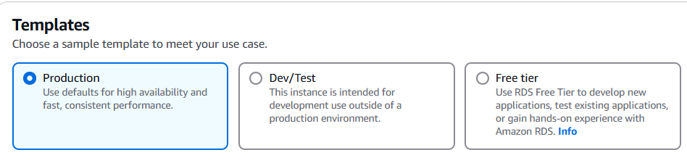

For availability and durability. We have three options. We have Single DB instance, Multi-AZ, or Multi-AZ DB Cluster. Because we want to remain within the free tier, we're going to use Single DB instance.

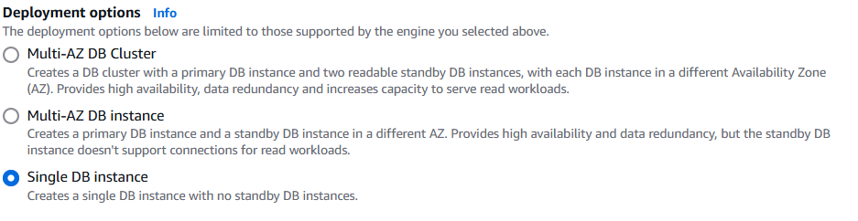

For the instance configuration, this is the size of the underlying EC2 instance. So, in our case, we can have standard classes, memory optimized classes, or burstable classes, and you can choose whatever instance you want amongst each class. But to remain within the free tier, we're going to use burstable classes and we're going to choose db.t3.micro.

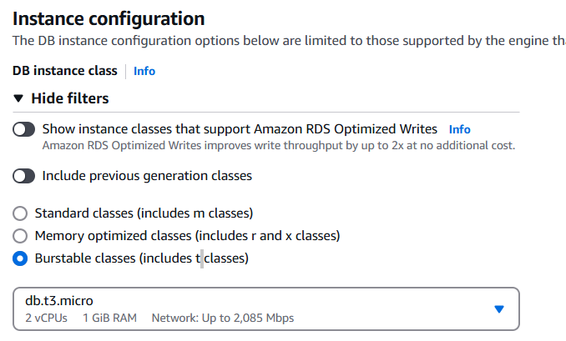

Now for storage type, if you are in production, you're going to use an io1 type of EBS volume. But as we're running within the free tier, I want to use a gp2 type of volume, which is lower performance, and we'll use maybe 10, 20 gigabytes of allocated storage. We can also enable storage autoscaling, which will automatically increase the size of the EBS volume in case we are starting to near a threshold

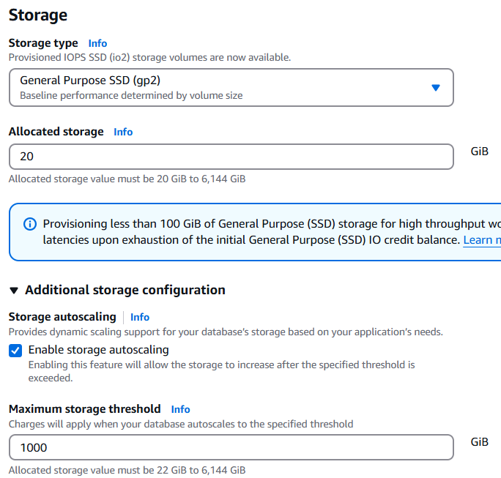

In case you wanted to make sure that there is connectivity between a specified EC2 instance and your RDS database. You would just choose it on this list. And then the configuration in terms of networking would be done automatically so you don't have to handle security groups.

If we are setting connectivity as don’t connect we have to select VPC and select whether or not we want public access to this database

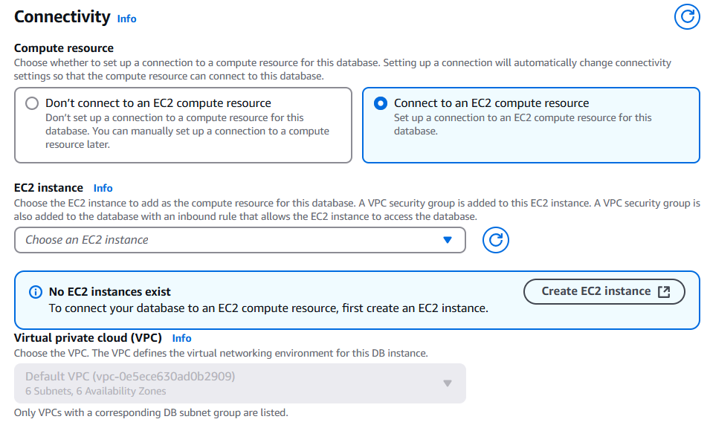

Can control public access

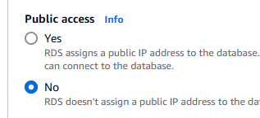

Can set monitoring and backup

RDS Custom

With RDS we don't have access to any underlying operating system, or customization, but with RDS Custom we actually do. And RDS Custom is for two database types, it's for Oracle and Microsoft SQL Server

|  |  |
| --- | --- |
| * Managed Oracle and Microsoft SQL Server Database with OS and database customization * RDS: Automates setup, operation, and scaling of database in AWS * Custom: access to the underlying database and OS so you can  1. Configure settings 2. Install patches 3. Enable native features 4. Access the underlying EC2 Instance using SSH or SSM Session Manager  * De-activate Automation Mode to perform your customization, better to take a DB snapshot before * RDS vs. RDS Custom  1. RDS: entire database and the OS to be managed by AWS 2. RDS Custom: full admin access to the underlying OS and the database |  |

## Amazon Aurora

* Aurora is a proprietary technology from AWS (not open sourced)
* Postgres and MySQL are both supported as Aurora DB (that means your drivers will work as if Aurora was a Postgres or MySQL database)
* Aurora is “AWS cloud optimized” and claims 5x performance improvement over MySQL on RDS, over 3x the performance of Postgres on RDS
* Aurora storage automatically grows in increments of 10GB, up to 128 TB. You can start at 10 GB.
* Aurora can have up to 15 replicas and the replication process is faster than MySQL (sub 10 milliseconds replica lag)
* Failover in Aurora is instantaneous. It’s HA (High Availability) native.
* Aurora costs more than RDS (20% more) – but is more efficient

Aurora High Availability and Read Scaling

|  |  |
| --- | --- |
| * 6 copies of your data across 3 AZ:  1. 4 copies out of 6 needed for writing 2. 3 copies out of 6 needed for reading 3. Self-healing with peer-to-peer replication  * Storage is striped across 100s of volumes * One Aurora Instance takes writes (master) * Automated failover for master in less than 30 seconds * Master + up to 15 Aurora Read Replicas serve reads * Support for Cross Region Replication |  |

Aurora DB Cluster

For Aurora have a shared storage volume which is auto expanding from 10GB to 128GB. Your master is the only thing that will write to your storage. Because the master can change and failover, what Aurora provides you is what's called a writer endpoint. It's a DNS name, a writer endpoint, and it's always pointing to the master. So even if the master fails over, your client still talks to the writer endpoint and is automatically redirected to the right instance.

For Aurora you also have a lot of read replicas. Also, we can have auto scaling on top of these read replicas. You can have one up to 15 read replicas and you can set up auto scaling such as you always have the right number of read replicas. Now, because you have auto scaling, it can be really, hard for your applications to keep track replica end points. There is something called a reader endpoint. It helps with connection load balancing, and it connects automatically to all the read replicas. So anytime the client connects to the reader endpoints it will get connected to one of the read replicas and there will be load balancing done this way. The load balancing happens at the connection level, not the statement level.

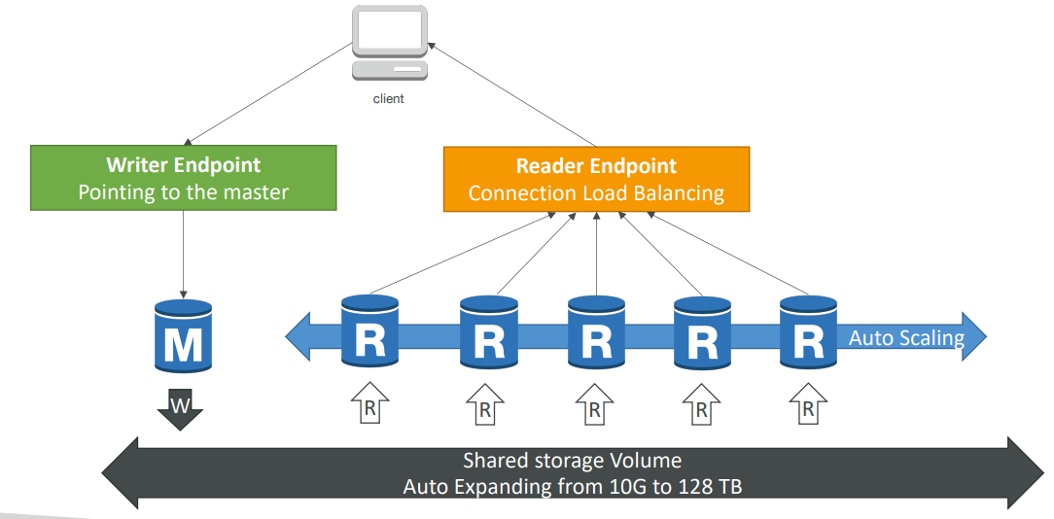

Features of Aurora

* Automatic fail-over
* Backup and Recovery
* Isolation and security
* Industry compliance
* Push-button scaling
* Automated Patching with Zero Downtime
* Advanced Monitoring
* Routine Maintenance
* Backtrack: restore data at any point of time without using backups

Aurora Replicas - Auto Scaling

Let's say we have a client, and we have three Aurora's instances right now. One will be writing through the writer endpoint and the other two would be reading through the reader endpoint. Okay. Now let's say that we are having many, many requests, read requests on the reader endpoint, and so therefore the Amazon Aurora databases have an increased CPU usage. In that case, we can set up replica auto-scaling, and what this will do is that it will add obviously Amazon Aurora replicas, and then what will happen is that automatically the reader endpoint is going to be extended to cover these new replicas and therefore these new replicas will start receiving some traffic and the reads will be happening in a more distributed fashion, hopefully bringing down the overall CPU usage. So this is replica auto scaling.

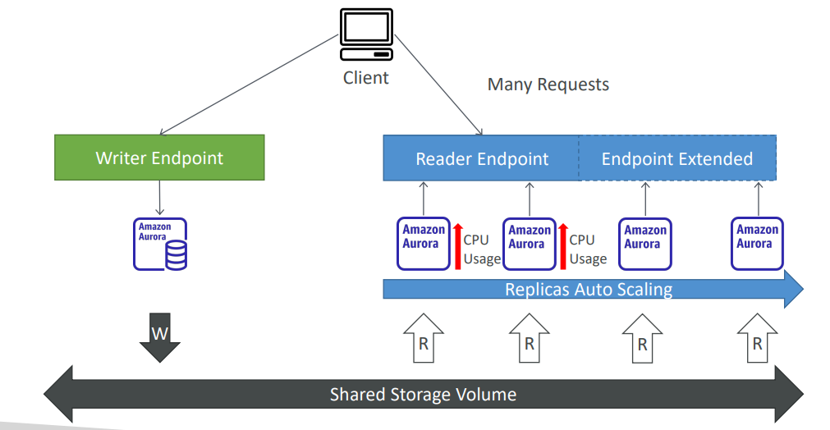

Aurora – Custom Endpoints

The second thing is custom endpoints. So, let's say we have the same setup, but this time we have two different kinds of replicas. As you can see, we have some DBR three large and some DBR five two X large. So, some replicas are bigger than others. And the reason you would do this is that you want to define a subset of your Aurora instances as a custom endpoint. Let's say we define a custom endpoint on these two bigger Aurora instances. The reason we would do so is, for example, that we know that these instances are more powerful and therefore they're going to be better to run analytical queries on these specific replicas. So, when you do so, you have a custom endpoint that's defined. And when you have a custom endpoint, generally the reader endpoint itself is not used after defining custom endpoints. It would not disappear, but you would not use it anymore. And what you would do in practice in like practically speaking, is set up many custom endpoints for many different kinds of workloads, therefore allowing you to query only a subsets of your Aurora replicas.

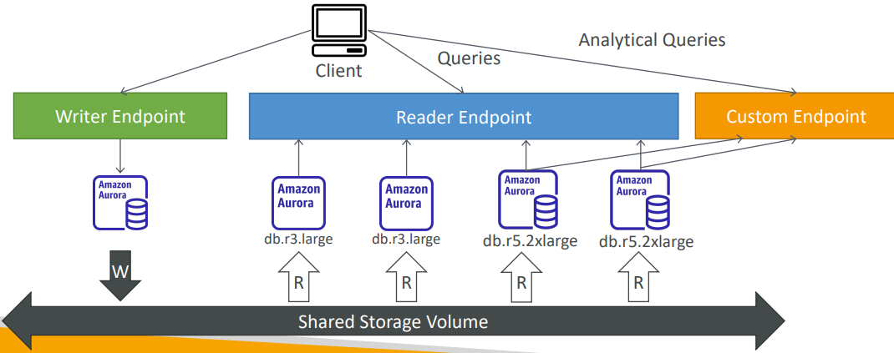

* Define a subset of Aurora Instances as a Custom Endpoint
* Example: Run analytical queries on specific replicas
* The Reader Endpoint is generally not used after defining Custom Endpoints

Aurora Serverless

So this is going to give you automated database instantiation and auto-scaling based on actual usage, which is great when you have infrequent, intermittent or unpredictable workloads. And therefore, you don't need to do any capacity planning. You're going to pay per second of each Aurora instance that is being spun up and this can be a lot more cost effective. So how does that work? Well, the client is going to talk to a proxy fleet that is managed by Aurora and in the back end, many Aurora instances will be created based on your workload in a serverless fashion, so you don't have to provision capacity at all in advance.

|  |  |
| --- | --- |
| * Automated database instantiation and auto - scaling based on actual usage * Good for infrequent, intermittent or unpredictable workloads * No capacity planning needed * • Pay per second, can be more cost -effective |  |

Global Aurora

In case we have a Aurora cross region read replica it's going to be very helpful for disaster recovery. But instead we can also set up the Aurora global database, which is the recommended way of doing things today. In this case, you have one primary region where all the reading and writes happen, but you can set up up to five secondary read-only regions, where the replication like should be less than one second and up to 16 read replicas per secondary region. And this will help you decrease latency for the read workloads all over the world, but also in case you have a database outage in one region, promoting another region for disaster recovery purposes has an RTO to recover a time objective of less than one minute. So, it takes us in one minute to recover into another region. It takes on average less than one second to replicate data across the region for your Aurora global database.

We have us-east1 as our primary region, which is where the applications do the read and writes, and then we'll set up a secondary region in us-one or some replication happening with a global database of Aurora and the applications that it can do read only from that setup. But in case us-east1 fails, then we can fail over to us-one by promoting it as a read write Aurora cluster.

|  |  |
| --- | --- |
| * Aurora Cross Region Read Replicas:  1. Useful for disaster recovery 2. Simple to put in place   • Aurora Global Database (recommended):  • 1 Primary Region (read / write)  • Up to 5 secondary (read-only) regions, replication lag is less  than 1 second  • Up to 16 Read Replicas per secondary region  • Helps for decreasing latency  • Promoting another region (for disaster recovery) has an RTO  of < 1 minute  • Typical cross-region replication takes less than 1 second |  |

Aurora Machine Learning

Aurora also has an integration with machine learning services within AWS. So, the idea with Aurora Machine Learning is that you can have ML based predictions to your applications via the SQL interface. It's a simple, optimized and secure integration between Aurora and different AWS machine learning services. So, two supported services are SageMaker, which allows you to use any kind of machine learning model in the backend or Amazon Comprehend if you want to do sentiment analysis. So in order to use Aurora Machine Learning, you don't have to, you don't need to have machine learning experience. And the use cases for this would be to have fraud detection, ads targeting, sentiment analysis or product recommendation all within Aurora.

So, to give you the architecture idea, Aurora is going to be connected to the machine learning services in AWS. And your application can just run a very simple SQL query. For example, what are the recommended products? Aurora will send some data into the machine learning services such as, for example, the user's profile, the shopping history, et cetera, et cetera. And then the machine learning service will return a prediction directly to Aurora. For example, the user should buy a red shirt and blue pants, and then Aurora can just return the query results to the application all through because of the SQL query, which is very handy.

|  |  |
| --- | --- |
| * Enables you to add ML-based predictions to your applications via SQL * Simple, optimized, and secure integration between Aurora and AWS ML services * Supported services * Amazon SageMaker (use with any ML model) * Amazon Comprehend (for sentiment analysis) * You don’t need to have ML experience * Use cases: fraud detection, ads targeting, sentiment analysis, product recommendations |  |

## Backup

RDS Backups

* Automated backups:

1. Daily full backup of the database (during the backup window)
2. Transaction logs are backed-up by RDS every 5 minutes
3. => ability to restore to any point in time (from oldest backup to 5 minutes ago)
4. 1 to 35 days of retention, set 0 to disable automated backups

* Manual DB Snapshots

1. Manually triggered by the user
2. Retention of backup for as long as you want

Trick: in a stopped RDS database, you will still pay for storage. If you plan on stopping it for a long time, you should snapshot & restore instead

Aurora Backups

* Automated backups

1. 1 to 35 days (cannot be disabled)
2. point-in-time recovery in that timeframe

* Manual DB Snapshots

1. Manually triggered by the user
2. Retention of backup for as long as you want

RDS & Aurora Restore options

* Restoring an RDS / Aurora backup or a snapshot creates a new database
* Restoring MySQL RDS database from S3
  1. Create a backup of your on-premises database
  2. Store it on Amazon S3 (object storage)
  3. Restore the backup file onto a new RDS instance running MySQL
* Restoring MySQL Aurora cluster from S3

1. Create a backup of your on-premises database using the software Percona XtraBackup
2. Store the backup file on Amazon S3
3. Restore the backup file onto a new Aurora cluster running MySQL

Aurora Database Cloning

So say you have a production database in Aurora and you want to actually run test on it but you want to copy the data because your test application must be in a staging environment. Well, for this you're just going to clone your production Aurora database. It's going to give you a new database,

* Create a new Aurora DB Cluster from an existing one
* Faster than snapshot & restore
* Uses copy-on-write protocol
* Initially, the new DB cluster uses the same data volume as the original DB cluster (fast and efficient – no copying is needed)
* When updates are made to the new DB cluster data, then additional storage is allocated, and data is copied to be separated
* Very fast & cost-effective
* Useful to create a “staging” database from a “production” database without impacting the production database

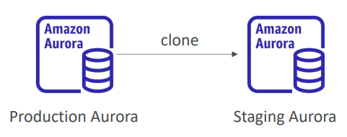

RDS & Aurora Security

• At-rest encryption:

1. Database master & replicas encryption using AWS KMS – must be defined as launch time
2. If the master is not encrypted, the read replicas cannot be encrypted
3. To encrypt an un-encrypted database, go through a DB snapshot & restore as encrypted

• In-flight encryption: TLS-ready by default, use the AWS TLS root certificates client-side

• IAM Authentication: IAM roles to connect to your database (instead of username/pw)

• Security Groups: Control Network access to your RDS / Aurora DB

• No SSH available except on RDS Custom

• Audit Logs can be enabled and sent to CloudWatch Logs for longer retention

## Amazon RDS Proxy

we can also deploy a fully managed database proxy for RDS . If you use an As an RDS Proxy, this will allow you, your application, to pool and share the database connections established with the database. So instead of having every single application connect to your RDS database instance, they will be instead connected to the proxy, and the proxy will pool these connections together into less connections to the RDS database instance

If you have a lot of connections into your RDS database instance, and it's going to improve your database efficiency by reducing the stress on database resources, for example, CPU and RAM, and minimize the open connections and the timeouts into your database.

RDS Proxy is fully serverless. It's auto scaling, so you don't need to manage its capacity. And it's highly available. It's across multiple AZ. And therefore, in case, for example, there is a failover that happens on your RDS database instance. For example, it goes from the primary instance to the standby instance, then it will, thanks to the RDS Proxy, reduce the failover time by up to 66%.

|  |  |
| --- | --- |
| • Fully managed database proxy for RDS  • Allows apps to pool and share DB connections established with the database  • Improving database efficiency by reducing the stress on database resources (e.g., CPU, RAM) and minimize open connections (and timeouts)  • Serverless, autoscaling, highly available (multi-AZ)  • Reduced RDS & Aurora failover time by up 66%  • Supports RDS (MySQL, PostgreSQL, MariaDB, MS  SQL Server) and Aurora (MySQL, PostgreSQL)  • No code changes required for most apps just need to connect to RDS Proxy endpoint  • Enforce IAM Authentication for DB, and securely store credentials in AWS Secrets Manager  • RDS Proxy is never publicly accessible (must be accessed from VPC) |  |

One service that is surely going to be very helped by the RDS Proxy is called Lambda functions. And the Lambda functions, they will execute pieces of code. The Lambda functions can multiply, multiply many, many times. And they will appear and disappear very, very fast. And therefore, imagine you have 100 or 1,000 Lambda functions appearing and disappearing just like that, and opening connections into your RDS database instance, they will be a big problem because it will leave open connections and timeouts, and it will be a mess. And therefore, what you do is use the RDS Proxy to pool connections for your Lambda functions, and then the Lambda functions will overload the RDS Proxy, but it's meant to be overload. And the RDS Proxy will pool these connections into less connections to the RDS database instance, thus, solving your problems, okay?

## Amazon ElastiCache

* The same way RDS is to get managed Relational Databases…
* ElastiCache is to get managed Redis or Memcached
* Caches are in-memory databases with high performance, low latency
* Helps reduce load off databases for read intensive workloads
* Help make your application stateless
* AWS takes care of OS maintenance / patching, optimizations, setup, configuration, monitoring, failure recovery and backups
* Using ElastiCache involves heavy application code changes

ElastiCache Solution Architecture - DB Cache

|  |  |
| --- | --- |
| • Applications queries ElastiCache, if not available, get from RDS and store in ElastiCache.  • Helps relieve load in RDS  • Cache must have an invalidation strategy to make sure only the most current data is used in there. |  |

ElastiCache Solution Architecture – User Session Store

|  |  |
| --- | --- |
| • User logs into any of the application  • The application writes the session data into ElastiCache  • The user hits another instance of our application  • The instance retrieves the data and the user is already logged in |  |

ElastiCache – Redis vs Memcached

If we compare Redis and Memcached, so for Redis we have multi-availability zone with auto-failover as a feature, and you can create read replicas to scale the reads and have high availability. You also get data durability using AOF persistence, and you have a backup and restore features on the open-source version of Redis. It also supports sets and sorted sets, which are a very nice way to create leaderboards and provide you with some very nice features in a cache. So, the way I like to think of Redis is a Redis node being replicated into another one to give you an idea of how it works. Of course, Redis is evolving fast, and this may not be general, but this is a simplification. And for Memcached, the idea is that you have multiple nodes set up and they're partitioning your data. That means it's called sharding, so you have multiple nodes together. And there's no high availability, there's no replication. Again, not everything may be true, for example, for the serverless version of Memcached, but I'm just trying to draw a simple image here. So, if you have an issue with Memcached, you may lose your entire cache and you have backup and restore features only for the serverless version of Memcached, not the self-managed version of Memcached on ElastiCache. You also have multi-thread architecture, which may be good for performance. So, the way I like to think of Memcached is they're sharding so you have multiple nodes next to each other, which are partitioning, which are sharing the data, okay?

|  |  |
| --- | --- |
| REDIS  • Multi AZ with Auto-Failover  • Read Replicas to scale reads and have high availability  • Data Durability using AOF persistence  • Backup and restore features  • Supports Sets and Sorted Sets | MEMCACHED  • Multi-node for partitioning of data (sharding)  • No high availability (replication)  • Non persistent  • Backup and restore (Serverless)  • Multi-threaded architecture |

ElastiCache – Cache Security

|  |  |
| --- | --- |
| • ElastiCache supports IAM Authentication for Redis  • IAM policies on ElastiCache are only used for AWS API-level security  • Redis AUTH  • You can set a “password/token” when you create a Redis cluster  • This is an extra level of security for your cache (on top of security groups)  • Support SSL in flight encryption  • Memcached  • Supports SASL-based authentication (advanced) |  |

Patterns for ElastiCache

|  |  |
| --- | --- |
| • Lazy Loading: all the read data is cached, data can become stale in  cache  • Write Through: Adds or update data in the cache when written to a DB (no stale data)  • Session Store: store temporary session data in a cache (using TTL features)  • Quote: There are only two hard things in Computer Science: cache invalidation and naming things |  |

ElastiCache – Redis Use Case

* Gaming Leaderboards are computationally complex
* Redis Sorted guarantees both uniqueness and element ordering
* Each time a new element is added, it’s ranked in real time, then added in correct order

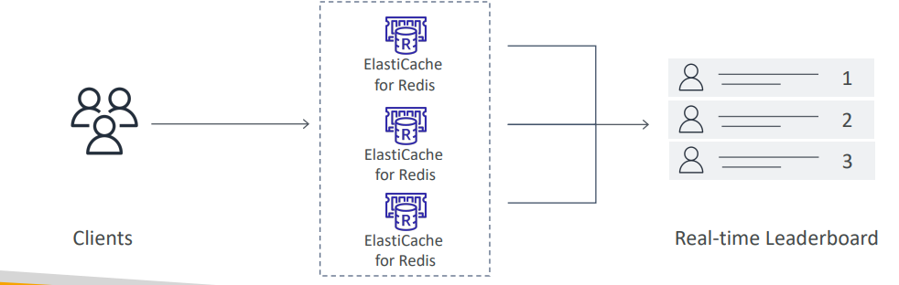

Handson

1. Can use Redis, Memcached or Valkey
2. We can use a serverless offering, which is to have a cache automatically scaling to meet your application traffic and no servers to manage. It is way more expensive, but easier to manage. Or we can design our own cache.

We can also create new or restore from existing

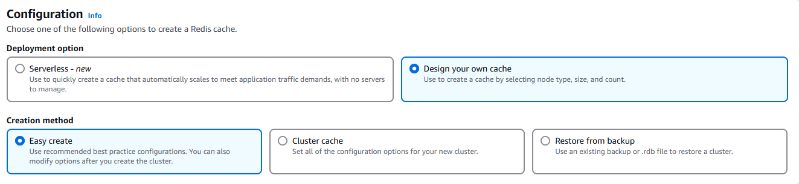

1. Can have single or multiple nodes/shards

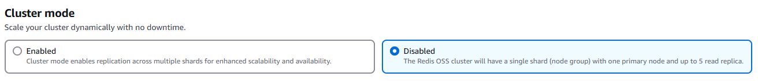

1. Can run AWS or on-premises also, also can enable multi AZ

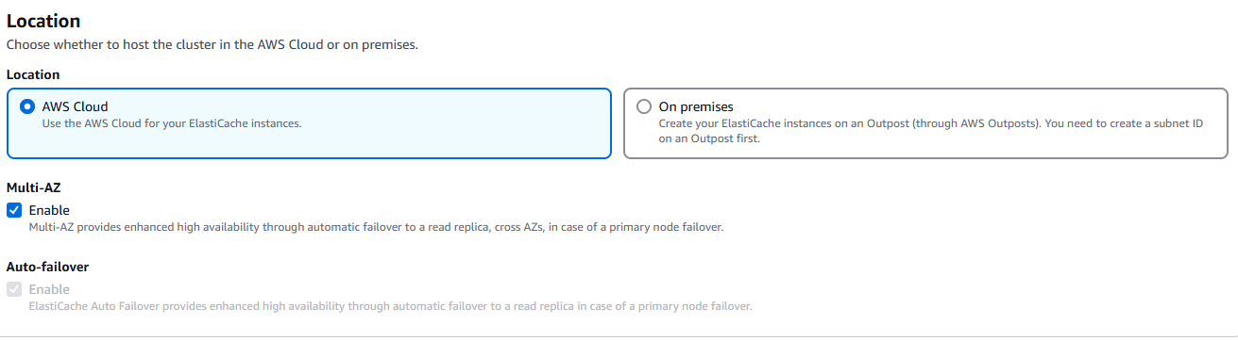

1. We can select instance type where we want to run subnet and AZ

## Questions

Top of Form

Amazon RDS supports the following databases, **EXCEPT**:

* MongoDB
* MySQL
* MariaDB
* Microsoft SQL Server

Bottom of Form

Ans RDS supports MySQL, PostgreSQL, MariaDB, Oracle, MS SQL Server, and Amazon Aurora.

Top of Form

You're planning for a new solution that requires a MySQL database that must be available even in case of a disaster in one of the Availability Zones. What should you use?

* Create Read Replicas
* Enable Encryption
* Enable Multi-AZ

Bottom of Form

Ans Multi-AZ helps when you plan a disaster recovery for an entire AZ going down. If you plan against an entire AWS Region going down, you should use backups and replication across AWS Regions.

Top of Form

We have an RDS database that struggles to keep up with the demand of requests from our website. Our million users mostly read news, and we don't post news very often. Which solution is **NOT** adapted to this problem?

* An ElastiCache Cluster
* RDS Multi-AZ
* RDS Read Replicas

Bottom of Form

Ans Be very careful with the way you read questions at the exam. Here, the question is asking which solution is NOT adapted to this problem. ElastiCache and RDS Read Replicas do indeed help with scaling reads.

Top of Form

You have set up read replicas on your RDS database, but users are complaining that upon updating their social media posts, they do not see their updated posts right away. What is a possible cause for this?

* There must be a bug in your application
* Read Replicas have Asynchronous Replication, therefore it's likely your users will only read Eventual Consistency
* You should have setup Multi-AZ instead

Bottom of Form

Ans B

Top of Form

Which RDS **(NOT Aurora)** feature when used does not require you to change the SQL connection string?

* Multi-AZ
* Read Replicas

Bottom of Form

Top of Form

Which RDS **(NOT Aurora)** feature when used does not require you to change the SQL connection string?

* Multi-AZ
* Read Replicas

Bottom of Form

Read Replicas add new endpoints with their own DNS name. We need to change our application to reference them individually to balance the read load. Multi-AZ keeps the same connection string regardless of which database is up.

Top of Form

Your application running on a fleet of EC2 instances managed by an Auto Scaling Group behind an Application Load Balancer. Users have to constantly log back in and you don't want to enable Sticky Sessions on your ALB as you fear it will overload some EC2 instances. What should you do?

* Use your own custom Load Balancer on EC2 instances instead of using ALB
* Store session data in RDS
* Store session data in ElastiCache
* Store session data in a shared EBS volume

Bottom of Form

Ans Storing Session Data in ElastiCache is a common pattern to ensuring different EC2 instances can retrieve your user's state if needed.

Top of Form

An analytics application is currently performing its queries against your main production RDS database. These queries run at any time of the day and slow down the RDS database which impacts your users' experience. What should you do to improve the users' experience?

* Setup a Read Replica
* Setup Multi-AZ
* Run the analytics queries at night

Bottom of Form

Ans Read Replicas will help as your analytics application can now perform queries against it, and these queries won't impact the main production RDS database.

Top of Form

You would like to ensure you have a replica of your database available in another AWS Region if a disaster happens to your main AWS Region. Which database do you recommend to implement this easily?

* RDS Read Replicas
* RDS Multi-AZ
* Aurora Read Replicas
* Aurora Global Database

Bottom of Form

Ans Aurora Global Databases allows you to have an Aurora Replica in another AWS Region, with up to 5 secondary regions.

Top of Form

How can you enhance the security of your ElastiCache Redis Cluster by allowing users to access your ElastiCache Redis Cluster using their IAM Identities (e.g., Users, Roles)?

* Using Redis Authentication
* Using IAM Authentication
* Use Security Groups

Bottom of Form

Ans B

Top of Form

Your company has a production Node.js application that is using RDS MySQL 5.6 as its database. A new application programmed in Java will perform some heavy analytics workload to create a dashboard on a regular hourly basis. What is the most cost-effective solution you can implement to minimize disruption for the main application?

* Enable Multi-AZ for the RDS database and run the analytics workload on the standby database
* Create a Read Replica in a different AZ and run the analytics workload on the replica database
* Create a Read Replica in a different AZ and run the analytics workload on the source database

Bottom of Form

Ans B

Top of Form

You would like to create a disaster recovery strategy for your RDS PostgreSQL database so that in case of a regional outage the database can be quickly made available for both read and write workloads in another AWS Region. The DR database must be highly available. What do you recommend?

* Create a Read Replica in the same region and enable Multi-AZ on the main database
* Create a Read Replica in a different region and enable Multi-AZ on the Read Replica
* Create a Read Replica in the same region and enable Multi-AZ on the Read Replica
* Enable Multi-Region option on the main database

Bottom of Form

Ans B

Top of Form

You have migrated the MySQL database from on-premises to RDS. You have a lot of applications and developers interacting with your database. Each developer has an IAM user in the company's AWS account. What is a suitable approach to give access to developers to the MySQL RDS DB instance instead of creating a DB user for each one?

* By default IAM users have access to your RDS database
* Use Amazon Cognito
* Enable IAM Database Authentication

Bottom of Form

Ans C

Top of Form

Which of the following statement is true regarding replication in both RDS Read Replicas and Multi-AZ?

* Read Replica uses Asynchronous Replication and Multi-AZ uses Asynchronous Replication
* Read Replica uses Asynchronous Replication and Multi-AZ uses Synchronous Replication
* Read Replica uses Synchronous Replication and Multi-AZ uses Synchronous Replication
* Read Replica uses Synchronous Replication and Multi-AZ uses Asynchronous Replication

Bottom of Form

Ans B

Top of Form

How do you encrypt an unencrypted RDS DB instance?

* Do it straight from AWS Console, select your RDS DB instance, choose Actions then Encrypt using KMS
* Do it straight from AWS Console, after stopping the RDS DB instance
* Create a snapshot of the unencrypted RDS DB instance, copy the snapshot and tick "Enable encryption", then restore the RDS DB instance from the encrypted snapshot

Bottom of Form

Ans C

Top of Form

For your RDS database, you can have up to ............ Read Replicas.

* 5
* 15
* 7

Bottom of Form

And 15

Top of Form

Which RDS database technology does **NOT** support IAM Database Authentication?

* Oracle
* PostgreSQL
* MySQL

Bottom of Form

Ans Oracle

Top of Form

You have an un-encrypted RDS DB instance and you want to create Read Replicas. Can you configure the RDS Read Replicas to be encrypted?

* No
* Yes

Bottom of Form

Ans You can not create encrypted Read Replicas from an unencrypted RDS DB instance.

Top of Form

An application running in production is using an Aurora Cluster as its database. Your development team would like to run a version of the application in a scaled-down application with the ability to perform some heavy workload on a need-basis. Most of the time, the application will be unused. Your CIO has tasked you with helping the team to achieve this while minimizing costs. What do you suggest?

* Use an Aurora Global Database
* Use an RDS database
* Use Aurora Serverless
* Run Aurora on EC2, and write a script to shut down the EC2 instance at night

Bottom of Form

Ans C

Top of Form

How many Aurora Read Replicas can you have in a single Aurora DB Cluster?

* 5
* 10
* 15

Bottom of Form

Ans 15

Top of Form

Amazon Aurora supports both .......................... databases.

* MySQL and MariaDB
* MySQL and PostgreSQL
* Oracle and MariaDB
* Oracle and MS SQL Server

Bottom of Form

Ans B

Top of Form

You work as a Solutions Architect for a gaming company. One of the games mandates that players are ranked in real-time based on their score. Your boss asked you to design then implement an effective and highly available solution to create a gaming leaderboard. What should you use?

* Use RDS for MySQL
* Use an Amazon Aurora
* Use ElastiCache for Memcached
* Use ElastiCache for Redis - Sorted Sets

Bottom of Form

Ans D

Top of Form

You need full customization of an Oracle Database on AWS. You would like to benefit from using the AWS services. What do you recommend?

* RDS for Oracle
* RDS Custom for Oracle
* Deploy Oracle on EC2

Bottom of Form

Ans B

Top of Form

You need to store long-term backups for your Aurora database for disaster recovery and audit purposes. What do you recommend?

* Enable Automated Backups
* Perform On Demand Backups
* Use Aurora Database Cloning

Bottom of Form

On demand backup

Top of Form

Your development team would like to perform a suite of read and write tests against your production Aurora database because they need access to production data as soon as possible. What do you advise?

* Create an Aurora Read Replica for them
* Do the test against the production database
* Make a DB Snapshot and Restore it into a new database
* Use the Aurora Cloning feature

Bottom of Form

Ans D its faster than snapshots

Top of Form

You have 100 EC2 instances connected to your RDS database and you see that upon a maintenance of the database, all your applications take a lot of time to reconnect to RDS, due to poor application logic. How do you improve this?

* Fix all the applications
* Disable Multi-AZ
* Enable Multi-AZ
* Use an RDS Proxy

Bottom of Form

This reduces the failover time by up to 66% and keeps connection actives for your applications

# Amazon Route 53

**What is DNS?** Domain Name System which translates the human friendly hostnames into the machine IP addresses

* www.google.com => 172.217.18.36

DNS uses hierarchical naming structure

* .com
* example.com
* www.example.com
* api.example.com

DNS Terminologies

* **Domain Registrar**: Amazon Route 53, GoDaddy, - Register domain names
* **DNS Records**: A, AAAA, CNAME, NS, … different types of records
  + NS The NS record is stored by the Top-Level Domain (TLD) server. There are over 1,000 TLD servers. There is one for .com domains, another for .gov domains, and so on.
  + A record is used to point the domain name at one or multiple IP addresses. It has 3 fields name, IP and TTL. The name contains SLD also called Domain name/Host Name/ Alias/DNS entry for e.g. google.com
  + AAAA used for IPV6
  + Canonical Name record (CNAME) tells anyone visiting that subdomain to use the same DNS records as another domain / subdomain. CNAME records must always point to another domain / subdomain, never directly to an IP address. For example, you couldn’t use a CNAME for pbrumby.com. But you could for a subdomain like www.pbrumby.com.
* **Zone File**: contains DNS records to match hostname to IP
* **Name Server** resolves DNS queries (Authoritative or Non-Authoritative)
* **Top Level Domain** (TLD): .com, .us, .in, .gov, .org, …
* **Second Level Domain** (SLD): amazon.com, google.com, …

Protocol <http://api.www.example.com>. . 🡪root

.com 🡪TLD

example.com 🡪SLD also called Domain name/Host Name/ Alias/DNS entry

[www.example.com](http://www.example.com) 🡪 Sub domain

api.www.example.com 🡪 FQDN Fully Qualified Domain Name

How DNS Works

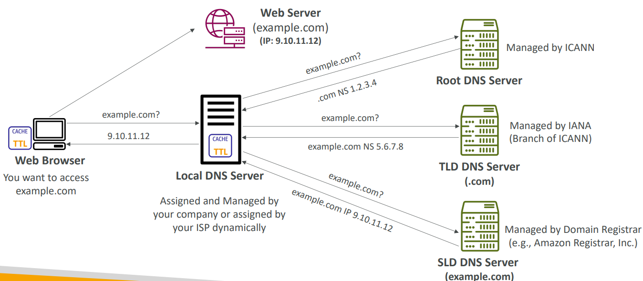

Amazon Route 53

|  |  |
| --- | --- |
| * A highly available, scalable, fully managed and Authoritative DNS   + Authoritative = the customer (you) can update the DNS records * Route 53 is also a Domain Registrar i.e. we can register our domain * Ability to check the health of your resources * The only AWS service which provides 100% availability SLA * Why Route 53? 53 is a reference to the traditional DNS port |  |

Route 53 – Records

* We can define multiple, DNS record and it defines how you want to route traffic for a domain
* Each record contains:

1. Domain/subdomain Name – e.g., example.com
2. Record Type – e.g., A or AAAA
3. Value – e.g., 12.34.56.78
4. Routing Policy – how Route 53 responds to queries
5. TTL – amount of time the record cached at DNS Resolvers

* Route 53 supports the following DNS record types:

1. (must know) A / AAAA / CNAME / NS
2. (advanced) CAA / DS / MX / NAPTR / PTR / SOA / TXT / SPF / SRV

## Route 53 – Record Types

* A – maps a hostname to IPv4
* AAAA – maps a hostname to IPv6
* CNAME – maps a hostname to another hostname

1. The target is a domain name which must have an A or AAAA record
2. Can’t create a CNAME record for the top node of a DNS namespace (Zone Apex)
3. Example: you can’t create for example.com, but you can create for [www.example.com](http://www.example.com) or api.example.com

* NS – Name Servers for the Hosted Zone

1. Control how traffic is routed for a domain

Route 53 – Hosted Zones

A container for records that defines how to route traffic to a domain and its subdomains. Say we have a company with domain or A record example.com we would multiple other URLS for our company like

* api.example.com
* m.example.com
* secured.example.com
* internal.example.com

etc. All these routing can be done by Hosted Zone. It is or 2 types

* Public Hosted Zones – contains records that specify how to route traffic on the Internet (public domain names) application1.mypublicdomain.com. Exposed on the Internet
* Private Hosted Zones – contain records that specify how you route traffic within one or more VPCs (private domain names) application1.company.internal. Not exposed on internet for internal traffic
* You pay $0.50 per month per hosted zone

Public vs. Private Hosted Zones

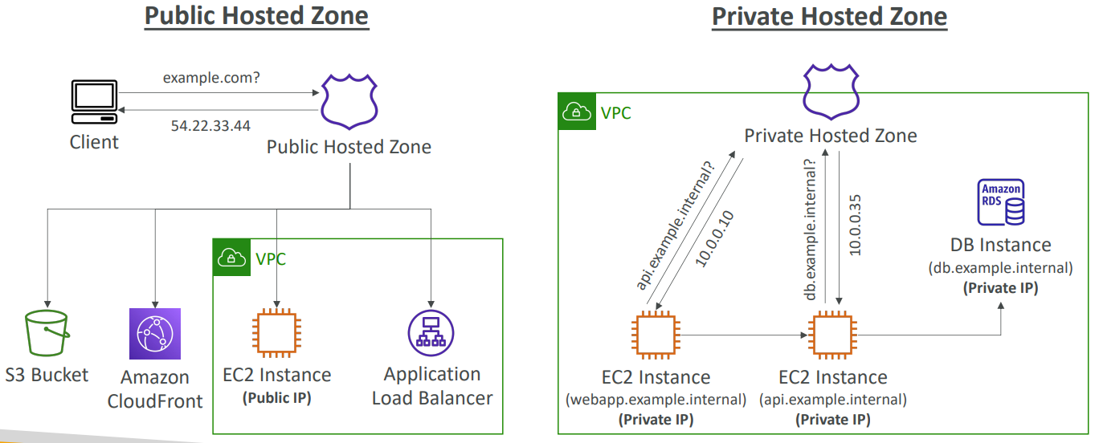

Route 53 – Records TTL (Time To Live)

|  |  |
| --- | --- |
| • High TTL – e.g., 24 hr   1. Less traffic on Route 53 2. Possibly outdated records   • Low TTL – e.g., 60 sec.   1. More traffic on Route 53 ($$) 2. Records are outdated for less time 3. Easy to change records   • Except for Alias records, TTL is mandatory for each DNS record |  |

CNAME vs Alias

AWS Resources (Load Balancer, CloudFront...) expose an AWS hostname like lb1-1234.us-east-2.elb.amazonaws.com and we want to point to a domain name myapp.mydomain.com. We can do it using

* CNAME:

1. Point a hostname to any other hostname. (app.mydomain.com => blabla.anything.com)
2. ONLY FOR NON-ROOT DOMAIN (aka something.mydomain.com) won’t work for mydomain.com

* Alias:

1. Points a hostname to an AWS Resource (app.mydomain.com => blabla.amazonaws.com)
2. Works for ROOT DOMAIN and NON-ROOT DOMAIN (aka mydomain.com)
3. Free of charge
4. Native health check

Route 53 – Alias Records

|  |  |
| --- | --- |
| • Maps a hostname to an AWS resource  • An extension to DNS functionality  • Automatically recognizes changes in the resource’s IP addresses like ALB IP changes  • Unlike CNAME, it can be used for the top node of a DNS namespace (Zone Apex), e.g.: example.com  • Alias Record is always of type A/AAAA for AWS resources (IPv4 / IPv6)  • You can’t set the TTL |  |

Route 53 – Alias Records Targets

* Elastic Load Balancers
* CloudFront Distributions
* API Gateway
* Elastic Beanstalk environments
* S3 Websites
* VPC Interface Endpoints
* Global Accelerator accelerator
* Route 53 record in the same hosted zone
* You cannot set an ALIAS record for an EC2 DNS name

## Route 53 – Routing Policies

While creating records we can add weight also

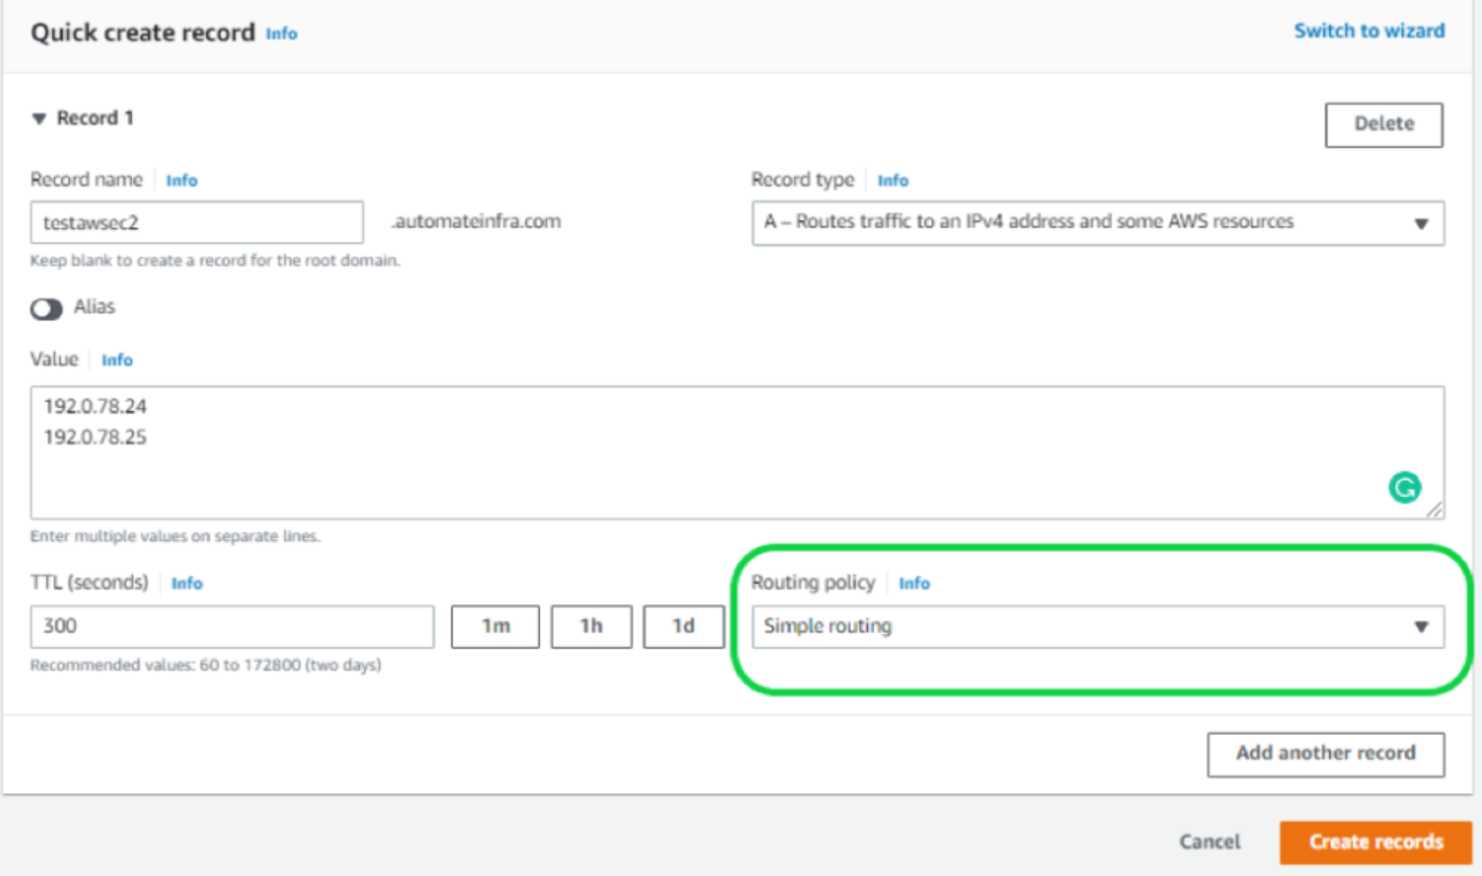

* Define how Route 53 responds to DNS queries
* Don’t get confused by the word “Routing”
  + It’s not the same as Load balancer routing which routes the traffic
  + DNS does not route any traffic, it only responds to the DNS queries
* Route 53 Supports the following Routing Policies

1. Simple
2. Weighted
3. Failover
4. Latency based
5. Geolocation
6. Multi-Value Answer
7. Geoproximity (using Route 53 Traffic Flow feature)

Routing Policies – Simple

The clients that will say, hey, I want to go to foo.example.com, and Routes 53 will say, hey, go to this IP address. And this is an A record. So it is possible for us to specify multiple values in the same record. And if so, if multiple values are returned by the DNS, then a random one will be chosen by the clients or client side.

|  |  |
| --- | --- |
| • Typically, route traffic to a single resource  • Can specify multiple values in the same record  • If multiple values are returned, a random one is chosen by the client  • When Alias enabled, specify only one AWS resource  • Can’t be associated with Health Checks |  |

Routing Policies – Weighted

|  |  |
| --- | --- |
| • Control the % of the requests that go to each specific resource  • Assign each record a relative weight    Weights don’t need to sum up to 100   * DNS records must have the same name and type * Can be associated with Health Checks * Use cases: load balancing between regions, testing * new application versions… * Assign a weight of 0 to a record to stop * sending traffic to a resource * If all records have weight of 0, then all records * will be returned equally |  |

Routing Policies – Latency -based

|  |  |
| --- | --- |
| • Redirect to the resource that has the least latency close to us  • Super helpful when latency for users is a priority  • Latency is based on traffic between users and AWS Regions  • Germany users may be directed to the US (if that’s the lowest latency)  • Can be associated with Health Checks (has a failover capability) |  |

Route 53 – Health Checks

|  |  |
| --- | --- |
| * HTTP Health Checks are only for public resources * Health Check => Automated DNS Failover:   + Health checks that monitor an endpoint (application, server, other AWS resource)   + Health checks that monitor other health checks (Calculated Health Checks)   + Health checks that monitor CloudWatch Alarms (full control !!) – e.g., throttles of DynamoDB, alarms on RDS, custom metrics, … (helpful for private resources)   Health Checks are integrated with Cloud watch metrics | Say we have two public Load balancers in different regions for high availability where Route 53 will route to these ALB. With health checks it will will failover if health checks fail. |

Health Checks – Monitor an Endpoint

|  |  |
| --- | --- |
| * About 15 global health checkers will check the endpoint health * Can set Healthy/Unhealthy Threshold – 3 (default) * Interval – 30 sec (can set to 10 sec – higher cost) * Supported protocol: HTTP, HTTPS and TCP * If > 18% of health checkers report the endpoint is healthy, Route 53 considers it Healthy. Otherwise, it’s Unhealthy * Ability to choose which locations you want Route 53 to use * Health Checks pass only when the endpoint responds with the 2xx and 3xx status codes * If it is text based response then Health Checks can be set up to pass / fail based on the text in the first 5120 bytes of the response to look for specific text. * Configure your router/firewall to allow incoming requests from Route 53 Health Checkers   [**https://ip-ranges.amazonaws.com/ip-ranges.json**](https://ip-ranges.amazonaws.com/ip-ranges.json) |  |

Route 53 – Calculated Health Checks

|  |  |
| --- | --- |
| • Combine the results of multiple Health Checks into a single Health Check  • You can use OR, AND, or NOT  • Can monitor up to 256 Child Health Checks  • Specify how many health checks need to pass to make the parent pass  • Usage: perform maintenance to your website without causing all health checks to fail |  |

Health Checks – Private Hosted Zones

|  |  |
| --- | --- |
| * Route 53 health checkers are outside the VPC (private) * They can’t access private endpoints (private VPC or on-premises resource) * You can create a CloudWatch Metric and associate a CloudWatch Alarm, then create a Health Check that checks the alarm itself |  |

Routing Policies – Failover (Active-Passive)

In failover policy I set 2 records one active another secondary

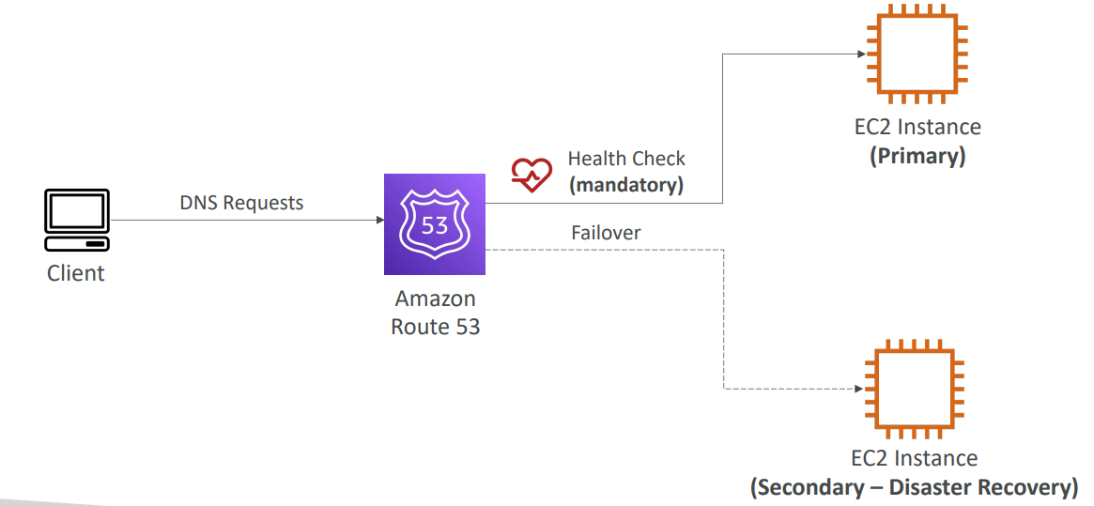

Routing Policies – Geolocation

|  |  |
| --- | --- |
| • Different from Latency-based!  • This routing is based on user location  • Specify location by Continent, Country or by US State (if there’s overlapping, most precise location selected)  • Should create a “Default” record (in case there’s no match on location)  • Use cases: website localization, restrict content distribution, load balancing, …  • Can be associated with Health Checks |  |

Routing Policies – Geoproximity

* Route traffic to your resources based on the geographic location of users and resources
* Ability to shift more traffic to resources based on the defined bias
* To change the size of the geographic region, specify bias values:

1. To expand (1 to 99) – more traffic to the resource
2. To shrink (-1 to -99) – less traffic to the resource

* Resources can be:

1. AWS resources (specify AWS region)
2. Non-AWS resources (specify Latitude and Longitude)

* You must use Route 53 Traffic Flow to use this feature

Let’s take an example of a resource in us-west-1, and one resource in us-east-1. And the bias is set to zero in both regions. So that means that if you have users all around the US trying to access these resources, there's going to be a line dividing the US is too into two, and users left of that line will go to us-west-1, and user rights of that line will go to us-east-1.

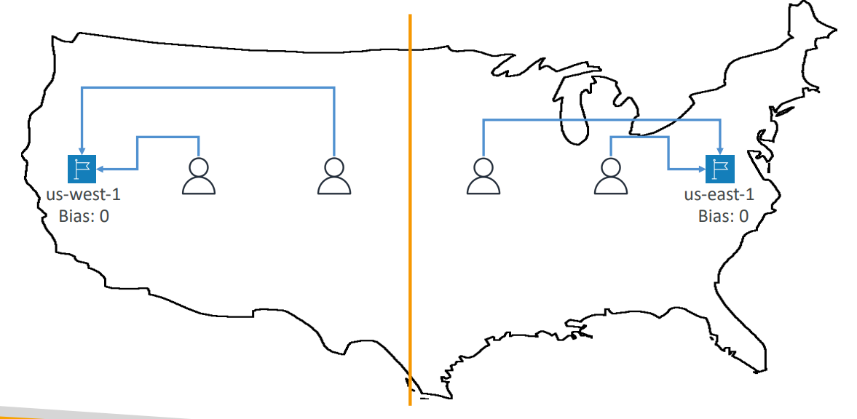

We have us-west-1 and us-east-1, and the bias is set to zero in us-west-1, but we're going to have a positive bias of 50 in us-east-1. And we've seen that the bias make more users and more traffic to that resource.  because of the bias now the quote in quote, dividing line between the first. The two resources is going to be a little bit more to the left because of the higher bias of us-east-1. And so that means is that's the user left of that line can go to us-west-1, but the users right or that one will go to us-east-1

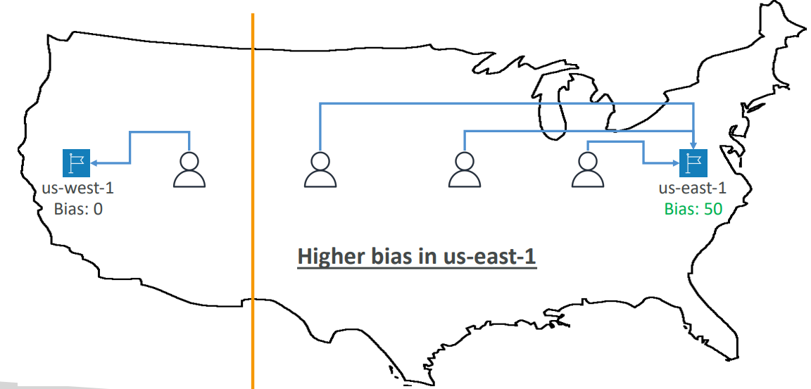

Routing Policies – IP-based Routing

|  |  |
| --- | --- |
| * Routing is based on clients’ IP addresses * You provide a list of CIDRs for your clients and the corresponding endpoints/locations (user-IP-to-endpoint mappings) * Use cases: Optimize performance, reduce network costs… * Example: route end users from a particular ISP to a specific endpoint |  |

Routing Policies – Multi-Value

* Use when routing traffic to multiple resources
* Route 53 return multiple values/resources
* Can be associated with Health Checks (return only values for healthy resources)
* Up to 8 healthy records are returned for each Multi-Value query
* Multi-Value is not a substitute for having an ELB

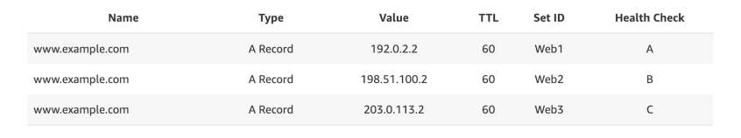

Domain Registar vs. DNS Service

* You buy or register your domain name with a Domain Registrar typically by paying annual charges (e.g., GoDaddy, Amazon Registrar Inc., …)
* The Domain Registrar usually provides you with a DNS service to manage your DNS records
* But you can use another DNS service to manage your DNS records
* Example: purchase the domain from GoDaddy and use Route 53 to manage your DNS records

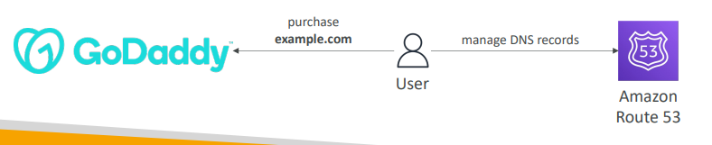

GoDaddy as Registrar & Route 53 as DNS Service

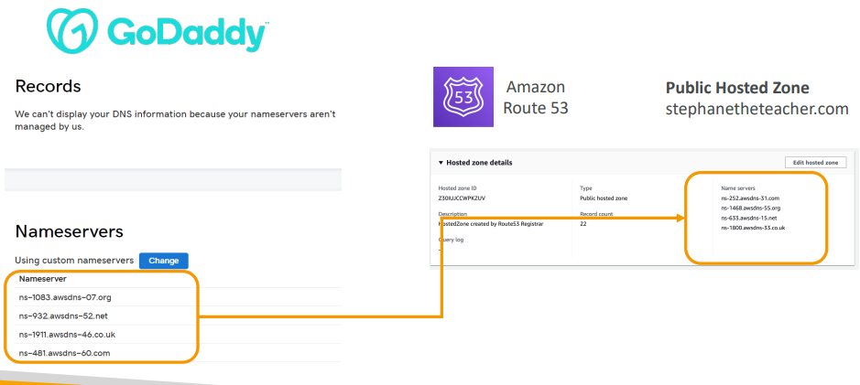

3rd Party Registrar with Amazon Route 53

* If you buy your domain on a 3rd party registrar, you can still use Route 53 as the DNS Service provider
  + Create a Hosted Zone in Route 53
  + Update NS Records on 3rd party website to use Route 53 Name Servers
* Domain Registrar != DNS Service
* But every Domain Registrar usually comes with some DNS features

## Questions

Top of Form

You have purchased **mycoolcompany.com** on Amazon Route 53 Registrar and would like the domain to point to your Elastic Load Balancer **my-elb-1234567890.us-west-2.elb.amazonaws.com**. Which Route 53 Record type must you use here?

* CNAME
* Alias

Bottom of Form

Alias 🡪 You can't create a CNAME record that has the same name as the top node of the DNS namespace (Zone Apex), in our case "mycoolcompany.com."

Top of Form

You have deployed a new Elastic Beanstalk environment and would like to direct 5% of your production traffic to this new environment. This allows you to monitor for CloudWatch metrics and ensuring that there're no bugs exist with your new environment. Which Route 53 Record type allows you to do so?

* Simple
* Weighted
* Latency
* Failover

Bottom of Form

Weighted Routing Policy allows you to redirect part of the traffic based on weight (e.g., percentage). It's a common use case to send part of traffic to a new version of your application.

Top of Form

You have updated a Route 53 Record's **myapp.mydomain.com** value to point to a new Elastic Load Balancer, but it looks like users are still redirected to the old ELB. What is a possible cause for this behavior?

* Because of the Alias record
* Because of the CNAME record
* Because of the TTL
* Because of Route 53 Health Checks

Bottom of Form

Each DNS record has a TTL (Time To Live) which orders clients for how long to cache these values and not overload the DNS Resolver with DNS requests. The TTL value should be set to strike a balance between how long the value should be cached vs. how many requests should go to the DNS Resolver.

Top of Form

You have an application that's hosted in two different AWS Regions us-west-1 and eu-west-2. You want your users to get the best possible user experience by minimizing the response time from application servers to your users. Which Route 53 Routing Policy should you choose?

* Multi Value
* Weighted
* Latency
* Geolocation

Bottom of Form

Latency Routing Policy will evaluate the latency between your users and AWS Regions, and help them get a DNS response that will minimize their latency (e.g. response time)

Top of Form

You have a legal requirement that people in any country, but France should **NOT** be able to access your website. Which Route 53 Routing Policy helps you in achieving this?

* Latency
* Simple
* Multi Value
* Geolocation

Geo location

Bottom of Form

Top of Form

You have purchased a domain on **GoDaddy** and would like to use Route 53 as the DNS Service Provider. What should you do to make this work?

* Request for a domain transfer
* Create a Private Hosted Zone and update the 3rd party Registrar NS records
* Create a Public Hosted Zone and update the Route 53 NS records
* Create a Public Hosted Zone and update the 3rd party Registrar NS records

Bottom of Form

Public Hosted Zones are meant to be used by people requesting your website through the Internet. Finally, NS records must be updated on the 3rd party Registrar.

Top of Form

Which of the following are **NOT** valid Route 53 Health Checks?

* Health Check that monitors SQS Queue
* Health Check that monitors an Endpoint
* Health Check that monitors other Health Checks
* Health Check that monitors CloudWatch Alarms

Health Check that monitors SQS Queue

Bottom of Form

# Classic Solutions Architecture

We’ll see the progression of a Solution’s architect mindset through many sample case studies:

1. WhatIsTheTime.Com
2. MyClothes.Com
3. MyWordPress.Com
4. Instantiating applications quickly
5. Beanstalk

Stateless Web App: WhatIsTheTime.com

WhatIsTheTime.com allows people to know what time it is

* We don’t need a database
* We want to start small and can accept downtime
* We want to fully scale vertically and horizontally, no downtime
* Let’s go through the Solutions Architect journey for this app
* Let’s see how we can proceed!

Stateless web app: What time is it? Starting simple

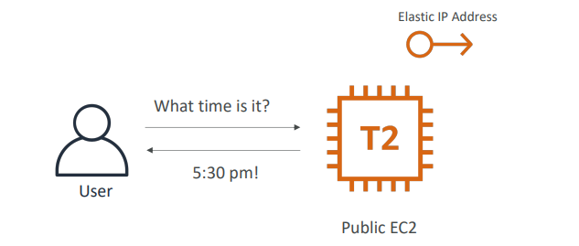

Stateless web app: What time is it? Scaling vertically

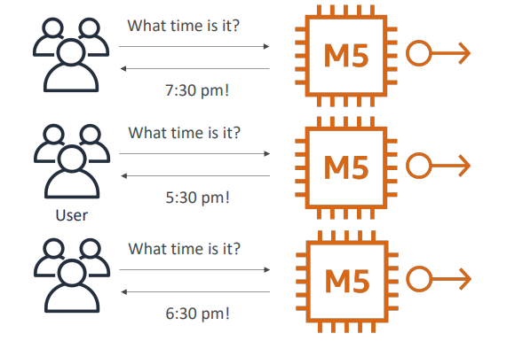

Stateless web app: What time is it? Scaling horizontally

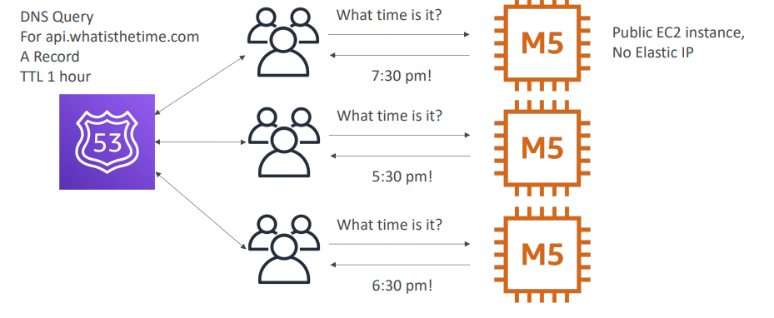

Stateless web app: What time is it? Scaling horizontally, adding and removing instances

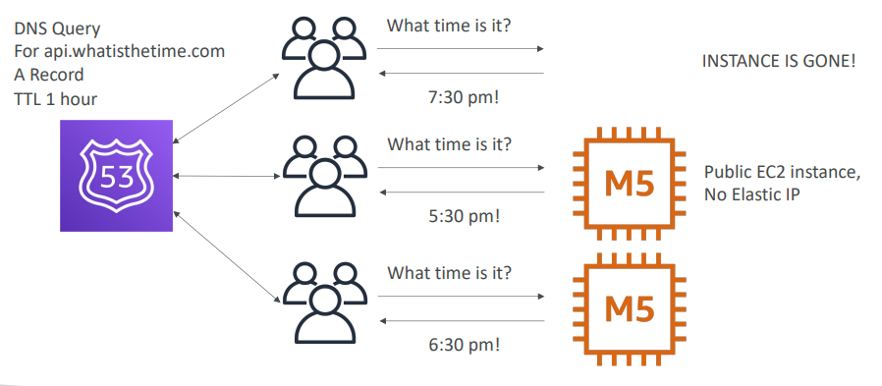

Stateless web app: What time is it? Scaling horizontally, with a load balancer

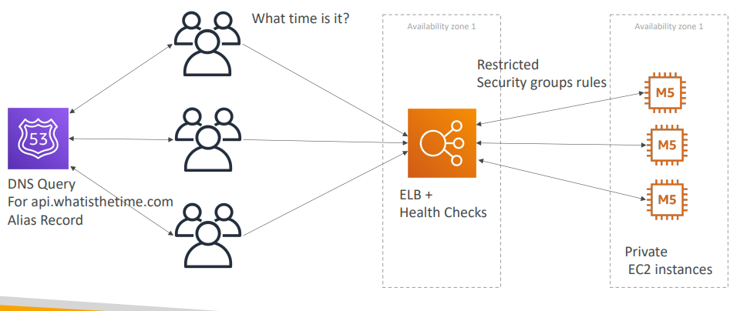

Stateless web app: What time is it? Scaling horizontally, with an auto-scaling group

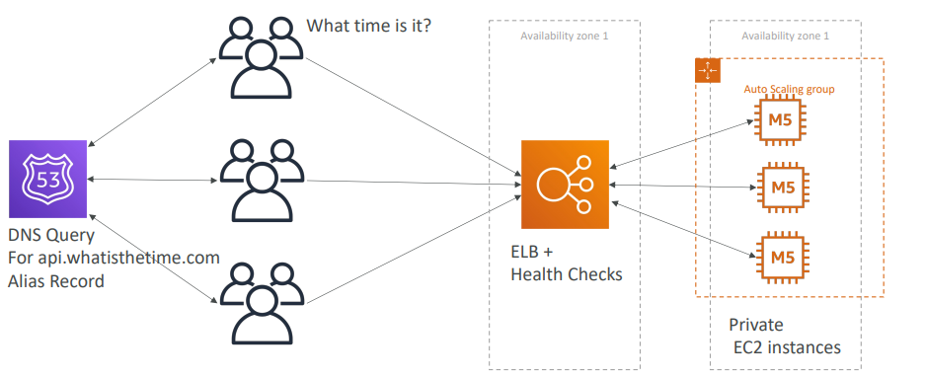

Stateless web app: What time is it? Making our app multi-AZ

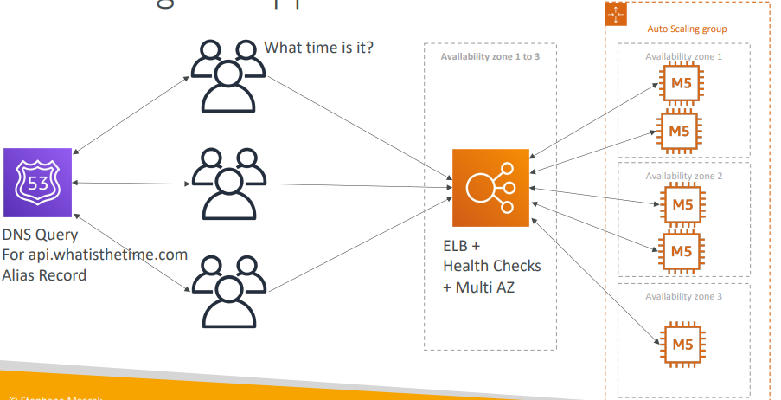

Minimum 2 AZ => Let’s reserve capacity

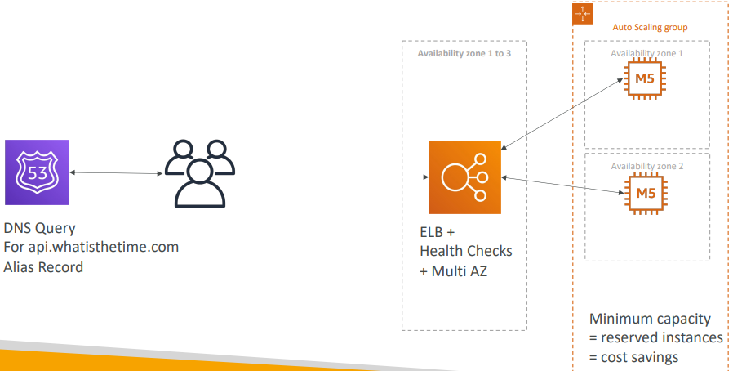

In this lecture we’ve discussed…

* Public vs Private IP and EC2 instances
* Elastic IP vs Route 53 vs Load Balancers
* Route 53 TTL, A records and Alias Records
* Maintaining EC2 instances manually vs Auto Scaling Groups
* Multi AZ to survive disasters
* ELB Health Checks
* Security Group Rules
* Reservation of capacity for costing savings when possible

Stateful Web App: MyClothes.com

* MyClothes.com allows people to buy clothes online.
* There’s a shopping cart
* Our website is having hundreds of users at the same time
* We need to scale, maintain horizontal scalability and keep our web application as stateless as possible
* Users should not lose their shopping cart
* Users should have their details (address, etc) in a database
* Let’s see how we can proceed!

Stateful Web App: MyClothes.com

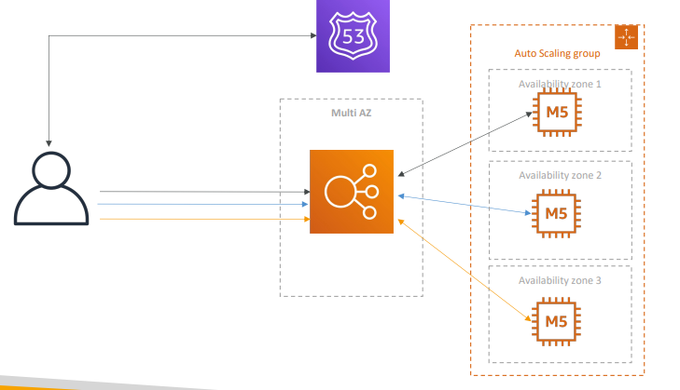

Stateful Web App: MyClothes.com Introduce Stickiness (Session Affinity)

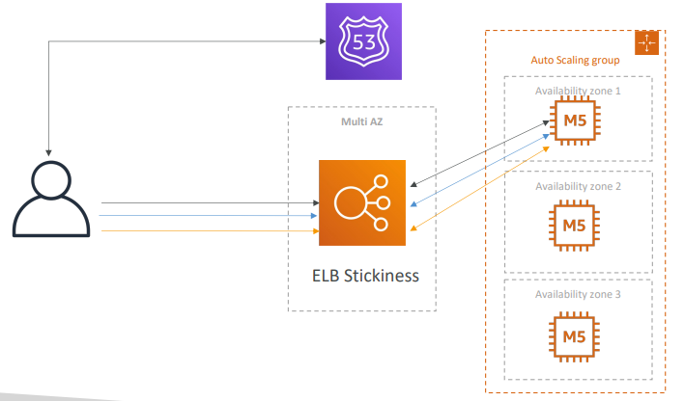

Stateful Web App: MyClothes.com Introduce User Cookies

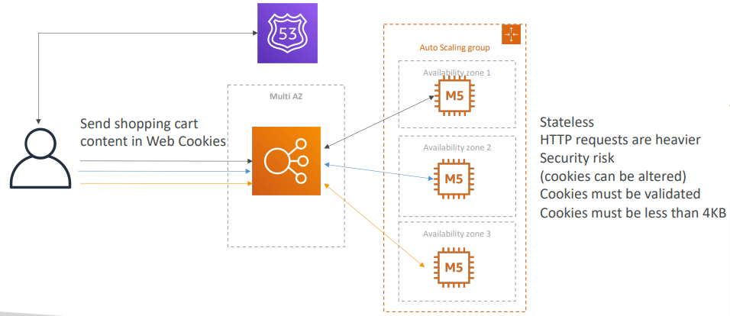

Stateful Web App: MyClothes.com Introduce Server Session  
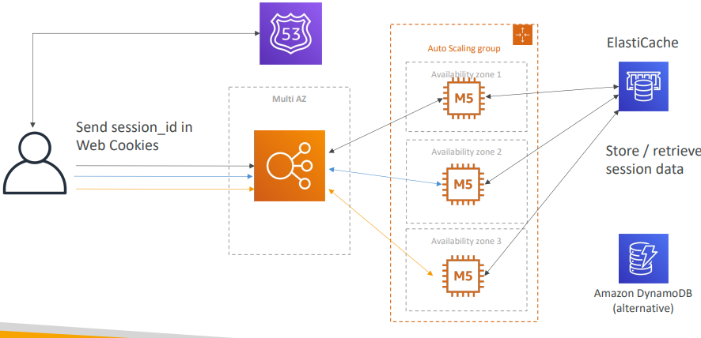

Stateful Web App: MyClothes.com Storing User Data in a database

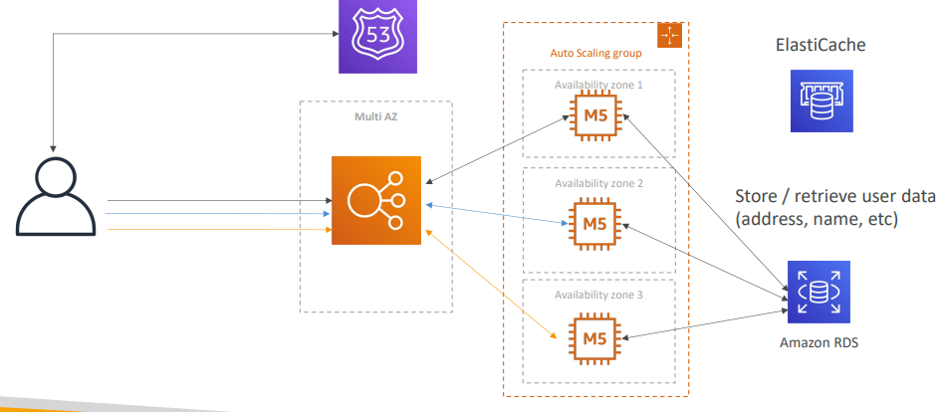

Stateful Web App: MyClothes.com Scaling Reads

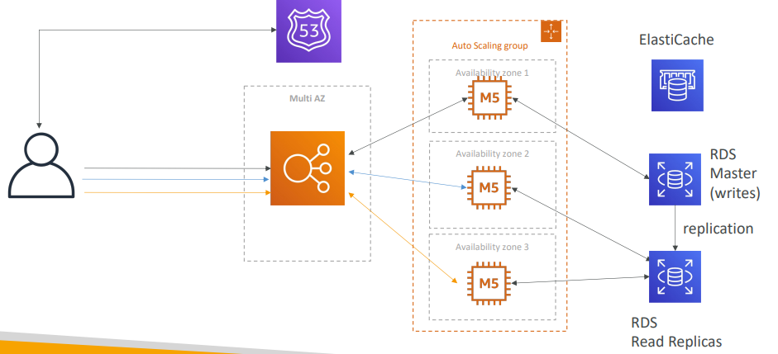

Stateful Web App: MyClothes.com Scaling Reads (Alternative) – Lazy Loading

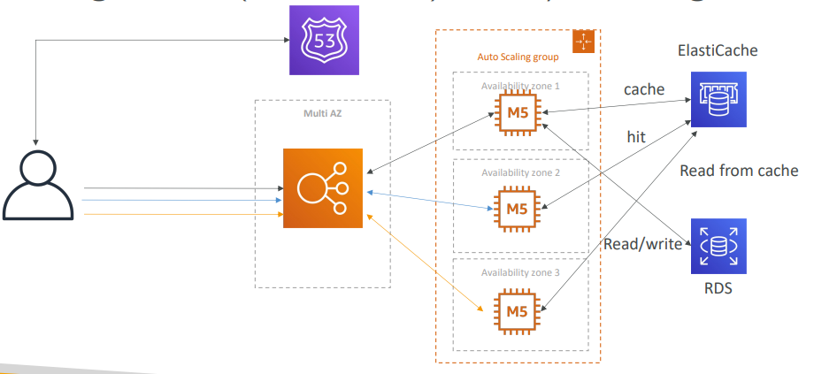

Stateful Web App: MyClothes.com Multi AZ – Survive disasters

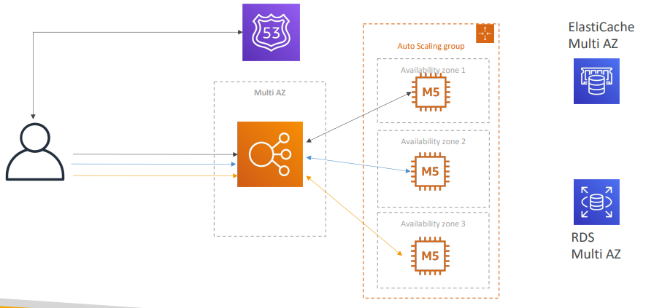

Stateful Web App: MyClothes.com Security Groups

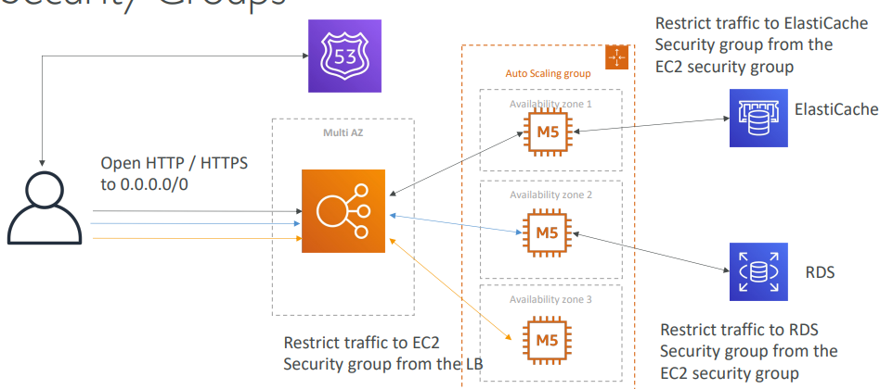

In this lecture we’ve discussed… 3-tier architectures for web applications

* ELB sticky sessions
* Web clients for storing cookies and making our web app stateless
* ElastiCache

1. For storing sessions (alternative: DynamoDB)
2. For caching data from RDS
3. Multi AZ

* RDS

1. For storing user data
2. Read replicas for scaling reads
3. Multi AZ for disaster recovery

* Tight Security with security groups referencing each other

Stateful Web App: MyWordPress.com

* We are trying to create a fully scalable WordPress website
* We want that website to access and correctly display picture uploads
* Our user data, and the blog content should be stored in a MySQL database.
* Let’s see how we can achieve this!

Stateful Web App: MyWordPress.com RDS layer

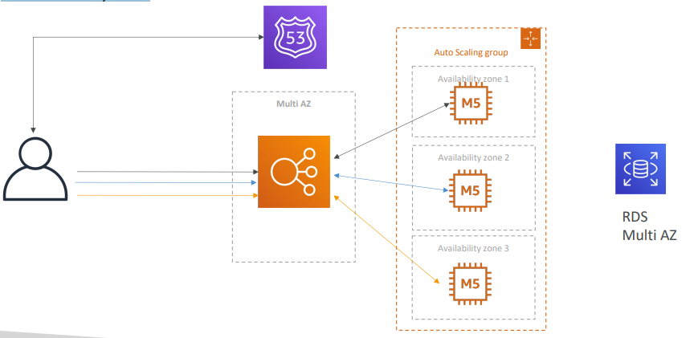

Stateful Web App: MyWordPress.com Scaling with Aurora: Multi AZ & Read Replicas

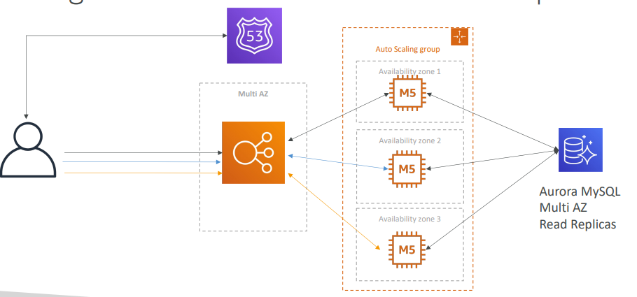

Stateful Web App: MyWordPress.com Storing images with EBS

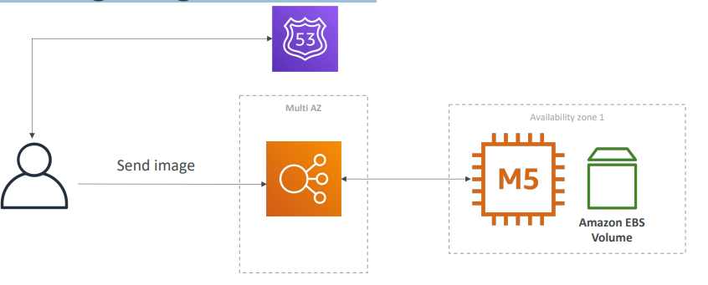

Stateful Web App: MyWordPress.com Storing images with EBS

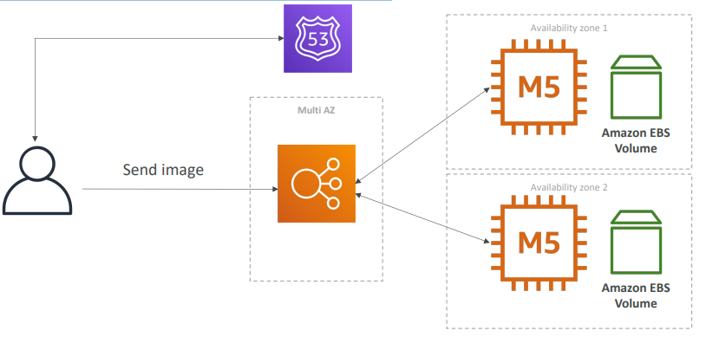

Stateful Web App: MyWordPress.com Storing images with EFS

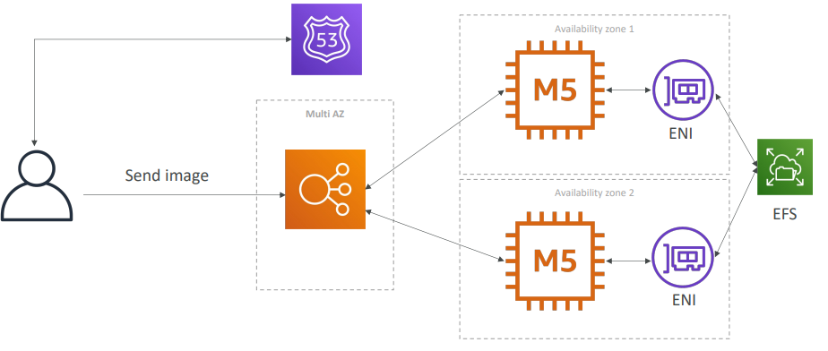

In this lecture we’ve discussed… • Aurora Database to have easy Multi-AZ and Read

* -Replicas
* Storing data in EBS (single instance application)
* Vs Storing data in EFS (distributed application)

Instantiating Applications quickly

* When launching a full stack (EC2, EBS, RDS), it can take time to:

1. Install applications
2. Insert initial (or recovery) data
3. Configure everything
4. Launch the application

* We can take advantage of the cloud to speed that up!

Instantiating Applications quickly

* EC2 Instances:

1. Use a Golden AMI: Install your applications, OS dependencies etc.. beforehand and launch your EC2 instance from the Golden AMI
2. Bootstrap using User Data: For dynamic configuration, use User Data scripts
3. Hybrid: mix Golden AMI and User Data (Elastic Beanstalk)

* RDS Databases:
  + Restore from a snapshot: the database will have schemas and data ready!
* EBS Volumes:
  + Restore from a snapshot: the disk will already be formatted and have data

Typical architecture: Web App 3-tier

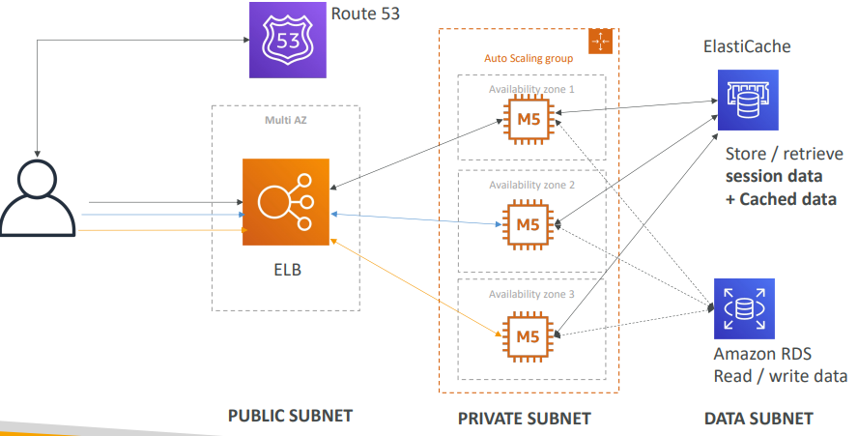

Developer problems on AWS

1. Managing infrastructure
2. Deploying Code
3. Configuring all the databases, load balancers, etc
4. Scaling concerns
5. Most web apps have the same architecture (ALB + ASG)
6. All the developers want is for their code to run!
7. Possibly, consistently across different applications and environments

Elastic Beanstalk – Overview

* Elastic Beanstalk is a developer centric view of deploying an application on AWS
* It uses all the component’s we’ve seen before: EC2, ASG, ELB, RDS, …
* Managed service

1. Automatically handles capacity provisioning, load balancing, scaling, application health monitoring, instance configuration, …
2. Just the application code is the responsibility of the developer

* We still have full control over the configuration
* Beanstalk is free but you pay for the underlying instances

Elastic Beanstalk – Components

* Application: collection of Elastic Beanstalk components (environments, versions, configurations, …)
* Application Version: an iteration of your application code
* Environment

1. Collection of AWS resources running an application version (only one application version at a time)
2. Tiers: Web Server Environment Tier & Worker Environment Tier
3. You can create multiple environments (dev, test, prod, …)

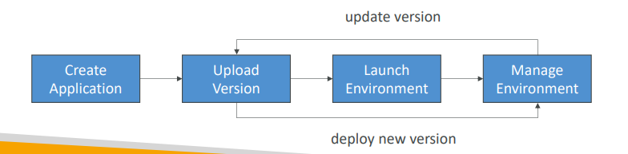

Elastic Beanstalk – Supported Platforms

* Go
* Java SE
* Java with Tomcat
* .NET Core on Linux
* .NET on Windows Server
* Node.js
* PHP
* Python
* Ruby
* Packer Builder
* Single Container Docker
* Multi-container Docker
* Preconfigured Docker

Web Server Tier vs. Worker Tier

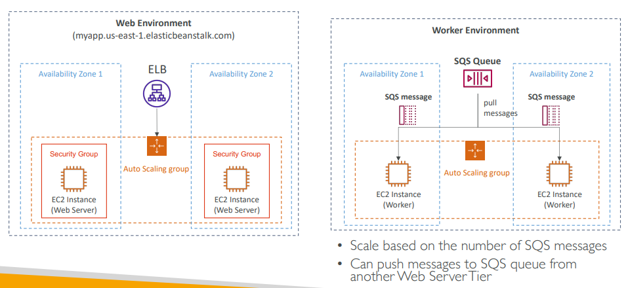

Elastic Beanstalk Deployment Modes

